St Alfege Church, Greenwich Enewsletter 19 December 2021
Vicar's Christmas message
This week I helped lead Christmas collective worship for St Alfege School and Year 2 presented the Nativity - reminding us that in coming among us a child, God did something extraordinary for ordinary vulnerable people. The tree has been put up in church and after the joyful and amusing nativity production by our Children's Church last Sunday, this week we reach the fourth and final Sunday in Advent - the countdown has really begun!
At 6.30pm this evening we hold our annual service of Nine Lessons and Carols which takes us across the sweep of scripture declaring the good news of God’s outrageous love and ongoing work of saving us from ourselves. We are reminded that the Lord’s love is expressed profoundly and personally by coming to us in human form. The incarnation, as we call it and which we celebrate especially at Christmas, is that moment in human history when the God we might think of as ‘distant’ from us, became more personal than any could have imagined. The incarnation is perhaps the highest expression of love. So, in the days ahead, through the story of scripture, the beauty of music and the reflection of our preaching and prayers, may we know the depth of God's extraordinary love more fully and hold the hope of ‘brighter visions’ for the year ahead for us all. If you are away from Greenwich, do enjoy worshipping where you are staying - and tell me about it when you're back, and for those of us who will be at St Alfege, let's offer a warm welcome and joyful experience for the many who will visit us.
A very Happy Christmas to us all
Simon
At the Heart of Christmas
As you leave the seasonal services you will see copies of 'At the Heart of Christmas' - a booklet of daily reflections from the Church of England for Christmas to Epiphany. Feel free to take a copy for use at home or to pass onto someone else who might appreciate a copy.
Christingle Christmas Eve 5pm
This year we will be ticketing our Christingle service and will be limiting the numbers of attendees and number of tickets to four per booking. You can book here now.
All our other Christmas services are not ticketed but please note that these services will have limited numbers and we cannot guarantee entry. Please check the website for up-to-date information and any changes. For worship in church, we recommend you continue to wear a mask unless exempt and to sanitise hands. We encourage you to take a lateral flow test before coming to worship, as the clergy and choir do twice a week.
A reminder that our services, including our Christmas services will be streamed live on the St Alfege Church YouTube channel. You will be able to find the services each week under ‘playlists’. A YouTube account or log-in is not required.
There will be no 8am Holy Communion service on Sunday December 26 - the service will return on Sunday 2 January - the Feast of the Epiphany.
Christmas and New Year closure
Please note that the church will be closed to visitors from the end of the service on 26 December until 4 January 2022. The church office will be reopened on 4 January.
Morning Prayer will resume at 8.30am on Tuesday 4 January.
Thursday 8am Holy Communion now takes a break and resumes on Thursday 6 January 2022.
Advent Windows
Our own "window", at the East end of the church, d this year features the original sculpture created by Jonathan Bishop for the first ever Advent Window.
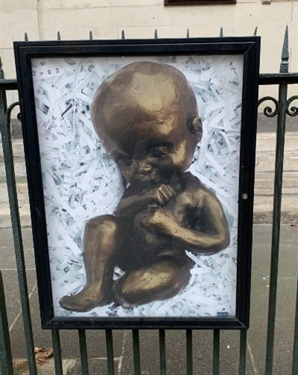
The image is of a bronze cast of a plasticine sculpture originally made in 2007 by Jonathan Bishop for an animated stain glass window. The animation was back projected onto the window of a nearby house for the first ever advent windows exhibition. It was originally sculpted as an eight-month foetus and the moving image resembled a medical scan. It was the first advent window to open, on 1 December, and the sculpture was presented in church re-shaped into a baby for Christmas Day.
You can find out more about all the Advent Windows here bringing the town centre to life with 24 unique offerings in the lead up to Christmas.
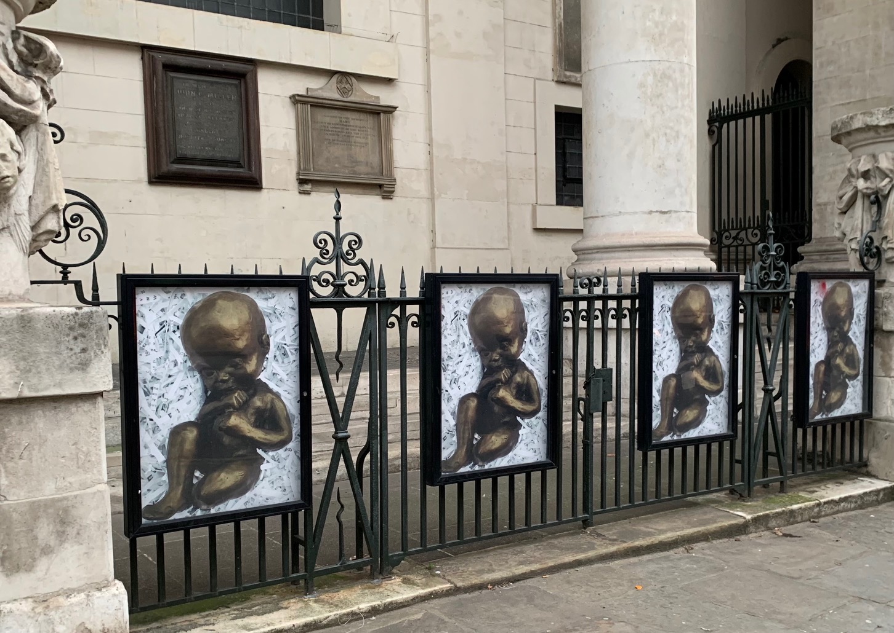
Director of Music
After 42 years' dedicated service at St Alfege Church, Stephen Dagg will be retiring as Director of Music on April 24 next year. We will ensure we make time to honour Steve's time here and thank him properly after Easter. We are now advertising to recruit his successor and hope to hold interviews in early February. Please hold potential applicants, those involved in the recruitment process, and our choir and music ministry in your prayers.
God of harmony and every beautiful sound, we praise you for all who make music to delight us as we worship you; may we with heart, mind and voice honour you in worship and witness to the praise of your glorious name, through Jesus Christ our Lord. Amen. Simon
Concerts and recitals
The programme for January is now available.
Feedback from Visit Greenwich website
St Alfege Church, Greenwich: Exterior, interior and details.
"I really enjoyed the atmosphere of this church - the people were friendly and the pleasantly well-lit rooms brought me much delight. The many plaques and information posters around the interiors made me very happy too; it's great to see people appreciating the history of the building. Hawksmoor certainly deserves that. I'll definitely be visiting this area again when I have the chance! Perhaps next time I can catch a recital in the church."

