
x

Last Sunday after Trinity
All Age Eucharist with Baptisms
25 October 2026
Welcome to our services of Holy Communion on the Last Sunday after Trinity. We welcome Revd Dr John Philpott Howard as president at 8am and Revd Dom Hubbuck at 10am. Dr Susan Pawlby is preaching at both services. Babies Daphne Gregory and Ivo Mycroft Conti will be baptized in the 10am service. We welcome them, their families and supporters. Today’s music reflects the theme of Black History Month.
Readings
1 Thessalonians 2: 1-8 (8am only)
Matthew 22: 34-40
Hymns
199 Immortal, invisible, God only wise
212 Who could true valour see
118 Firmly I believe and truly
99 O God, our help in ages past
Collect
Blessed Lord, who caused all holy Scriptures to be written for our learning: help us so to hear them, to read, mark, learn and inwardly digest them that, through patience, and the comfort of your holy word, we may embrace and for ever hold fast the hope of everlasting life, which you have given us in our Saviour Jesus Christ, who is alive and reigns with you, in the unity of the Holy Spirit, one God, now and for ever. Amen
Prayer after Communion
God of all grace, your Son Jesus Christ fed the hungry
with the bread of his life and the word of his kingdom:
renew your people with your heavenly grace, and in all our weakness sustain us by your true and living bread; who is alive and reigns, now and for ever.
Kyrie
Please join in singing the Kyrie from Schubert’s German Mass.
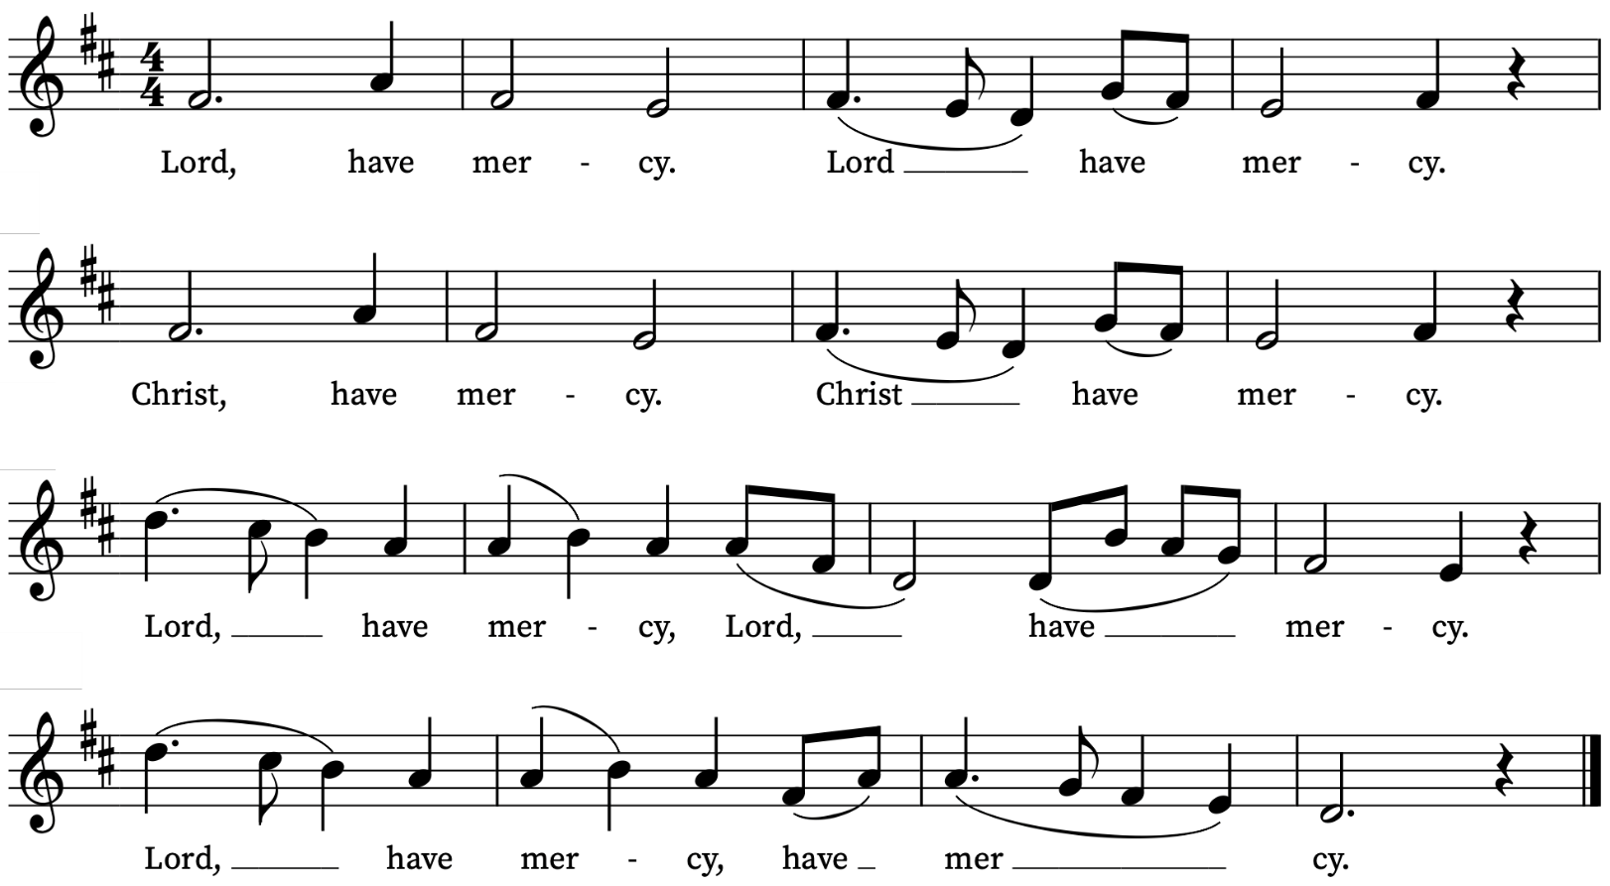

First Reading (8am only)
1 Thessalonians 2: 1-8
A reading from Paul’s letter to the Thessalonians
You yourselves know, brothers and sisters, that our coming to you was not in vain, but though we had already suffered and been shamefully maltreated at Philippi, as you know, we had courage in our God to declare to you the gospel of God in spite of great opposition. For our appeal does not spring from deceit or impure motives or trickery, but just as we have been approved by God to be entrusted with the message of the gospel, even so we speak, not to please mortals, but to please God who tests our hearts. As you know and as God is our witness, we never came with words of flattery or with a pretext for greed; nor did we seek praise from mortals, whether from you or from others, though we might have made demands as apostles of Christ. But we were gentle among you, like a nurse tenderly caring for her own children. So deeply do we care for you that we are determined to share with you not only the gospel of God but also our own selves, because you have become very dear to us.
This is the Word of the Lord
Thanks be to God

Gospel Reading
Matthew 22: 34-40
Hear the Gospel of our Lord Jesus Christ according to Matthew
Glory be to thee, O Lord
When the Pharisees heard that he had silenced the Sadducees, they gathered together, and one of them, a lawyer, asked him a question to test him. ‘Teacher, which commandment in the law is the greatest?’ He said to him, ‘“You shall love the Lord your God with all your heart, and with all your soul, and with all your mind.” This is the greatest and first commandment. And a second is like it: “You shall love your neighbour as yourself.” On these two commandments hang all the law and the prophets.’
This is the Gospel of the Lord
Praise be to thee, O Christ

Today’s Music
Today’s music reflects the theme of Black History Month.
Mass setting (Gloria, Sanctus/Benedictus, Agnus Dei):
German Mass – Franz Schubert
Anthem
Rivers of Living Water – Trevor Weston
Out of his heart shall flow rivers of living water.
A river flowing in a parched land.
If anyone thirst, let him come to me and drink.
John 7: 37-38
Communion Motets
Bring me all your dreams – Christopher H. Harris
Bring me all your dreams, you dreamers.
Bring me all your heart melodies
that I may wrap them in a blue cloud cloth
away from the too rough fingers of the world.
Bring me all your dreams, you dreamers.
Words: Langston Hughes (1902–67)
Organ Postlude
March from Herod – Samuel Coleridge-Taylor

Prayers for the week
We pray for babies Daphne and Ivo who are being baptized in the 10am service and we ask God’s blessing on them, their families and supporters.
We pray for those in need: George Coles, Fr Giles Harcourt, William Higginson, Carole Hubble, Marion Kokott, James Markham, Sara Mauleverer, Lylian Meira, Véronique Müller, Vernon Mustoe, Marion Reid, Karen Robjont, Geoff Staden, Tina Stanley, Doreen Waller, and Pauline Youll.
We remember those who have died recently including David Batten, Sarah Batten, Calum Clarke, Colin Coveney, Tony Currie, Dominic Meetabix, Jean Elaine Rose, Mimi, Jean Smith, Maulene Sweet and John Yeomans.
If you wish to add names to the prayers for those in need or departed please contact David McEvoy dmcevoy@btinternet.com

Choral Evensong today, 25 October
Do join us for our service of Choral Evensong at 4pm today. Revd Mark Hatcher is leading. Music by Gibbons, Rose, Sumsion, Stopford, Reger and Howells.
All Souls Service 1 November at 10am
We will be remembering our departed loved ones at our service for All Souls on Sunday 1 November at 10am. If you would like the names of loved ones read out in the service, please write their names clearly on the sheets on the welcome desk or email David McEvoy with the names: dmcevoy@btinternet.com. Please do this by today, Sunday 25 October.
Supporting St Alfege Church
Please do make a gift to support the life and ministry of St Alfege Church – during the collection in the service or by using a card reader at the North and West Doors. Please complete a Gift Aid envelope (if you are eligible) whether you donate by cash or card. You can also use this QR code to donate. | 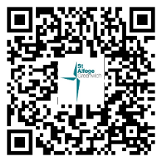

Services this week
Sunday 25 October Last Sunday after Trinity
8.00am Holy Communion
10.00am Parish Eucharist
4.00pm Choral Evensong
Monday 26 October
8.30am Morning Prayer
5.30pm Old Royal Naval College Choral Evensong in church
Tuesday 27 October
8.30am Morning Prayer
Wednesday 28 October
8.30am Morning Prayer
Thursday 29 October
8.00am Holy Communion
Sunday 1 November All Saints and All Souls
8.00am Holy Communion
10.00am Sung Eucharist
5.30pm Abide, a contemplative service with music from Taizé
Walk-in Wednesdays
Every Wednesday 10am-12noon in the small hall
Contact us
Vicar: Revd Simon Winn
Curate: Revd Dr Tati Gutteridge (on maternity leave)
Church Office: 020 8853 0687
Email: office@st-alfege.org.uk Website: www.st-alfege.org.uk
Safeguarding Team
Karen Hansen Lead Safeguarding Officer 07866 932 894
Carole Moses Safeguarding Officer 07889 396 671
Irene Bishop Safeguarding Officer 020 8698 2658
safeguarding@st-alfege.org.uk
Please take this sheet home with you.

