
x

Sung Eucharist
St Luke
18 October 2026
Welcome to our services of Holy Communion on the Feast of St Luke, when we focus on healing. There will be an opportunity in the service for you to receive laying on of hands and anointing with oil. We welcome Revd Barbara Moss as president at the 8am and 10am services. David McEvoy, Reader (Licensed Lay Minister), is preaching at both services.
Readings
Isaiah 35: 3-6
Psalm 147: 1-7
2 Timothy 4: 5-17
Luke 10: 1-9
Hymns
431 We have a gospel to proclaim
417 Praise we now the Word of grace
423 Thanks to God whose Word was spoken (tune: St Helen)
422 Tell out, my soul, the greatness of the Lord
Collect
Almighty God, you called Luke the physician, whose praise is in the gospel, to be an evangelist and physician of the soul:
by the grace of the Spirit and through the wholesome medicine of the gospel, give your Church the same love and power to heal; through Jesus Christ your Son our Lord, who is alive and reigns with you, in the unity of the Holy Spirit,
one God, now and for ever. Amen
Prayer after Communion
Lord God, the source of truth and love, keep us faithful to the apostles’ teaching and fellowship, united in prayer and the breaking of bread, and one in joy and simplicity of heart,
in Jesus Christ our Lord. Amen
Kyrie
Please join in singing the Kyrie from Schubert’s German Mass.
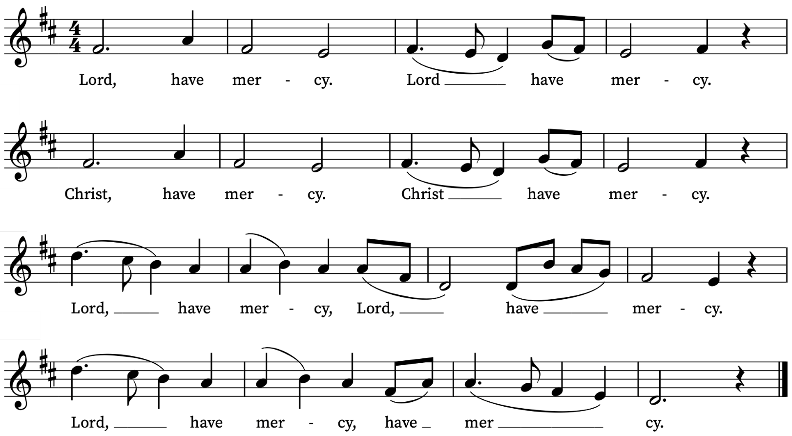
First Reading
Isaiah 35: 3-6
A reading from the prophet Isaiah
Strengthen the weak hands,
and make firm the feeble knees.
Say to those who are of a fearful heart,
‘Be strong, do not fear!
Here is your God.
He will come with vengeance,
with terrible recompense.
He will come and save you.’
Then the eyes of the blind shall be opened,
and the ears of the deaf unstopped;
then the lame shall leap like a deer,
and the tongue of the speechless sing for joy.
For waters shall break forth in the wilderness,
and streams in the desert;
This is the Word of the Lord
Thanks be to God
Psalm 147: 1-7
Laudate Dominum
O praise the Lord, for it is a good thing to sing praises unto our God : yea, a joyful and pleasant thing it is to be thankful.
2 The Lord doth build up Jerusalem : and gather together the out-casts of Israel.
3 He healeth those that are broken in heart : and giveth medicine to heal their sickness.
4 He telleth the number of the stars : and calleth them all by their names.
5 Great is our Lord, and great is his power : yea, and his wisdom is infinite.
6 The Lord setteth up the meek : and bringeth the ungodly down to the ground.
7 O sing unto the Lord with thanksgiving : sing praises upon the harp unto our God.
Second Reading
2 Timothy 4: 5-17
A reading from Paul’s Letter to Timothy
As for you, always be sober, endure suffering, do the work of an evangelist, carry out your ministry fully.
As for me, I am already being poured out as a libation, and the time of my departure has come. I have fought the good fight, I have finished the race, I have kept the faith. From now on there is reserved for me the crown of righteousness, which the Lord, the righteous judge, will give to me on that day, and not only to me but also to all who have longed for his appearing.
Do your best to come to me soon, for Demas, in love with this present world, has deserted me and gone to Thessalonica; Crescens has gone to Galatia, Titus to Dalmatia. Only Luke is with me. Get Mark and bring him with you, for he is useful in my ministry. I have sent Tychicus to Ephesus. When you come, bring the cloak that I left with Carpus at Troas, also the books, and above all the parchments. Alexander the coppersmith did me great harm; the Lord will pay him back for his deeds. You also must beware of him, for he strongly opposed our message.
At my first defence no one came to my support, but all deserted me. May it not be counted against them! But the Lord stood by me and gave me strength, so that through me the message might be fully proclaimed and all the Gentiles might hear it. So I was rescued from the lion’s mouth.
This is the Word of the Lord
Thanks be to God
Gospel Reading
Luke 10: 1-9
Hear the Gospel of our Lord Jesus Christ according to Luke
Glory be to thee, O Lord
After this the Lord appointed seventy others and sent them on ahead of him in pairs to every town and place where he himself intended to go. He said to them, ‘The harvest is plentiful, but the labourers are few; therefore ask the Lord of the harvest to send out labourers into his harvest. Go on your way. See, I am sending you out like lambs into the midst of wolves. Carry no purse, no bag, no sandals; and greet no one on the road. Whatever house you enter, first say, “Peace to this house!” And if anyone is there who shares in peace, your peace will rest on that person; but if not, it will return to you. Remain in the same house, eating and drinking whatever they provide, for the labourer deserves to be paid. Do not move about from house to house. Whenever you enter a town and its people welcome you, eat what is set before you; cure the sick who are there, and say to them, “The kingdom of God has come near to you.”
This is the Gospel of the Lord
Praise be to thee, O Christ
Today’s Music
Mass setting (Gloria, Sanctus/Benedictus, Agnus Dei):
Missa Sancti Patricii – Charles Wood
Psalm 147: 1-7
You can find the words on page 3 of this sheet.
Anthem
Benedictus – Thomas Tallis
Blessed be the Lord God of Israel : for he hath visited, and redeemed his people; And hath raised up a mighty salvation for us : in the house of his servant David; As he spake by the mouth of his holy Prophets : which have been since the world began; That we should be saved from our enemies : and from the hands of all that hate us; To perform the mercy promised to our forefathers : and to remember his holy covenant; To perform the oath which he sware to our forefather Abraham : that he would give us, That we being delivered out of the hands of our enemies : might serve him without fear, In holiness and righteousness before him : all the days of our life.
And thou, child, shalt be called the Prophet of the Highest : for thou shalt go before the face of the Lord to prepare his ways; To give knowledge of salvation unto his people : for the remission of their sins; Through the tender mercy of our God : whereby the dayspring from on high hath visited us; To give light to them that sit in darkness, and in the shadow of death : and to guide our feet into the way of peace.
Glory be to the Father, and to the Son : and to the Holy Ghost;
as it was in the beginning, is now, and ever shall be :
world without end. Amen.
Luke 1.68-79
Communion Motets
Agnus Dei from Missa Sancti Patricii – Charles Wood
Ubi Caritas – Maurice Duruflé (1902-1986)
Ubi caritas et amor Deus ibi es
Congregavit nos in unum Christi amor
Exultemus, et in ipso jucundemur
Timeamus, et amemus Deum vivum
Et ex corde diligamus nos sincero. Amen.
Where charity and love are, God is there.
Christ's love has gathered us into one.
Let us rejoice and be pleased in Him.
Let us fear, and let us love the living God.
And may we love each other with a sincere heart. Amen.
Organ Postlude
Sortie – Percy Whitlock

Prayers for the week
We pray for those in need: George Coles, Fr Giles Harcourt, William Higginson, Carole Hubble, Marion Kokott, James Markham, Sara Mauleverer, Lylian Meira, Véronique Müller, Vernon Mustoe, Marion Reid, Karen Robjont, Jean Smith, Geoff Staden, Tina Stanley, Doreen Waller, and Pauline Youll.
We remember those who have died recently including David Batten, Sarah Batten, Calum Clarke, Colin Coveney, Tony Currie, Mimi, Maulene Sweet and John Yeomans. We also remember Lilian Bishop on her year’s mind.
If you wish to add names to the prayers for those in need or departed please contact David McEvoy dmcevoy@btinternet.com
All Souls Service 1 November at 10am
We will be remembering our departed loved ones at our service for All Souls on Sunday 1 November at 10am. If you would like the names of loved ones read out in the service, please write their names clearly on the sheets on the welcome desk or email David McEvoy with the names: dmcevoy@btinternet.com. Please do this by Sunday 25 October.

Supporting St Alfege Church
Please do make a gift to support the life and ministry of St Alfege Church – during the collection in the service or by using a card reader at the North and West Doors. Please complete a Gift Aid envelope (if you are eligible) whether you donate by cash or card. You can also use this QR code to donate. | 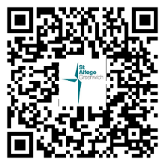

Services this week
Sunday 18 October Feast of St Luke
10.00am Parish Eucharist
Monday 19 October
8.30am Morning Prayer
Tuesday 20 October
8.30am Morning Prayer
Wednesday 21 October
8.30am Morning Prayer
Thursday 22 October
8.00am Holy Communion
2.00pm Funeral of Maulene Sweet at QEC Chapel
Sunday 25 October Last Sunday after Trinity
Please note - the clocks go back by one hour at 2am today.
8.00am Holy Communion
10.00am All Age Eucharist with Baptisms
4.00pm Choral Evensong

Walk-in Wednesdays
Every Wednesday 10am-12noon in the small hall
Contact us
Vicar: Revd Simon Winn
Curate: Revd Dr Tati Gutteridge (on maternity leave)
Church Office: 020 8853 0687
Email: office@st-alfege.org.uk Website: www.st-alfege.org.uk
Safeguarding Team
Karen Hansen Lead Safeguarding Officer 07866 932 894
Carole Moses Safeguarding Officer 07889 396 671
Irene Bishop Safeguarding Officer 020 8698 2658
safeguarding@st-alfege.org.uk
Please take this sheet home with you.

