
x

Sung Eucharist
Nineteenth Sunday after Trinity
11 October 2026
Welcome to our services of Holy Communion. Revd Mark Hatcher, Honorary Associate Priest, is presiding and preaching at 8am and preaching at 10am. Revd Stephen Nshimye presides at 10am. Revd Simon Winn, Vicar, is leading Children’s Church in the hall.
Readings
Isaiah 25: 1-9
Psalm 23
Philippians 4: 1-9
Matthew 22: 1-14
Hymns
312 Jesus calls us: o’er the tumult
126 The King of love my shepherd is
139 Rejoice! The Lord is King
24 Hark, a thrilling voice is sounding
Collect
O God, forasmuch as without you we are not able to please you; mercifully grant that your Holy Spirit may in all things direct and rule our hearts; through Jesus Christ your Son our Lord, who is alive and reigns with you, in the unity of the Holy Spirit, one God, now and for ever. Amen
Prayer after Communion
Holy and blessed God, you have fed us with the body and blood of your Son and filled us with your Holy Spirit:
may we honour you, not only with our lips but in lives dedicated to the service of Jesus Christ our Lord. Amen
Kyrie
Please join in singing the Kyrie from Schubert’s German Mass.
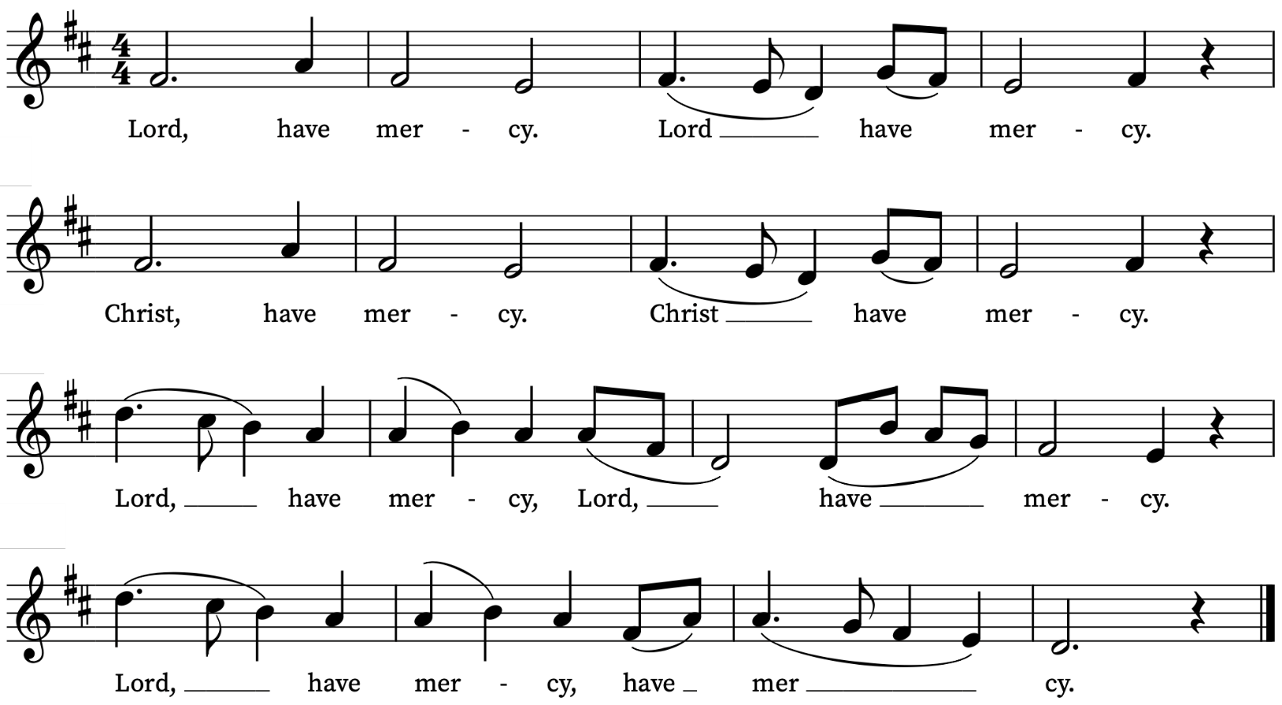
First Reading
Isaiah 25: 1-9
A reading from the prophet Isaiah
O Lord, you are my God;
I will exalt you, I will praise your name;
for you have done wonderful things,
plans formed of old, faithful and sure.
For you have made the city a heap,
the fortified city a ruin;
the palace of aliens is a city no more,
it will never be rebuilt.
Therefore strong peoples will glorify you;
cities of ruthless nations will fear you.
For you have been a refuge to the poor,
a refuge to the needy in their distress,
a shelter from the rainstorm and a shade from the heat.
When the blast of the ruthless was like a winter rainstorm,
the noise of aliens like heat in a dry place,
you subdued the heat with the shade of clouds;
the song of the ruthless was stilled.
On this mountain the Lord of hosts will make for all peoples
a feast of rich food, a feast of well-matured wines,
of rich food filled with marrow, of well-matured wines strained clear.
And he will destroy on this mountain
the shroud that is cast over all peoples,
the sheet that is spread over all nations;
he will swallow up death for ever.
Then the Lord God will wipe away the tears from all faces,
and the disgrace of his people he will take away from all the earth,
for the Lord has spoken.
It will be said on that day,
Lo, this is our God; we have waited for him, so that he might save us.
This is the Lord for whom we have waited;
let us be glad and rejoice in his salvation.
This is the Word of the Lord
Thanks be to God
Psalm 23
Dominus regit me.
The Lord is my shepherd: therefore, can I lack nothing.
2 He shall feed me in a green pasture : and lead me forth beside the waters of comfort.
3 He shall convert my soul : and bring me forth in the paths of righteousness, for his Name's sake.
4 Yea, though I walk through the valley of the shadow of death, I will fear no evil : for thou art with me; thy rod and thy staff comfort me.
5 Thou shalt prepare a table before me against them that trouble me : thou hast anointed my head with oil, and my cup shall be full.
6 Surely thy loving-kindness and mercy shall follow me all the days of my life : and I will dwell in the house of the Lord for ever.
Second Reading
Philippians 4: 1-9
A reading from Paul’s Letter to the Philippians
Therefore, my brothers and sisters, whom I love and long for, my joy and crown, stand firm in the Lord in this way, my beloved.
I urge Euodia and I urge Syntyche to be of the same mind in the Lord. Yes, and I ask you also, my loyal companion, help these women, for they have struggled beside me in the work of the gospel, together with Clement and the rest of my co-workers, whose names are in the book of life.
Rejoice in the Lord always; again I will say, Rejoice. Let your gentleness be known to everyone. The Lord is near. Do not worry about anything, but in everything by prayer and supplication with thanksgiving let your requests be made known to God. And the peace of God, which surpasses all understanding, will guard your hearts and your minds in Christ Jesus.
Finally, beloved, whatever is true, whatever is honourable, whatever is just, whatever is pure, whatever is pleasing, whatever is commendable, if there is any excellence and if there is anything worthy of praise, think about these things. Keep on doing the things that you have learned and received and heard and seen in me, and the God of peace will be with you.
This is the Word of the Lord
Thanks be to God
Gospel Reading
Matthew 22: 1-14
Hear the Gospel of our Lord Jesus Christ according to Matthew
Glory be to thee, O Lord
Once more Jesus spoke to them in parables, saying: ‘The kingdom of heaven may be compared to a king who gave a wedding banquet for his son. He sent his slaves to call those who had been invited to the wedding banquet, but they would not come. Again he sent other slaves, saying, “Tell those who have been invited: Look, I have prepared my dinner, my oxen and my fat calves have been slaughtered, and everything is ready; come to the wedding banquet.” But they made light of it and went away, one to his farm, another to his business, while the rest seized his slaves, maltreated them, and killed them. The king was enraged. He sent his troops, destroyed those murderers, and burned their city. Then he said to his slaves, “The wedding is ready, but those invited were not worthy. Go therefore into the main streets, and invite everyone you find to the wedding banquet.” Those slaves went out into the streets and gathered all whom they found, both good and bad; so the wedding hall was filled with guests.
‘But when the king came in to see the guests, he noticed a man there who was not wearing a wedding robe, and he said to him, “Friend, how did you get in here without a wedding robe?” And he was speechless. Then the king said to the attendants, “Bind him hand and foot, and throw him into the outer darkness, where there will be weeping and gnashing of teeth.” For many are called, but few are chosen.
This is the Gospel of the Lord
Praise be to thee, O Christ

Today’s Music
Mass setting (Gloria, Sanctus/Benedictus, Agnus Dei):
Communion Service in F – Herbert Sumsion
Psalm 23
You can find the words on page 3 of this sheet.
Anthem
And I saw a new heaven – Edgar Bainton
And I saw a new heaven and a new earth
For the first heaven and the first earth were passed away
and there was no more sea, And I John saw the holy city,
Jerusalem coming down from God out of heaven,
prepared as a bride adorned for her husband.
And I heard a great voice out of heaven, saying,
Behold the tabernacle of God is with men
and he will dwell with them and they shall be his people,
and God himself shall be with them and be their God
And God shall wipe away all tears from their eyes
And there shall be no more death, neither sorrow nor crying
neither shall there be any more pain for the former things are
passed away. Revelation 21:1-4

Communion Motet
The Call – William Harris
Come, my Way, my Truth, my Life:
Such a Way, as gives us breath:
Such a Truth, as ends all strife:
Such a Life, as killeth death
Come, My Light, my Feast, my Strength:
Such a Light, as shows a feast:
Such a Feast, as mends in length:
Such a Strength, as makes his guest
Come, my Joy, my Love, my Heart:
Such a Joy, as none can move:
Such a Love, as none can part:
Such a Heart, as joys in love.
Words by George Herbert
Organ Postlude
Fanfare – Kenneth Leighton
Prayers for the week
We pray for those in need: Sarah Batten, George Coles, Colin Coveney, Fr Giles Harcourt, William Higginson, Carole Hubble, Marion Kokott, James Markham, Sara Mauleverer, Lylian Meira, Véronique Müller, Vernon Mustoe, Nicola Orme, Karen Robjont, Jean Smith, Geoff Staden, Tina Stanley, Doreen Waller, and Pauline Youll.
We remember those who have died recently including Tony Currie, Maulene Sweet and John Yeomans. We also remember Anthony Godwin Oriakhi on the anniversary of his burial and Thomas Hills and Michael Jenvey on their year’s minds.
If you wish to add names to the prayers for those in need or departed please contact David McEvoy dmcevoy@btinternet.com
Supporting St Alfege Church
Please do make a gift to support the life and ministry of St Alfege Church – during the collection in the service or by using a card reader at the North and West Doors. Please complete a Gift Aid envelope (if you are eligible) whether you donate by cash or card. You can also use this QR code to donate. | 

Services this week
Sunday 11 October Nineteenth Sunday after Trinity
10.00am Parish Eucharist
Monday 12 October
8.30am Morning Prayer
Tuesday 13 October
8.30am Morning Prayer
Wednesday 14 October
8.30am Morning Prayer
Thursday 15 October
8.00am Holy Communion
Sunday 18 October Feast of St Luke
8.00am Holy Communion
10.00am Sung Eucharist

Walk-in Wednesdays
Every Wednesday 10am-12noon in the small hall
Contact us
Vicar: Revd Simon Winn
Curate: Revd Dr Tati Gutteridge (on maternity leave)
Church Office: 020 8853 0687
Email: office@st-alfege.org.uk Website: www.st-alfege.org.uk
Safeguarding Team: safeguarding@st-alfege.org.uk
All Souls Service 1 November at 10am
We will be remembering our departed loved ones at our service for All Souls on Sunday 1 November at 10am. If you would like the names of loved ones read out in the service, please write their names clearly on the sheets on the welcome desk or email David McEvoy with the names: dmcevoy@btinternet.com. Please do this by by Sunday 25 October.
Please take this sheet home with you.

