

Sung Eucharist

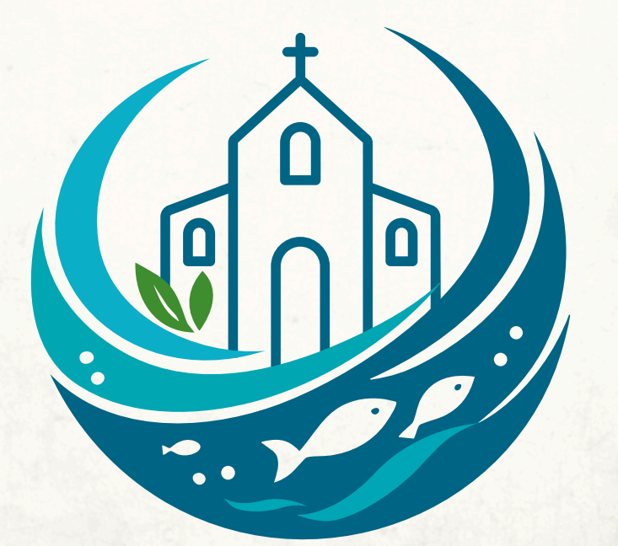
Creation Sunday

Sunday 4 October 2026
at 10am
Welcome to our service of Holy Communion on this day when, with Christians around the world, we mark Creation Sunday at the end of the Church’s Season of Creation. October 4th is also St Francis’ Day and 2026 is the 800th anniversary of his death.
Surrounded as we are with constant devastating news about climate chaos, bio-diversity loss and pollution, it is easy to fall into despair. And yet as people of faith, we have hope - confidence in what we hope for and the assurance of what we do not yet see (cf. Hebrews 11:1). In the words of Archbishop Tutu, “Hope is being able to see that there is light - despite all the darkness.”
As faith without action is dead (James 2:26) so hope without action is meaningless. In this service we acknowledge and lament our sense of despair, hold to our faith and hope, and commit ourselves to act with Creation for the renewal of life.
Our service is led by Revd Simon Winn, our Vicar. Today’s preacher is Richard Mash, one of our Readers, supported by members of St Alfege Eco Group.
The Mass setting today (Gloria, Sanctus/Benedictus, and Agnus Dei) is Missa Brevis by G.P. da Palestrina.
St Alfege Choir is directed by Director of Music Joshua Ryan.
The flowers today are in loving memory of Phyllis Belton.
There will be a collection during the Offertory hymn for the Malawi Tree Planting project supported by St Alfege. We also have a card reader for electronic payments by the North Door and by the welcome desk at the West Door.

You can also set up a standing order to St Alfege Church using the following details: PCC of St Alfege, Greenwich. Sort Code: 60-09-16 Account number: 25249304. If you are a UK tax payer the church can claim 25% Gift Aid in addition to your donation. Therefore if eligible and setting up a standing order, please request a gift aid declaration form from office@st-alfege.org.uk You can also use this QR code to donate:

Please stand to sing the processional hymn as the choir, servers and clergy process into church.
Processional hymn
All creatures of our God and King,
lift up your voice and with us sing
Alleluia, alleluia!
Thou burning sun with golden beam,
thou silver moon with softer gleam,
O praise him, O praise him,
Alleluia, alleluia, alleluia.
Thou rushing winds that art so strong,
ye clouds that sail in Heav'n along,
O praise him, alleluia!
Thou rising morn, in praise rejoice,
ye lights of evening, find a voice.
O praise him …
And all ye saints of tender heart,
forgiving others, take your part,
O sing ye, alleluia!
Ye who long pain and sorrow bear,
praise God and on him cast your care:
O praise him …
Let all things their creator bless,
and worship him in humbleness,
O praise him, alleluia!
Praise, praise the Father, praise the Son,
and praise the Spirit, Three in One:
O praise him …
Words: W.H. Draper (1855-1933) Based on Canticle of the Sun by St Francis of Assisi (1181-1226). Melody: Geistliche Kirchengesang arranged by R. Vaughan Williams (1872-1958)
THE GATHERING
The Greeting
In the name of the Father, and the Son and the
Holy Spirit. Amen.
Revd Simon welcomes us and introduces the celebration.
Blessed be the name of God, God of our ancestors,
God of the generations yet to come.
Blessed be the creating God, redeeming Son and the sustaining Spirit.
As we gather, we hear the groans of Creation and the cries of our sisters and brothers.
As we gather, we bring our seeds of hope, the firstfruits of the Spirit.
(Rev Sikawu, Central Methodist Church, Cape Town)
Almighty and ever living God, we thank you for your love in all creation, and especially for your gift of water to sustain and cleanse all life.
Christ is the living water, cleansing, refreshing, and making all things new.
So now we offer our thanks for the waters that bring beauty to all that we enjoy, the wild places, the forest, the mountains, coast and the sea.
We give thanks and praise for all good lands, for the trees and pastures, for our plentiful crops, and for the living water that quenches them.
Hear this prayer for your love’s sake.
Amen
Come, let us worship God, who gifted us with life and Creation to sustain life.
We praise God for the wondrous Creation.
Come, let us follow Lord Jesus Christ, who inspires us to hope and act for justice and righteousness.
We give glory to God, who restores the groaning Creation and the vulnerable.
Come let us move with the Holy Spirit, striving to establish justice and produce the first fruits of hope.
We praise God for the abundant life that is assured to all Creation.
Confession and Forgiveness
The earth is the Lord’s and all that fills it. Let us confess our failure to receive with gratitude God’s gift of creation, and repent of the ways in which we have caused it harm.
You laid the foundations of the earth,
but we have claimed your world as our own.
Lord, have mercy.
All Lord, have mercy.
All things were created through you and for you,
but we have not lived as those who belong to you.
Christ, have mercy.
All Christ, have mercy.
You make all things new,
but our hope has grown dim.
Lord, have mercy.
All Lord, have mercy.
Kyrie
We join in singing the Kyrie from Schubert’s German Mass:
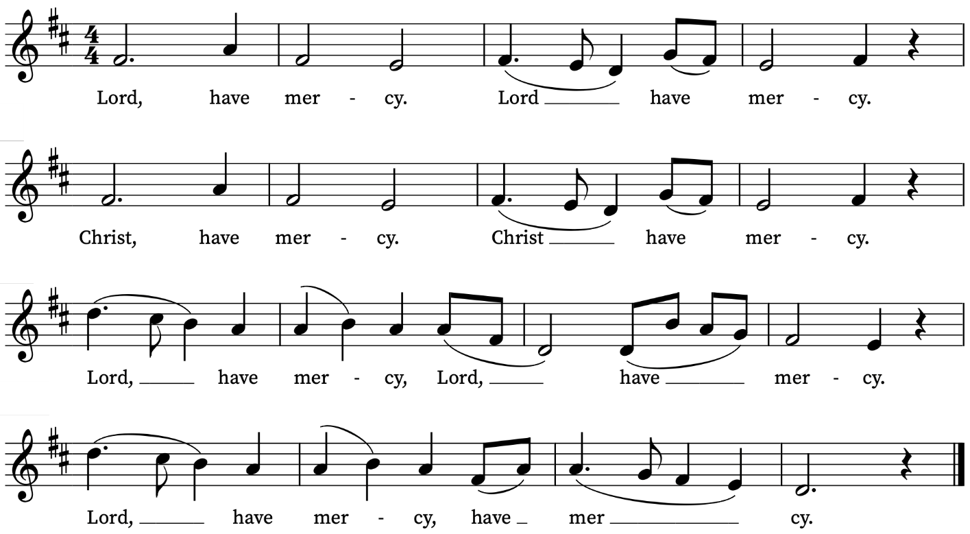

Revd Simon prays
May the Father of all mercies
cleanse you from your sins,
and restore you in his image
to the praise and glory of his name,
through Jesus Christ our Lord.
Amen.

Gloria
The choir sings the Gloria from Palestrina’s Missa Brevis
Glory to God in the highest,
and peace to his people on earth.
Lord God, heavenly King,
almighty God and Father,
we worship you, we give you thanks,
we praise you for your glory.
Lord Jesus Christ, only Son of the Father,
Lord God, Lamb of God,
you take away the sin of the world:
have mercy on us;
you are seated at the right hand of the Father:
receive our prayer.
For you alone are the Holy One,
you alone are the Lord,
you alone are the Most High, Jesus Christ,
with the Holy Spirit,
in the glory of God the Father.
Amen.

THE LITURGY OF THE WORD
The Collect
Let us pray.
Creator, you have wonderfully fashioned the heavens and the earth and us in your own image.
Teach us to discern your hand in all your works and your breath in all your creatures
that we may be of service in the healing of the earth,
through Jesus Christ and the Holy Spirit,
through whom you breathe all creation into being.
Amen.
Old Testament Reading
Read by Susan Doering and Nial Tobal
The first reading is taken from the book of Ezekiel
Ezekiel 47: 1-9, 12
The man brought me back to the entrance to the temple, and I saw water trickling out from under the threshold of the temple toward the east.
As the man went eastward with a measuring line in his hand, he measured off a thousand cubits and then led me through water that was ankle-deep.
He measured off another thousand cubits and led me through water that was knee-deep.
He measured off another thousand and led me through water that was up to the waist.
He measured off another thousand, but now it was a river that I could not cross, because the water had risen and was deep enough to swim in—a river that no one could cross. He asked me, “Son of man, do you see this?”
Then he led me back to the bank of the river. When I arrived there, I saw a great number of trees on each side of the river.
He said to me, “When this water empties into the sea, the salty water there becomes fresh. Swarms of living creatures will live wherever the river flows. There will be large numbers of fish, because this water flows there and makes the salt water fresh; so where the river flows everything will live.”
“Fruit trees of all kinds will grow on both banks of the river. Their leaves will not wither, nor will their fruit fail. Every month they will bear fruit, because the water from the sanctuary flows to them.
Their fruit will serve for food and their leaves for healing.”

May the Word, as living water,
make everything live.

Psalm
The choir sings Psalm 65: 5-13
5 Thou shalt shew us wonderful things in thy righteousness, O God of our salvation : thou that art the hope of all the ends of the earth, and of them that remain in the broad sea.
6 Who in his strength setteth fast the mountains : and is girded about with power.
7 Who stilleth the raging of the sea : and the noise of his waves, and the madness of the people.
8 They also that dwell in the uttermost parts of the earth shall be afraid at thy tokens : thou that makest the outgoings of the morning and evening to praise thee.
9 Thou visitest the earth, and blessest it : thou makest it very plenteous.
10 The river of God is full of water : thou preparest their corn, for so thou providest for the earth.
11 Thou waterest her furrows, thou sendest rain into the little valleys thereof : thou makest it soft with the drops of rain, and blessest the increase of it.
12 Thou crownest the year with thy goodness : and thy clouds drop fatness.
13 They shall drop upon the dwellings of the wilderness : and the little hills shall rejoice on every side.

New Testament Reading
Read by Clare Hatcher
The second reading is taken from the book of Revelation
Revelation 22:1-2
Then the angel showed me the river of the water of life, as clear as crystal, flowing from the throne of God and of the Lamb down the middle of the great street of the city. On each side of the river stood the tree of life, bearing crops of fruit and yielding fruit in every month. And the leaves of the tree are for the healing of the nations.
May the Word, as living water,
make everything live.
We stand to sing
Gradual Hymn
Creation sings! Each plant and tree,
each bird and beast in harmony;
the brightest star, the smallest cell,
God’s tender care and glory tell
from ocean depths to mountain peaks
in praise of God creation speaks!
Creation speaks a message true,
reminds us we are creatures too:
to serve as stewards in our role,
despite our dreams of full control –
when we disparage what God owns,
in turmoil, all creation groans.

Creation groans to see the day
which ends all bondage, all decay:
frustrated now, it must await
the Lord who comes to recreate
till round the universe there rings
the song his new creation sings!

Words: Martin E. Leckebusch (b. 1962)
Music: Melita, John Baccus Dykes (1823-1876)
Gospel Reading
Read by Revd Simon Winn, Vicar
Hear the Gospel of our Lord Jesus Christ according
to John.
Glory to you O Lord.
John 7: 37-39a
On the last and greatest day of the Feast, Jesus stood and said in a loud voice, “If a man is thirsty, let him come to me and drink. Whoever believes in me, as the Scripture has said, streams of living water will flow from within him.” By this he meant the Spirit, whom those who believed in him were later to receive.
This is the Gospel of the Lord.
Praise to you O Christ.
Please sit

Sermon
Richard Mash and members of the Eco Group
Anthem
The choir sings the Anthem
Sicut cervus – G.P. da Palestrina
Sicut cervus desiderat ad fontem aquarum,
ita desiderat anima mea ad te, Deus.
As a deer longs for flowing streams, so my soul longs for you, O God
Psalm 42:1
Please sit or kneel
Prayers of Intercession
Led by David Abrahams
Bidding: Creator God
Response: Hear our prayer
At the end:
Merciful Father,
accept these prayers for the sake of your Son
our Saviour, Jesus Christ. Amen.
We stand
THE LITURGY OF THE SACRAMENT
The Peace
Revd Simon says
In Christ, we are called not to conform to this world, but to be transformed by the renewing of our minds.
We seek to discern the will of God, to do what is good and acceptable and perfect.
Let us not lag in zeal but be ardent in spirit and
serve God.
We intend to live in harmony with one another and with all of Creation.
Let us strive to live peaceably with all and share a sign of peace with one another.
The peace of the Lord be always with you.
And also with you
Let us offer one another a sign of peace.
We remain standing to sing
Offertory Hymn
For the beauty of the earth
For the beauty of the skies,
For the love which from our birth
Over and around us lies
Lord of all, to thee we raise
This our joyful hymn of praise.

For the beauty of each hour
of the day and of the night,
hill and vale, and tree and flower,
sun and moon and stars of light:
Lord of all, to thee we raise
This our joyful hymn of praise.
For the joy of human love,
brother, sister, parent, child
friends on earth, and friends above,
pleasures pure and undefiled
Lord of all, to thee we raise
This our joyful hymn of praise.
For each perfect gift of thine
To our race so freely given,
Graces human and divine,
Flow'rs of earth and buds of heav'n:
Lord of all, to thee we raise
This our joyful hymn of praise.
For thy church which evermore
lifteth holy hands above,
offering up on every shore
her pure sacrifice of love.
Lord of all, to thee we raise
This our joyful hymn of praise.
Words: F.S. Pierpoint (1835-1917)
Music: Dix, adapted from C. Kocher (1786-1872)
by W.H. Monk (1823-89)

The Preparation of the Bread and Wine
Revd Simon says
Blessed be God,
by whose grace creation is renewed,
by whose love heaven is opened,
by whose mercy we offer our sacrifice of praise.
Blessed be God for ever.
We remain standing
The Eucharistic Prayer
Revd Simon says
The Lord be with you
And also with you
Lift up your hearts.
We lift them to the Lord
Let us give thanks to the Lord, our God of all Creation
It is right to give God thanks and praise
It is indeed joyful and right to give heartfelt thanks,
through Christ and in the power of the Spirit,
to you our Heavenly Father and Creator.
For you have prepared for your people
an eternal city for them to dwell in,
whose light is the Glory of God,
through which runs the river of life:
a city which nothing unclean will enter,
whose temple is the Lord.
And you have called us to make the city
where we now dwell
into an image of the city that is to come,
banishing all that pollutes your creation
and letting the rivers flow freely.
Therefore we raise our voices from our earthly habitations,
joining with the blessed company of heaven
to praise and glorify your holy name forever:
The choir sings the Sanctus
Holy, holy, holy Lord,
God of power and might,
heaven and earth are full of your glory.
Hosanna in the highest.
Blessed is he who comes in the name of the Lord.
Hosanna in the highest.
Please sit or kneel.

In the night that Jesus was betrayed,
he took bread, work of human hands, gift of our earth,
and gave thanks to God.
He broke the bread to speak to us
of the breaking of his body upon the cross.
He gave it to his friends and said:
Take and eat, for this is my body which is given for you.
Do this in remembrance of me.
He took the wine, work of human hands,
gift of our earth,
and gave thanks to God, Creator.
He poured out the wine to speak to us
of the pouring out of his blood.
He gave it to his friends saying:
This is my blood of the new covenant,
shed for you and for all creation
for the forgiveness of sins.
Every time you drink of the wine,
do this in remembrance of me.
So we proclaim the mystery of faith:
Christ has died, Christ is risen,
Christ will come again.
We have faith in one God, one Source of all life,
one Ground of the whole Earth,
who created all things good.
And we have faith in Christ,
in whom we have been shown
the special role of humanity
to bear God’s likeness in working and
caring for Creation,
in seeking to understand her mysteries and powers,
in working with these powers for the wellbeing of life
on Earth.
And we have faith in God’s Spirit who leads us
to a meek, unselfish and compassionate lifestyle.
So that the Earth is inherited in peace,
her life is transformed for all creatures
and her bounty shared justly.
So be it. Amen.

The Lord’s Prayer
Let us pray for the coming of God’s kingdom
in the words our Saviour taught us.
Our Father, who art in heaven,
hallowed be thy name;
thy kingdom come;
thy will be done;
on earth as it is in heaven.
Give us this day our daily bread.
And forgive us our trespasses,
as we forgive those who trespass against us.
And lead us not into temptation;
but deliver us from evil.
For thine is the kingdom,
the power and the glory,
for ever and ever.
Amen.
Breaking of the Bread
We break this bread to share in the body of Christ.
Though we are many, we are one body,
because we all share in one bread.
Giving of Communion
God’s holy gifts for God’s holy people.
Jesus Christ is holy,
Jesus Christ is Lord
to the glory of God the Father.
Everyone is invited to receive the sacrament or a blessing after which we reply Amen.
Please come forward as directed by a welcomer. If you need communion brought to you please let a welcomer know. If you would like to receive a blessing rather than communion, please bow your head.
Please let a welcomer know if you need a gluten-free wafer.
We are offering communion in both kinds, the bread (wafer) and the wine (in the cup or chalice). If you would prefer not to receive the wine from the chalice/cup please bow your head or simply leave the altar rail after receiving the wafer. Please do not intinct (dip your wafer in the chalice).
Please return to your seats via the side chapels.
During Communion the choir sings
O praise God in his holiness – R. Whyte
O praise God in his holiness : praise him in the firmament of his power.
Praise him in his noble acts : praise him according to his excellent greatness.
Praise him in the sound of the trumpet : praise him upon the lute and harp.
Praise him in the cymbals and dances : praise him upon the strings and pipe.
Praise him upon the well-tuned cymbals : praise him upon the loud cymbals.
Let every thing that hath breath : praise the Lord.
Psalm 150
Prayer after Communion
We pray together
Lord of all Creation,
as we have received the bread and wine,
fruits of the earth and tokens of salvation,
so with joy we celebrate your goodness
and commit ourselves to serve you on your earth,
through Jesus Christ our Lord. Amen.
Please sit as members of Children’s Church bring forward their pieces of creation artwork.
Notices

Final Hymn

He’s got the whole world, in His hand,
He’s got the whole wide world, in His hand,
He’s got the whole world, in His hand,
He’s got the whole world, in His hand.
He’s got the wind and the rain, in His hand,
He’s got the wind and the rain, in His hand,
He’s got the wind and the rain, in His hand,
He’s got the whole world in His hand.
Chorus
He’s got the sun and the moon, in His hand,
He’s got the sun and the moon, in His hand,
He’s got the sun and the moon, in His hand,
He’s got the whole world in His hand.
Chorus
He’s got the plants and the creatures, in His hand,
He’s got the plants and the creatures, in His hand,
He’s got the plants and the creatures, in His hand,
He’s got the whole world in His hand.
Chorus
He’s got everybody here, in His hand,
He’s got everybody here, in His hand,
He’s got everybody here, in His hand,
He’s got the whole world in His hand.
Chorus
Words and Music: Traditional
THE DISMISSAL
Revd Simon says
May the Creator fill us with wonder and compassion for all that is made
Now and always.
May the Saviour who cares for all
help us act with love for all creation
Now and always.
May the Spirit who sustains the springs of life
give us hope and joy to share
Now and always.
And may the Triune God,
Creator, Redeemer and Sanctifier,
pour into our hearts the river of life
with ever greater abundance
to grow fruit for the healing of all.
Amen.

Freely you have received, freely give.
Go in peace to love and serve the Lord.
In the name of Christ. Amen.

Organ Voluntary
Carillon – Herbert Murrill

Please remain standing as the choir, clergy and servers depart. An organ voluntary is played. You are welcome to remain to listen or leave quietly.

If you would like to pray with someone in confidence after the service, a lay member of our prayer ministry team will be available in the South Chapel. You are welcome to ask for prayer for wholeness and healing, personal circumstances, or anything else that is on your heart. The St Alfege Chapel remains available for private prayer and lighting candles.

Please come for tea and coffee in the church hall after the service
During refreshments in the hall members of the church Eco Group will be sharing further information about the climate emergency, the challenges we are all facing, and what we can do about it. There will also be information about the Diocese of Malawi Tree Planting Project that our church is supporting.
A Rocha UK’s Eco Church programme helps equip churches in England and Wales to care for creation. St Alfege is working to achieve Silver status. Find out more about what this involves at https://arocha.org.uk/what-we-do/eco-church/

Prayers for the week
We pray for Tara Starmer and Rory Gallagher and for Gaudy Sandoval-Arana and Jack Foxabbot who were married here on Friday and Saturday respectively.
We pray for those in need: George Coles, Colin Coveney, Fr Giles Harcourt, William Higginson, Carole Hubble, Marion Kokott, James Markham, Sara Mauleverer, Lylian Meira, Véronique Müller, Vernon Mustoe, Nicola Orme, Karen Robjont, Jean Smith, Geoff Staden, Tina Stanley, Doreen Waller, and Pauline Youll.

We remember those who have died recently including David Batten, Tony Currie, Myles Dove, Gilli Frewer, Joe Geshwiler, Nomsa Monareng, Maulene Sweet and John Yeomans. We also remember Phyllis Belton on her year’s mind. We ask God’s comfort on all who are mourning the loss of loved ones.
If you wish to add names to the prayers for those in need or departed please contact David McEvoy dmcevoy@btinternet.com
A Prayer for Peace in the Middle East
Compassionate and loving God, we stand with those who cry in anguish in Israel, Palestine and Lebanon. With those who have lost their lives to violence, those who mourn, those who have been displaced, those who are held unjustly against their will, those who have lost their homes and livelihoods. We pray for an end to the fighting and violence. We pray for the courage to speak up for peace, to challenge the hatred in our own hearts and minds, and to do all that we can to make for the peace that builds our common life as the nations of your world. Lord, move our hearts.
A Prayer from Embrace the Middle East.
Services this Week
Today, Sunday 4 October Creation Sunday
8.00am Holy Communion (BCP)
10.00am Sung Eucharist for Creation Sunday
Monday 5 October
8.30am Morning Prayer
Tuesday 6 October
8.30am Morning Prayer
Wednesday 7 October
8.30am Morning Prayer
Thursday 8 October
8.00am Holy Communion
3.00pm Funeral of Myles Dove
Sunday 10 October (21st Sunday after Trinity)
8.00am Holy Communion (BCP)
10.00am Sung Eucharist
Walk-In Wednesdays
Every Wednesday 10am to 12 noon in the Frank Smith Room in the hall. Drop in for a cuppa, cake and a chat.

All Souls Service 1 November at 10am
We will be remembering our departed loved ones at our service for All Souls on Sunday 1 November at 10am. If you would like the names of loved ones read out in the service, please write their names clearly on the sheets on the welcome desk or email David McEvoy with the names: dmcevoy@btinternet.com
Supporting St Alfege Church
Please do make a gift to support the life and ministry of St Alfege Church –during the collection in the service or by using our card reader at the North and West Doors. Please complete a Gift Aid envelope (if you are eligible) whether you donate by cash or card. You can also use this QR code to donate. | 

Welcome to Children's Church! 🌈
🌟 Join us in the Church Hall for a Sunday morning of fun, friendship, and faith! All families with children are welcome. We ask that a parent or carer accompanies their child/children.
🎨 Activities Include: Bible stories; praying together; sing-along songs; creative crafts and Holy Communion together.
🗓️ Children’s Church begins with registration between 9.55 and 10.05 am

Abide in Church today, 4 October at 5.30pm
Do join us for this contemplative service with prayer, readings, meditation and music from the Taizé tradition. The theme today is 'receiving gifts from the creation and giving back' and will feature reflections by the Native American poet and biologist Robin Wall Kimmerer and a time of contemplation in nature.

FIND OUT MORE
You can find details of our regular services and our Church on our website: www.st-alfege.org.uk
Vicar: Revd Simon Winn
Curate: Revd Dr Tati Gutteridge (on maternity leave)
Church Office: office@st-alfege.org.uk
020 8853 0687 www.st-alfege.org.uk

Please take this service booklet away with you. Why not share it with a friend or neighbour when you have finished with it?

Material used in this service comes from Common Worship & A Time for Creation © The Archbishops’ Council, 2000 and from liturgies authorised by the Anglican Church of Canada, the Anglican Church of Southern Africa and a morning prayer of thanksgiving for God's creation from Aotearoa New Zealand, translated from Te Reo Māori.

