

All Age Eucharist
Sunday 27 September 2026
at 10am
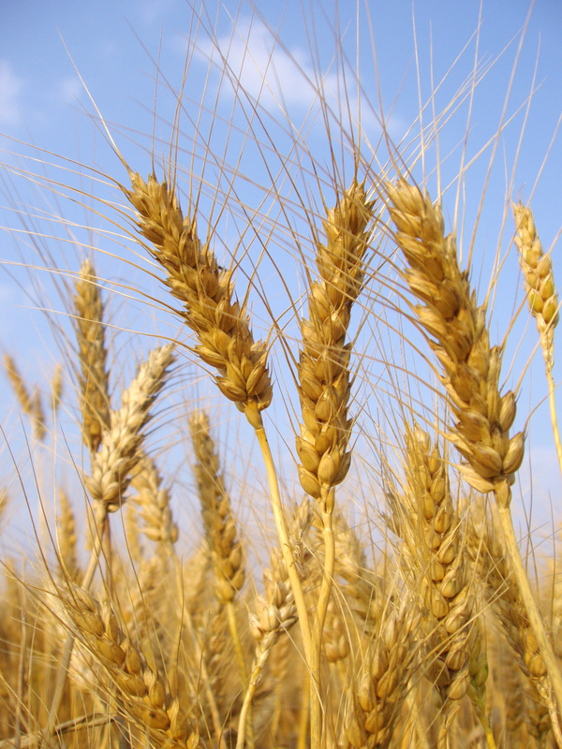

Harvest Festival
Welcome to our all-age Eucharist as we celebrate Harvest Festival and bring our gifts to support the work of the foodbank run from our church school, St Alfege with St Peter Primary School. Our collection today will go towards the school foodbank.
Our service is led by our Vicar, Revd Simon Winn. Children’s Church members will be reading and leading the prayers.
Everything you need to follow the service is in this booklet. The congregation says the words in bold.
We will all join in singing the Gloria, Sanctus/Benedictus, and Agnus Dei from Schubert’s German Mass.
St Alfege Choir is directed by Joshua Ryan, our Director of Music. The organist is Ben Banks.
Our collection will be in aid of our church school foodbank. We will accept cash offerings, and also have card readers for electronic payments at the West and North doors. You can also pay online using the following details (please use ‘School Foodbank’ as the reference): PCC of St Alfege, Greenwich. Sort Code: 60-09-16 Account number: 25249304.
Please also note that if you are a UK tax payer the church can claim 25% Gift Aid in addition to your donation therefore if eligible and setting up a standing order, please request a gift aid declaration form from the church office office@st-alfege.org.uk
Please join us in the church hall afterwards for refreshments.
Please stand as the choir, altar party and clergy process into church.
Opening Hymn
Come, ye thankful people, come,
raise the song of harvest-home:
all is safely gathered in,
ere the winter storms begin;
God, our maker, doth provide
for our wants to be supplied;
come to God's own temple, come;
raise the song of harvest-home!
All this world is God's own field,
fruit unto his praise to yield;
wheat and tares therein are sown,
unto joy or sorrow grown;
ripening with a wondrous power
til the final harvest hour:
grant, O Lord of life, that we
holy grain and pure may be.
For we know that thou wilt come,
and wilt take thy people home;
from thy field wilt purge away
all that doth offend, that day;
and thine angels charge at last
in the fire the tares to cast,
but the fruitful ears to store
in thy garner evermore.

Come then, Lord of mercy, come,
Bid us sing thy harvest-home;
let thy saints be gathered in,
free from sorrow, free from sin,
all upon the golden floor,
praising him for evermore:
come, with all thine angels come,
bid us sing thy harvest-home.
Music: St George, G.J. Elvey (1816-93)
Words: H. Alford (1810-71)
The Gathering
The Greeting
Words of welcome may be said.
The Lord is here
God’s Spirit is with us.
O give thanks to the Lord for he is good
for his mercy endures forever.
God tends the earth and waters it,
and makes it rich and fertile.
Lord of the harvest, all is yours,
the rain that falls, the sun that shines.
The seed once hidden in the ground,
the skill that makes the harvest grow.
Our thanks we bring to you this day,
new praises from our lips shall sound.
The land has yielded its harvest:
God, our God has blessed us.
The earth is filled with the gifts of the Lord:
wine and oil and bread to strengthen us
and cheer our hearts.
Confession and Forgiveness
Let us confess our forgetfulness of the needs of the poor,
and repent of the ways in which we waste the resources of
the world.
A short silence is held.
God has blessed us,
but still God’s children go hungry.
Lord, have mercy.
Lord, have mercy.
God has blessed us,
but still the poor cry out for justice.
Christ, have mercy.
Christ, have mercy.
God has blessed us,
but still we see inequality and oppression in the earth.
Lord, have mercy.
Lord, have mercy.

Revd Simon prays:
Almighty God,
who forgives all who truly repent,
have mercy upon you,
pardon and deliver you from all your sins,
confirm and strengthen you in all goodness,
and keep you in life eternal;
through Jesus Christ our Lord. Amen.
We sing the Gloria from Schubert’s German Mass:

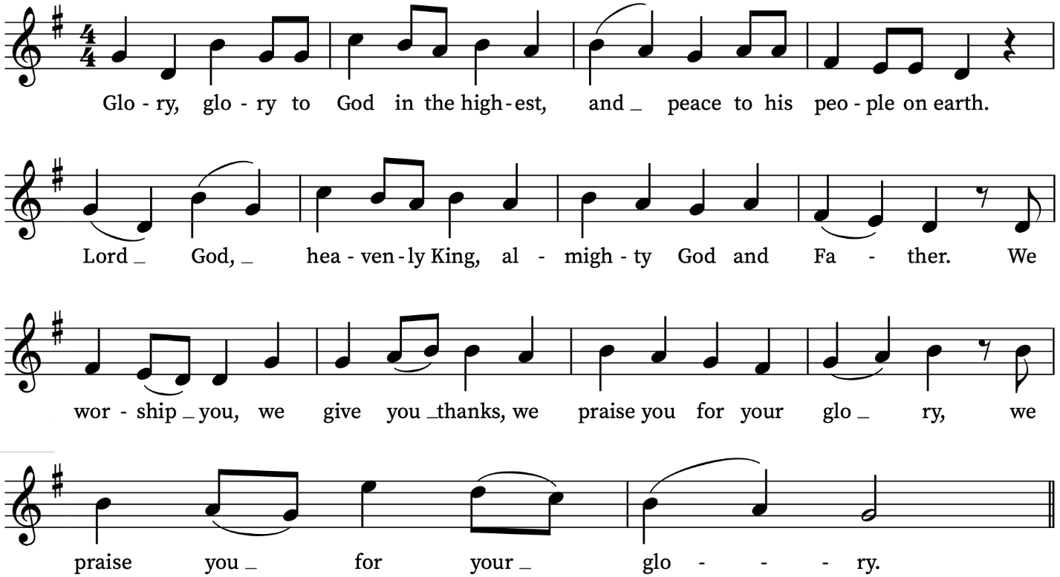
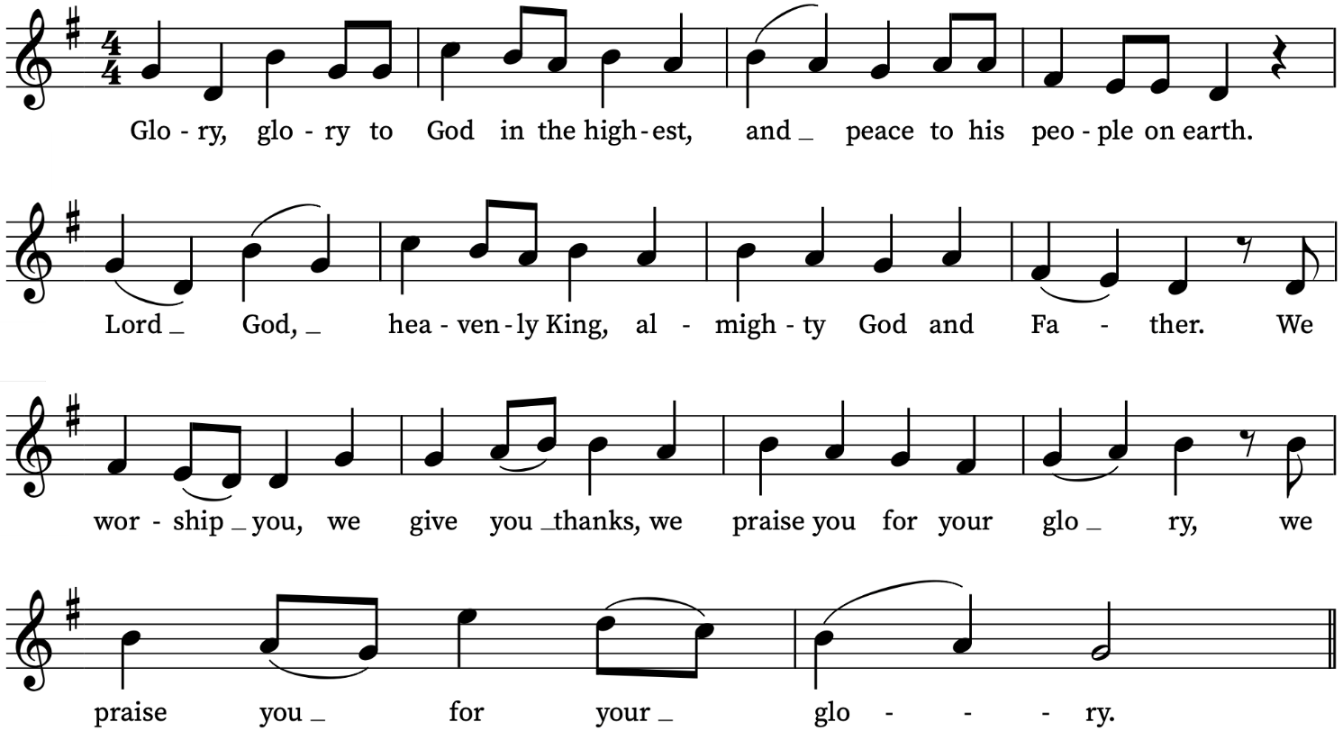

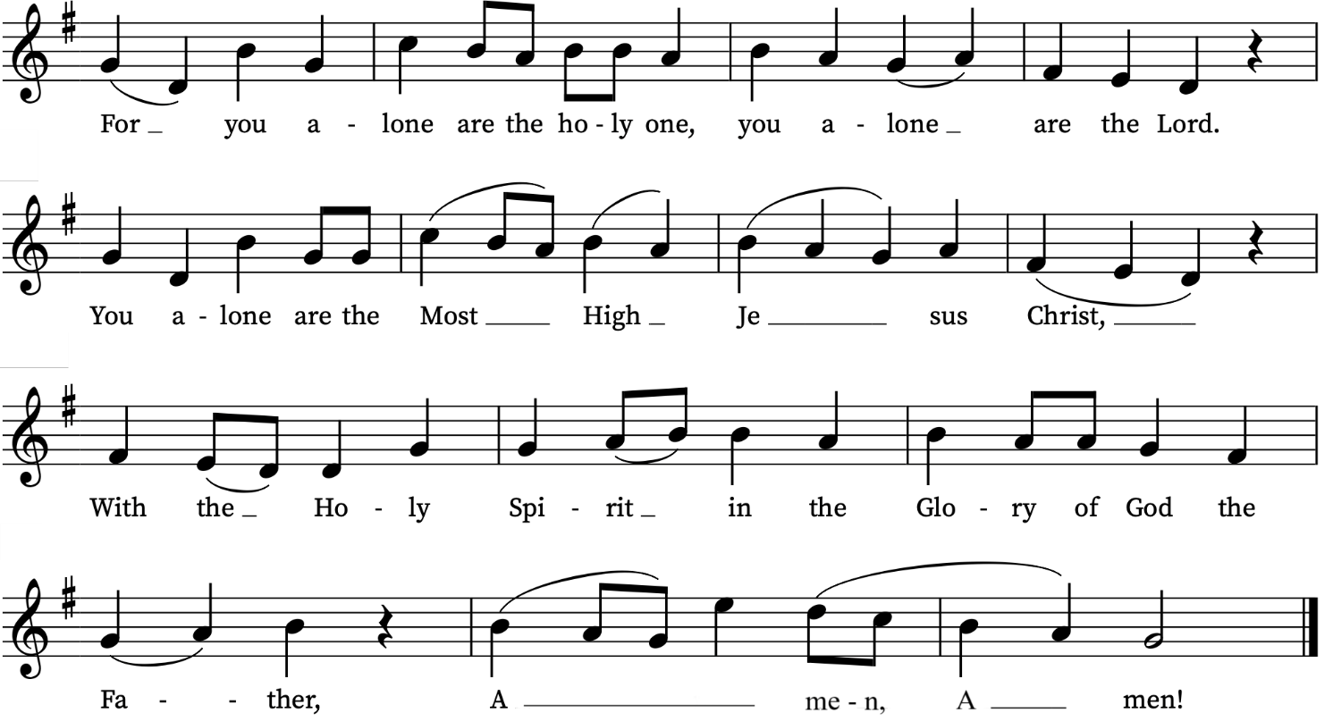

The Collect
Creator God, you made the goodness of the land, the riches of the sea and the rhythm of the seasons; as we thank you for the harvest, may we cherish and respect this planet and its peoples, through Jesus Christ our Lord. Amen.
The Liturgy of the Word
Please sit
First Reading
2 Corinthians 9: 6-15
Read by a member of Children’s Church
A reading from the letter to the Corinthians
The point is this: the one who sows sparingly will also reap sparingly, and the one who sows bountifully will also reap bountifully. Each of you must give as you have made up your mind, not reluctantly or under compulsion, for God loves a cheerful giver. And God is able to provide you with every blessing in abundance, so that by always having enough of everything, you may share abundantly in every good work. As it is written,
‘He scatters abroad, he gives to the poor;
his righteousness endures for ever.’
He who supplies seed to the sower and bread for food will supply and multiply your seed for sowing and increase the harvest of your righteousness. You will be enriched in every way for your great generosity, which will produce thanksgiving to God through us; for the rendering of this ministry not only supplies the needs of the saints but also overflows with many thanksgivings to God. Through the testing of this ministry you glorify God by your obedience to the confession of the gospel of Christ and by the generosity of your sharing with them and with all others, while they long for you and pray for you because of the surpassing grace of God that he has given you. Thanks be to God for his indescribable gift!
This is the word of the Lord.
Thanks be to God.
We stand to sing
Gradual Hymn
For the fruit of his creation,
thanks be to God;
for his gifts to ev’ry nation,
thanks be to God;
for the ploughing, sowing, reaping,
silent growth while we are sleeping,
future needs in earth’s safekeeping,
thanks be to God.
In the just reward of labour,
God’s will is done;
in the help we give our neighbour,
God’s will is done;
in our worldwide task of caring
for the hungry and despairing,
in the harvests we are sharing,
God’s will is done.
For the harvests of the Spirit,
thanks be to God;
for the good we all inherit,
thanks be to God;
for the wonders that astound us,
for the truths that still confound us,
most of all, that love has found us,
thanks be to God.
Words: Fred Pratt Green (1903-2000)
Music: Francis Jackson (1917-2022)
Gospel Reading
Luke 12: 16-30
Read by a member of Children’s Church
Hear the Gospel of our Lord Jesus Christ according to Luke
Glory to you O Lord.
Then Jesus told the crowd a parable: ‘The land of a rich man produced abundantly. And he thought to himself, “What should I do, for I have no place to store my crops?” Then he said, “I will do this: I will pull down my barns and build larger ones, and there I will store all my grain and my goods. And I will say to my soul, Soul, you have ample goods laid up for many years; relax, eat, drink, be merry.” But God said to him, “You fool! This very night your life is being demanded of you. And the things you have prepared, whose will they be?” So it is with those who store up treasures for themselves but are not rich towards God.’
He said to his disciples, ‘Therefore I tell you, do not worry about your life, what you will eat, or about your body, what you will wear. For life is more than food, and the body more than clothing. Consider the ravens: they neither sow nor reap, they have neither storehouse nor barn, and yet God feeds them. Of how much more value are you than the birds! And can any of you by worrying add a single hour to your span of life? If then you are not able to do so small a thing as that, why do you worry about the rest? Consider the lilies, how they grow: they neither toil nor spin; yet I tell you, even Solomon in all his glory was not clothed like one of these. But if God so clothes the grass of the field, which is alive today and tomorrow is thrown into the oven, how much more will he clothe you—you of little faith! And do not keep striving for what you are to eat and what you are to drink, and do not keep worrying. For it is the nations of the world that strive after all these things, and your Father knows that you need them.
This is the Gospel of the Lord.
Praise to you O Christ.
Sermon
Revd Simon Winn, Vicar
We sit for the sermon.
The choir sings the Anthem

Anthem
Fear not, O land – Elgar
Fear not, O land, be glad and rejoice:
for the Lord will do great things.
Be not afraid, ye beasts of the field:
for the pastures of the wilderness do spring,
for the tree beareth her fruit,
the fig tree and the vine do yield their strength.
Be glad then, ye children of Zion,
and rejoice in the Lord your God.
The floors shall be full of wheat.
And ye shall eat in plenty, and praise the Name of the Lord your God that hath dealt wondrously with you. Amen.
(Joel 2: 21-24, 26)
Please stand
Affirmation of Faith
Do you believe and trust in God the Father,
source of all being and life, the one for whom we exist?
We believe and trust in the Father.
Do you believe and trust in God the Son,
who took our human nature, died for us and rose again?
We believe and trust in the Son.
Do you believe and trust in God the Holy Spirit,
who gives life to the people of God
and makes Christ known in the world?
We believe and trust in the Holy Spirit.
This is the faith of the Church.
This is our faith.
We believe and trust in one God,
Father, Son and Holy Spirit. Amen.
Prayers of Intercession
Please sit or kneel as members of Children’s Church lead the prayers.
Bidding: Lord of harvest
Response: Hear our prayer
The Liturgy of the Sacrament
The Peace
We stand
The harvest of the Spirit is love, joy, peace, patience, kindness, goodness, faithfulness, gentleness and self-control.
The peace of the Lord be always with you.
And also with you
Let us offer one another a sign of peace.
During the hymn we bring forward our gifts for the foodbank run by our church school, St Alfege with St Peter Primary School and a collection is taken. You can also donate using one of the card readers at the West and North doors.
Offertory Hymn
We plough the fields, and scatter
the good seed on the land,
but it is fed and watered
by God's almighty hand;
he sends the snow in winter,
the warmth to swell the grain,
the breezes and the sunshine,
and soft refreshing rain.
All good gifts around us
are sent from heaven above;
then thank the Lord, O thank the Lord
for all his love.
He only is the Maker
of all things near and far;
he paints the wayside flower,
he lights the evening star;
the winds and waves obey him,
by him the birds are fed;
much more to us, his children,
he gives our daily bread.
All good gifts around us
are sent from heaven above;
then thank the Lord, O thank the Lord
for all his love.

We thank thee, then, O Father,
for all things bright and good,
the seed-time and the harvest,
our life, our health, and food.
Accept the gifts we offer
for all thy love imparts,
and, what thou most desirest,
our humble, thankful hearts.
All good gifts around us
are sent from heaven above;
then thank the Lord, O thank the Lord
for all his love.
Music: Wir pflügen, J.A.P. Schulz (1747-1800)
Words: M. Claudius (1740-1815) tr. Jane Montgomery Campbell (1817-78)
The Preparation of the Bread and Wine
Blessed are you, Lord God of all creation;
you bring forth bread from the earth.
Blessed be God for ever.
Blessed are you, Lord God of all creation;
you create the fruit of the vine.
Blessed be God for ever.
We remain standing

The Eucharistic Prayer
The Lord be with you
and also with you.
Lift up your hearts.
We lift them to the Lord.
Let us give thanks to the Lord our God.
It is right to give thanks and praise.
And now we give you thanks
because all things are of your making,
all times and seasons obey your laws,
but you have chosen to create us in your own image,
setting us over the whole world in all its wonder.
You have made us stewards of your creation,
to praise you day by day
for the marvels of your wisdom and power:
so earth unites with heaven
to sing the new song of creation:
We sing the Sanctus from Schubert’s German Mass

Sanctus
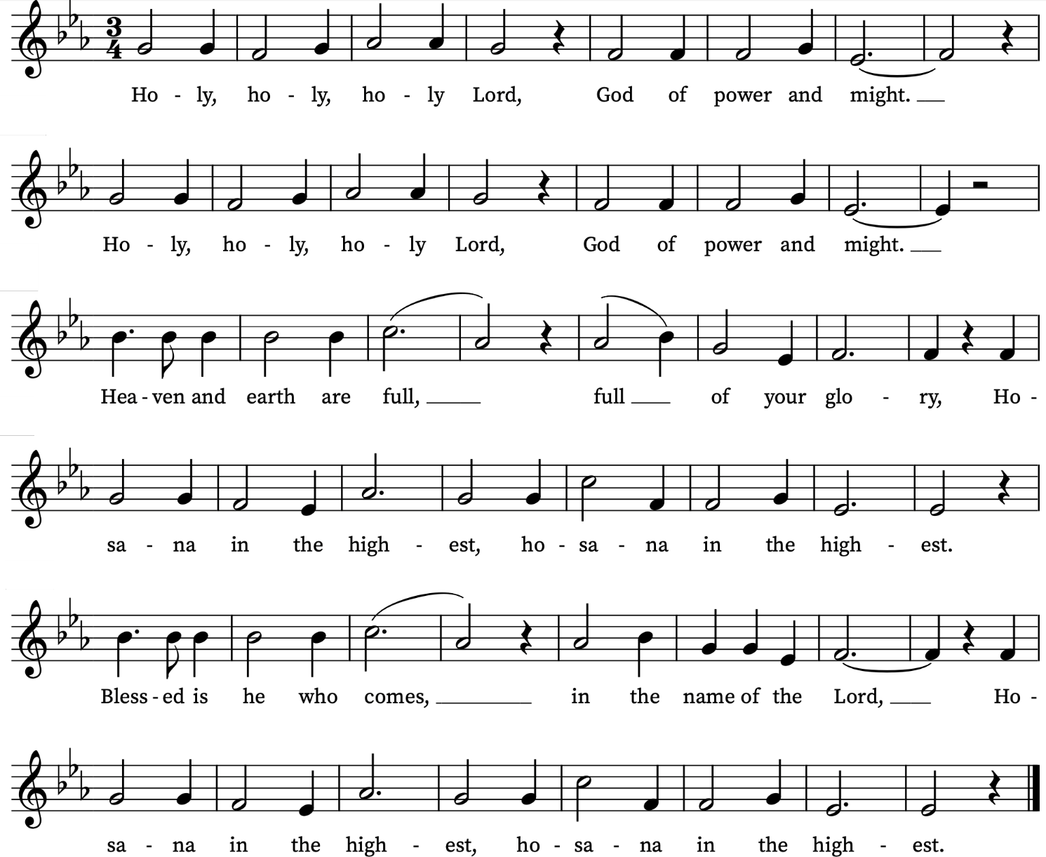

Please sit
The Eucharistic prayer continues:
We praise and bless you, loving Father,
through Jesus Christ, our Lord;
and as we obey his command,
send your Holy Spirit,
that broken bread and wine outpoured
may be for us the body and blood of your dear Son.
On the night before he died he had supper with his friends
and, taking bread, he praised you.
He broke the bread, gave it to them and said:
Take, eat; this is my body which is given for you;
do this in remembrance of me.
When supper was ended he took the cup of wine.
Again he praised you, gave it to them and said:
Drink this, all of you;
this is my blood of the new covenant,
which is shed for you and for many for the forgiveness
of sins.
Do this, as often as you drink it, in remembrance of me.
So, Father, we remember all that Jesus did,
in him we plead with confidence his sacrifice made once for all upon the cross.
Bringing before you the bread of life and cup of salvation,
we proclaim his death and resurrection
until he comes in glory.
Great is the mystery of faith:
Christ has died:
Christ is risen:
Christ will come again.
Lord of all life,
help us to work together for that day
when your kingdom comes
and justice and mercy will be seen in all the earth.

Look with favour on your people,
gather us in your loving arms
and bring us with St Alfege, the Blessed Virgin Mary and all the saints
to feast at your table in heaven.
Through Christ, and with Christ, and in Christ,
in the unity of the Holy Spirit,
all honour and glory are yours, O loving Father,
for ever and ever.
Amen.
The Lord’s Prayer
Let us pray with confidence as our Saviour has taught us:
Our Father, who art in heaven,
hallowed be thy name;
thy kingdom come;
thy will be done;
on earth as it is in heaven.
Give us this day our daily bread.
And forgive us our trespasses,
as we forgive those who trespass against us.
And lead us not into temptation;
but deliver us from evil.
For thine is the kingdom,
the power and the glory,
for ever and ever. Amen.

Breaking of the Bread
We break this bread to share in the body of Christ.
Though we are many, we are one body, because we all share in one bread.
Agnus Dei
We sing the Agnus Dei from Schubert’s German Mass as the bread is broken.
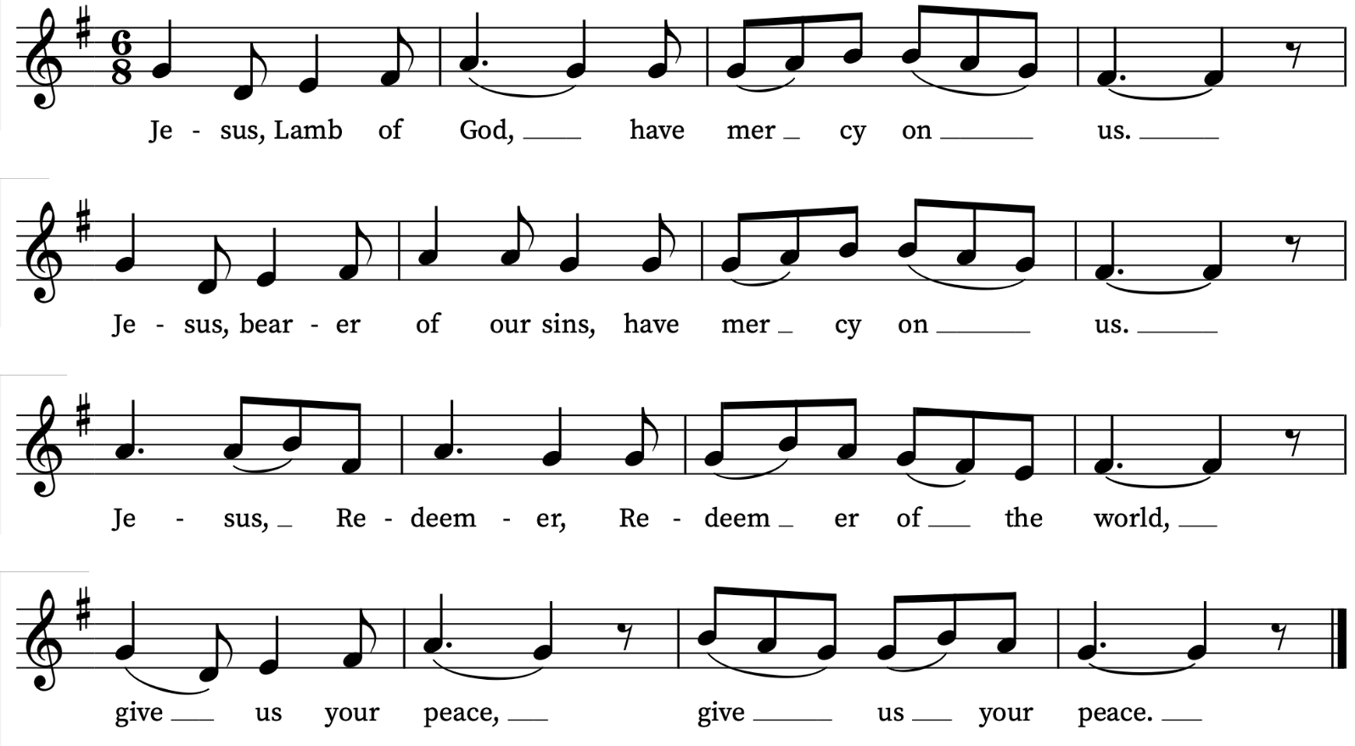

Giving of Communion
Revd Simon says:
Draw near with faith. Receive the body of our Lord Jesus Christ which he gave for you, and his blood which he shed for you. Eat and drink in remembrance that he died for you, and feed on him in your hearts by faith with thanksgiving.
Everyone is invited to receive the sacrament or a blessing after which we reply Amen.
Please come forward as directed by a welcomer. If you need communion brought to you please let a welcomer know. If you would like to receive a blessing rather than communion, please bow your head.
Please let a welcomer know if you need a gluten-free wafer.
We are offering communion in both kinds, the bread (wafer) and the wine (in the cup or chalice). If you would prefer not to receive the wine from the chalice/cup please bow your head or simply leave the altar rail after receiving the wafer. Please do not intinct (dip your wafer in the chalice).
Please return to your seats via the side chapels.
During Communion the choir sings
For the beauty of the earth – John Rutter
For the beauty of the earth
For the beauty of the skies,
For the love which from our birth
Over and around us lies
over and around us lies
Lord of all, to thee we raise
This our joyful hymn of praise.
For the beauty of each hour
Of the day and of the night,y
Hill and vale,
and tree and flower,
Sun and moon and stars of light:
Sun and moon and stars of light:
Lord of all, to thee we raise
This our joyful hymn of praise.
For the joy of human love,
Brother, sister, parent, child
Friends on earth,
and friends above,
For all gentle thoughts and mild,
For all gentle thoughts and mild:
Lord of all, to thee we raise
This our joyful hymn of praise.
For each perfect gift of thine
To our race so freely given,
Graces human and divine,
Flow'rs of earth and buds of heav'n:
flow'rs of earth and buds of heav'n:
Lord of all, to thee we raise
This our joyful hymn of praise, our hymn of praise
This our joyful hymn of praise, our hymn of praise.
Prayer after Communion
We pray together:
Lord of the harvest,
with joy we have offered thanksgiving
for your love in creation
and have shared in the bread and wine of the kingdom:
by your grace plant within us a reverence
for all that you give us
and make us generous and wise stewards
of the good things we enjoy;
through Jesus Christ our Lord.
Amen.
Notices
Final Hymn
Praise, O praise our God and King;
hymns of adoration sing:
for his mercies still endure
ever faithful, ever sure.
Praise him that he made the sun
day by day his course to run:
for his mercies still endure
ever faithful, ever sure.
Praise him that he gave the rain
to mature the swelling grain:
for his mercies still endure
ever faithful, ever sure.
And hath bid the fruitful field
crops of precious increase yield:
for his mercies still endure
ever faithful, ever sure.
Praise him for our harvest-store;
he hath filled the garner-floor:
for his mercies still endure
ever faithful, ever sure.
Glory to our bounteous King;
glory let creation sing:
glory to the Father, Son,
and blest Spirit, Three in One.
Words: Henry Williams Baker (1821-1877)
Music: from ‘Hymn Tunes of the United Brethren’ adapt. by John Bernard Wilkes (1785-1869)

The Dismissal
The Blessing and Dismissal
May God our creator give you grace to be wise stewards of creation and bring forth the fruits of love, joy and peace;
and the blessing of God almighty, the Father, the Son and the Holy Spirit, be among you and remain with you always.
Amen.
Freely you have received, freely give.
Go in peace to love and serve the Lord.
In the name of Christ. Amen.
Organ Postlude
Toccata in Seven – John Rutter
Please remain standing as the choir, clergy and servers depart. An organ voluntary is played.
You are welcome to remain to listen or leave quietly.
Please come for tea and coffee in the church hall afterwards.
If you would like to pray with someone in confidence after the service, a lay member of our prayer ministry team will be available in the South Chapel. You are welcome to ask for prayer for wholeness and healing, personal circumstances, or anything else that is on your heart. The St Alfege Chapel is available for private prayer and lighting candles.

Prayers for the week
We pray for Louisa Parsons and Joseph Hills and for Daniel Minis and Caroline Miller who were married here on Friday and Saturday respectively.
We pray for those in need: George Coles, Colin Coveney, Fr Giles Harcourt, William Higginson, Carole Hubble, Marion Kokott, James Markham, Sara Mauleverer, Lylian Meira, Véronique Müller, Vernon Mustoe, Nicola Orme, Karen Robjont, Jean Smith, Geoff Staden, Tina Stanley, Doreen Waller, and Pauline Youll.
We remember those who have died recently including Myles Dove, Gilli Frewer, Joe Geshwiler, Nomsa Monareng, Maulene Sweet and John Yeomans. We ask God’s comfort on all who are mourning the loss of loved ones.
To include names of loved ones on the prayer list, please contact David McEvoy dmcevoy@btinternet.com

Choral Evensong this evening
Do join us for a service of Choral Evensong at 4.00pm in church today. Led by Peter Kinnison, Reader. Music by Stanford, Ley, Rose, Rubbra, Dering and Cox.

Supporting St Alfege Church
Please do make a gift to support the life and ministry of St Alfege Church –during the collection in the service or by using our card reader at the North and West Doors. Please complete a Gift Aid envelope (if you are eligible) whether you donate by cash or card. You can also use this QR code to donate. | 

Welcome to Children's Church!
Join us on Sundays in the Church Hall for a morning of fun, friendship, and faith! All families with children are welcome. We ask that a parent or carer accompanies their child/children.
Activities include:
- Bible stories; praying together;
- sing-along songs; creative crafts; Holy Communion together.
Our usual schedule is:
- Registration from 9.55 to 10.05; Worship from 10.05 to 10.15;
- Bible Time from 10.15 to 10.35; Fun Activities from 10.35 to 11.00.
For more details please speak to Alison Wood or Moira Searle. Please check the Children’s Church board at the back of church and chat to them in the Hall over tea/coffee after the service. Alternatively contact the church office: office@st-alfege.org.uk or 020 8853 0687.
Services this week
Sunday 27 September Sixteenth Sunday after Trinity
8.00am Holy Communion (Book of Common Prayer)
10.00am Parish Eucharist
4.00pm Choral Evensong
Monday 28 September
8.30am Morning Prayer
Tuesday 29 September
8.30am Morning Prayer
Wednesday 30 September
8.30am Morning Prayer
2.45 for 3.00pm Radio 3 Choral Evensong at the Chapel of the Old Royal Naval College
Thursday 1 October
8.00am Holy Communion
Sunday 4 October Creation Sunday
8.00am Holy Communion
10.00am Sung Eucharist
5.30pm Abide, a contemplative service with music from Taizé
Walk-In Wednesdays
Every Wednesday 10am to 12noon in the Frank Smith Room in the hall for a cuppa, company and a chat.
Contact Us
Vicar: Revd Simon Winn
Curate: Revd Dr Tati Gutteridge (on maternity leave)
Church Office: office@st-alfege.org.uk 020 8853 0687
www.st-alfege.org.uk
Safeguarding Team
safeguarding@st-alfege.org.uk

