
x

Sung Eucharist
Sixteenth Sunday after Trinity
20 September 2026
Welcome to our services of Holy Communion. Revd Dr Robert Tobin is presiding and preaching at 8am. Revd Mark Hatcher, Honorary Associate Priest, is presiding at 10am. We welcome Revd Dr Charlie Bączyk-Bell as preacher at 10am. Children’s Church is meeting in the in the hall.
Readings
Jonah 3:10 – 4:11
Psalm 145: 1-8
Philippians 1: 21-30
Matthew 20: 1-16
Hymns
422 Tell out, my soul, the greatness of the Lord
284 In our day of thanksgiving
Led like a lamb (tune: Two Oaks). On page 6 of this sheet
271 Bread of heaven, on thee we feed
Collect
O Lord, we beseech you mercifully to hear the prayers of your people who call upon you; and grant that they may both perceive and know what things they ought to do, and also may have grace and power faithfully to fulfil them; through Jesus Christ your Son our Lord, who is alive and reigns with you, in the unity of the Holy Spirit, one God, now and for ever. Amen
Prayer after Communion
Almighty God, you have taught us through your Son that love is the fulfilling of the law: grant that we may love you with our whole heart and our neighbours as ourselves; through Jesus Christ our Lord. Amen
Kyrie
Please join in singing the Kyrie from Schubert’s German Mass.
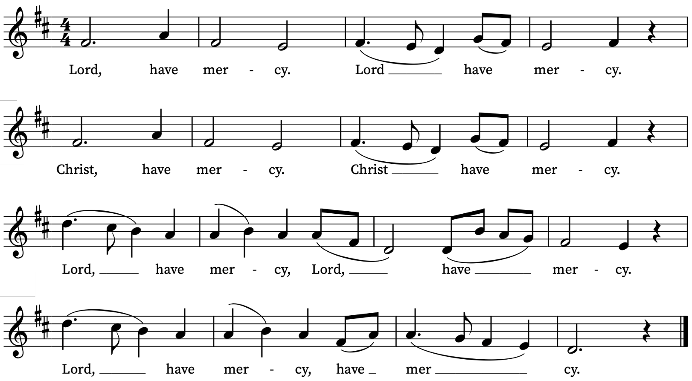
First Reading
Jonah 3:10 – 4:11
A reading from the prophet Jonah
When God saw what they did, how they turned from their evil ways, God changed his mind about the calamity that he had said he would bring upon them; and he did not do it.
But this was very displeasing to Jonah, and he became angry. He prayed to the Lord and said, ‘O Lord! Is not this what I said while I was still in my own country? That is why I fled to Tarshish at the beginning; for I knew that you are a gracious God and merciful, slow to anger, and abounding in steadfast love, and ready to relent from punishing. And now, O Lord, please take my life from me, for it is better for me to die than to live.’ And the Lord said, ‘Is it right for you to be angry?’ Then Jonah went out of the city and sat down east of the city, and made a booth for himself there. He sat under it in the shade, waiting to see what would become of the city.
The Lord God appointed a bush, and made it come up over Jonah, to give shade over his head, to save him from his discomfort; so Jonah was very happy about the bush. But when dawn came up the next day, God appointed a worm that attacked the bush, so that it withered. When the sun rose, God prepared a sultry east wind, and the sun beat down on the head of Jonah so that he was faint and asked that he might die. He said, ‘It is better for me to die than to live.’
But God said to Jonah, ‘Is it right for you to be angry about the bush?’ And he said, ‘Yes, angry enough to die.’ Then the Lord said, ‘You are concerned about the bush, for which you did not labour and which you did not grow; it came into being in a night and perished in a night. And should I not be concerned about Nineveh, that great city, in which there are more than a hundred and twenty thousand people who do not know their right hand from their left, and also many animals?’
This is the Word of the Lord
Thanks be to God
Psalm 145: 1-8
Exaltabo te, Deus
I will magnify thee, O God, my King : and I will praise thy Name for ever and ever.
2 Every day will I give thanks unto thee : and praise thy Name for ever and ever.
3 Great is the Lord, and marvellous worthy to be praised : there is no end of his greatness.
4 One generation shall praise thy works unto another : and declare thy power.
5 As for me, I will be talking of thy worship : thy glory, thy praise, and wondrous works;
6 So that men shall speak of the might of thy marvellous acts : and I will also tell of thy greatness.
7 The memorial of thine abundant kindness shall be shewed : and men shall sing of thy righteousness.
8 The Lord is gracious and merciful : long-suffering and of great goodness.
Second Reading
Philippians 1: 21-30
A reading from Paul’s Letter to the Philippians
For to me, living is Christ and dying is gain. If I am to live in the flesh, that means fruitful labour for me; and I do not know which I prefer. I am hard pressed between the two: my desire is to depart and be with Christ, for that is far better; but to remain in the flesh is more necessary for you. Since I am convinced of this, I know that I will remain and continue with all of you for your progress and joy in faith, so that I may share abundantly in your boasting in Christ Jesus when I come to you again.
Only, live your life in a manner worthy of the gospel of Christ, so that, whether I come and see you or am absent and hear about you, I will know that you are standing firm in one spirit, striving side by side with one mind for the faith of the gospel, and are in no way intimidated by your opponents. For them this is evidence of their destruction, but of your salvation. And this is God’s doing. For he has graciously granted you the privilege not only of believing in Christ, but of suffering for him as well— since you are having the same struggle that you saw I had and now hear that I still have.
This is the Word of the Lord
Thanks be to God

Gospel Reading
Matthew 20: 1-16
Hear the Gospel of our Lord Jesus Christ according to Matthew
Glory be to thee, O Lord
Jesus said, ‘For the kingdom of heaven is like a landowner who went out early in the morning to hire labourers for his vineyard. After agreeing with the labourers for the usual daily wage, he sent them into his vineyard. When he went out about nine o’clock, he saw others standing idle in the market-place; and he said to them, “You also go into the vineyard, and I will pay you whatever is right.” So they went. When he went out again about noon and about three o’clock, he did the same. And about five o’clock he went out and found others standing around; and he said to them, “Why are you standing here idle all day?” They said to him, “Because no one has hired us.” He said to them, “You also go into the vineyard.” When evening came, the owner of the vineyard said to his manager, “Call the labourers and give them their pay, beginning with the last and then going to the first.” When those hired about five o’clock came, each of them received the usual daily wage. Now when the first came, they thought they would receive more; but each of them also received the usual daily wage. And when they received it, they grumbled against the landowner, saying, “These last worked only one hour, and you have made them equal to us who have borne the burden of the day and the scorching heat.” But he replied to one of them, “Friend, I am doing you no wrong; did you not agree with me for the usual daily wage? Take what belongs to you and go; I choose to give to this last the same as I give to you. Am I not allowed to do what I choose with what belongs to me? Or are you envious because I am generous?” So the last will be first, and the first will be last.’
This is the Gospel of the Lord
Praise be to thee, O Christ

Offertory Hymn
Led like a lamb to the slaughter,
in silence and shame,
there on your back you carried
a world of violence and pain.
Bleeding, dying, bleeding, dying.
You’re alive, you’re alive, you have risen!
Alleluia! alleluia! alleluia!
And the pow’r and the glory is given,
alleluia! alleluia! alleluia! Jesus to you
At break of dawn, poor Mary,
still weeping she came,
when through her grief she heard your voice
now speaking her name.
Mary, Master, Mary Master.
You’re alive, you’re alive …
At the right hand of the Father
now seated on high
you have begun your eternal reign
of justice and joy.
Glory, glory, glory, glory.
You’re alive, you’re alive …
Graham Kendrick (b.1950)

Today’s Music
Mass setting (Gloria, Sanctus/Benedictus, Agnus Dei):
Mass for four voices – William Byrd
Psalm 145
You can find the words on page 3 of this sheet.
Anthem
Verleih uns Frieden – Felix Mendelssohn
Verleih uns Frieden gnädiglich,  Herr Gott, zu unsern Zeiten;  Es ist doch ja kein ander nicht,  Der für uns könnte streiten,  Denn du, unser Gott, alleine. | Grant us peace graciously,  Lord God, in our time;  there is indeed no other  who could fight for us  than you, our God, alone.  Words: Martin Luther
Communion Motet
Rejoice in the Lord alway - Anon
Rejoice in the Lord alway, and again I say, rejoice. Let your softness be known unto all men: the Lord is at hand. Be careful for nothing: but in all prayer and supplication, let your petitions be manifest unto God with giving of thanks. And the peace of God, which passeth all understanding, shall keep your hearts and minds through Christ Jesu. Amen. Philippians 4:4-7
Organ voluntary
Ciacona in E – Dieterich Buxtehude
Prayers for the week
We pray for those in need: Colin Coveney, Fr Giles Harcourt, William Higginson, Carole Hubble, Marion Kokott, James Markham, Sara Mauleverer, Lylian Meira, Véronique Müller, Vernon Mustoe, Nicola Orme, Karen Robjont, Jean Smith, Geoff Staden, Tina Stanley, Doreen Waller, and Pauline Youll.
We remember those who have died recently including Myles Dove, Gilli Frewer, Joe Geshwiler, Nomsa Monareng, Maulene Sweet and John Yeomans. We ask God’s comfort on all who are mourning the loss of loved ones.
If you wish to add names to the prayers for those in need or departed please contact David McEvoy dmcevoy@btinternet.com
Supporting St Alfege Church
Please do make a gift to support the life and ministry of St Alfege Church – during the collection in the service or by using a card reader at the North and West Doors. Please complete a Gift Aid envelope (if you are eligible) whether you donate by cash or card. You can also use this QR code to donate. | 
Services this week
Sunday 20 September Sixteenth Sunday after Trinity
10.00am Parish Eucharist
Monday 21 September
8.30am Morning Prayer
Tuesday 22 September
8.30am Morning Prayer
Wednesday 23 September
8.30am Morning Prayer
Thursday 24 September
8.00am Holy Communion
Sunday 27 September Seventeenth Sunday after Trinity
8.00am Holy Communion
10.00am All Age Eucharist/ Harvest Festival
4.00pm Choral Evensong

Walk-in Wednesdays
Every Wednesday 10am-12noon in the small hall
Contact us
Vicar: Revd Simon Winn
Curate: Revd Dr Tati Gutteridge (on maternity leave)
Church Office: 020 8853 0687
Email: office@st-alfege.org.uk Website: www.st-alfege.org.uk
Safeguarding Team: safeguarding@st-alfege.org.uk
Please take this sheet home with you. When you have finished with it why not share it with a neighbour?

