

All Age Eucharist
with Baptisms and Thanksgiving for the Gift of a Child



Sunday 26 July 2026
at 10am

Welcome to our all age Eucharist for the 8th Sunday after Trinity as we celebrate the Baptism of baby Delphina Dalton and Laura Navick and give thanks for the birth of Matilda Belton-King.
Our service is led by Revd Simon Winn, Vicar, and Richard Mash, Licensed Lay Minister, is preaching.
You will find everything you need for the service in this booklet. Please join in the words in bold.
We will all join in singing the Kyrie, Gloria, Sanctus/Benedictus and Agnus Dei from Schubert’s German Mass.
St Alfege Choir is directed by Director of Music Joshua Ryan with Assistant Organist Ben Banks.
During the service we will take a collection to support the ministry and mission of our church. You can also use the card reader by the West and North door for electronic payments.
You can also pay online using the following details: PCC of St Alfege, Greenwich Sort Code: 60-09-16 Account number: 25249304. Please also note that if you are a UK tax payer the church can claim 25% Gift Aid in addition to your donation therefore, if eligible and if you are setting up a standing order, please request a Gift Aid declaration form from the church office: office@st-alfege.org.uk You can also use this QR code to donate.
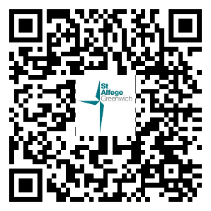
Please join us in the Hall after the service for refreshments.

Please stand as the choir, servers and clergy process into church.
THE GATHERING
Processional Hymn
King of glory, King of peace,
I will love thee;
and, that love may never cease,
I will move thee.
Thou hast granted my request,
thou hast heard me;
thou didst note my working breast,
thou hast spared me.
Wherefore with my utmost art
I will sing thee,
and the cream of all my heart
I will bring thee.
Though my sins against me cried,
thou didst clear me,
and alone, when they replied,
thou didst hear me.
Seven whole days, not one in seven,
I will praise thee;
in my heart, though not in heaven,
I can raise thee.
Small it is, in this poor sort
to enrol thee:
e'en eternity's too short
to extol thee.

The Greeting
Revd Simon welcomes us and says
The grace of our Lord Jesus Christ, the love of God
and the fellowship of the Holy Spirit be with you all
and also with you.
We pray together:
Almighty God,
to whom all hearts are open,
all desires known,
and from whom no secrets are hidden:
cleanse the thoughts of our hearts
by the inspiration of your Holy Spirit,
that we may perfectly love you,
and worthily magnify your holy name;
through Christ our Lord.
Amen.

Confession and Forgiveness
Revd Simon says:
The grace of God has dawned upon the world
with healing for all.
Let us come to Christ, in sorrow for our sins,
seeking healing and salvation.

We keep silence for reflection
Most merciful God,
Father of our Lord Jesus Christ,
we confess that we have sinned
in thought, word and deed.
We have not loved you with our whole heart.
We have not loved our neighbours as ourselves.
In your mercy
forgive what we have been,
help us to amend what we are,
and direct what we shall be;
that we may do justly,
love mercy,
and walk humbly with you, our God.
Amen.

Kyrie
We join in singing the Kyrie from Schubert’s German Mass
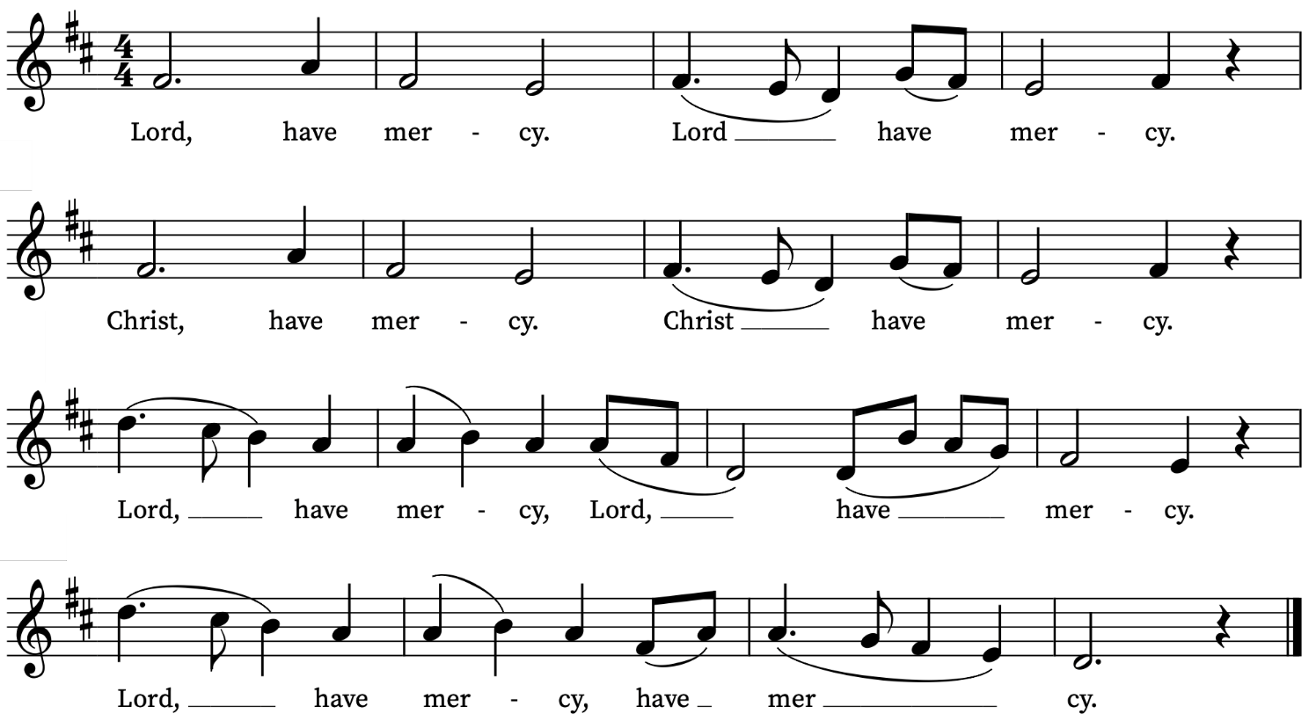
Revd Simon prays
May the Father forgive you
by the death of his Son
and strengthen you to live in the power of the Spirit
all your days. Amen.

Gloria in Excelsis
We sing the Gloria from Schubert’s German Mass
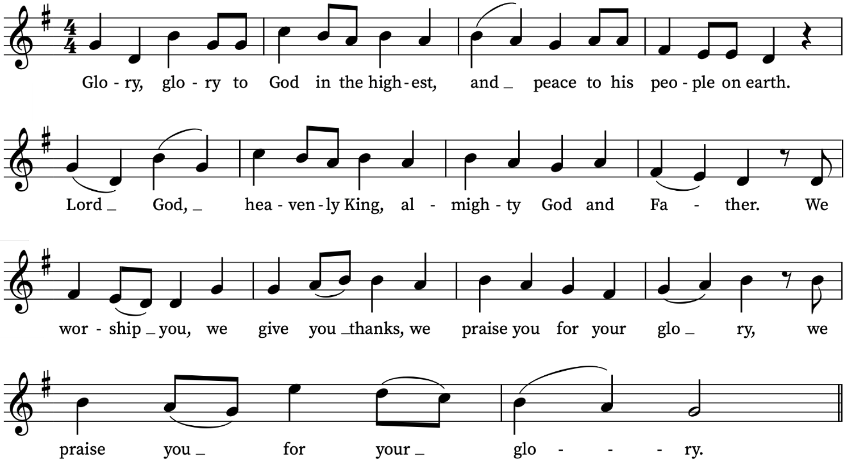
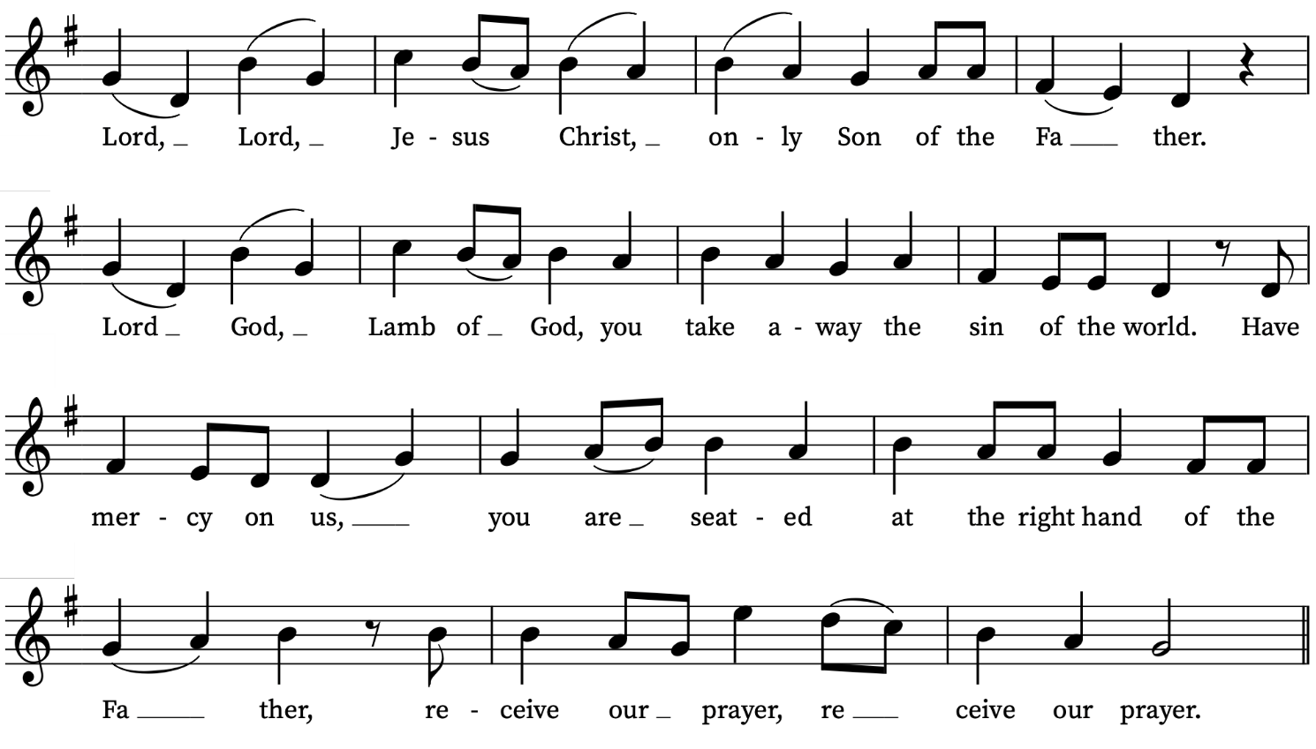
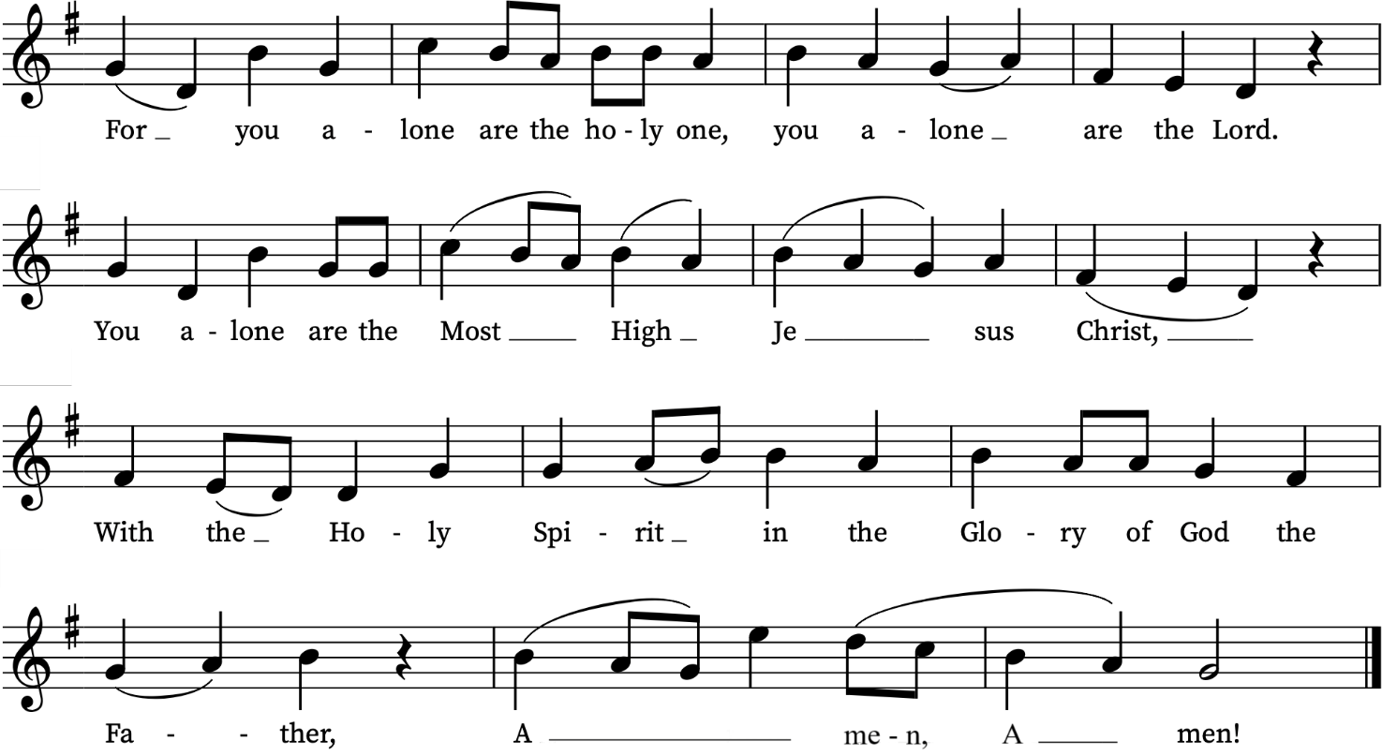
The Collect
Revd Simon prays:

Heavenly Father,
by the power of your Holy Spirit
you give to your faithful people new life in the water of baptism.
Guide and strengthen us by the same Spirit,
that we who are born again may serve you in faith and love,
and grow into the full stature of your Son, Jesus Christ our Lord.
Amen.

Please sit for the first reading

THE LITURGY OF THE WORD

First Reading
Romans 8: 26-39
read by Arno Levin
The Spirit helps us in our weakness; for we do not know how to pray as we ought, but that very Spirit intercedes with sighs too deep for words. And God, who searches the heart, knows what is the mind of the Spirit, because the Spirit intercedes for the saints according to the will of God.
We know that all things work together for good for those who love God, who are called according to his purpose. For those whom he foreknew he also predestined to be conformed to the image of his Son, in order that he might be the firstborn within a large family. And those whom he predestined he also called; and those whom he called he also justified; and those whom he justified he also glorified.
What then are we to say about these things? If God is for us, who is against us? He who did not withhold his own Son, but gave him up for all of us, will he not with him also give us everything else? Who will bring any charge against God’s elect? It is God who justifies. Who is to condemn? It is Christ Jesus, who died, yes, who was raised, who is at the right hand of God, who indeed intercedes for us. Who will separate us from the love of Christ? Will hardship, or distress, or persecution, or famine, or nakedness, or peril, or sword? As it is written,
‘For your sake we are being killed all day long;
we are accounted as sheep to be slaughtered.’
No, in all these things we are more than conquerors through him who loved us. For I am convinced that neither death, nor life, nor angels, nor rulers, nor things present, nor things to come, nor powers, nor height, nor depth, nor anything else in all creation, will be able to separate us from the love of God in Christ Jesus our Lord.
At the end:
This is the word of the Lord Thanks be to God
Please stand for the Gradual Hymn
Gradual Hymn
‘The kingdom is upon you!’
the voice of Jesus cries,
fulfilling with its message
the wisdom of the wise;
it lightens with fresh insight
the striving human mind,
creating new dimensions
of purpose for mankind.
‘God’s kingdom is upon you!’
the message sounds today,
it summons every pilgrim
to take the questing way,
with eyes intent on Jesus,
our leader and our friend,
who trod faith’s road before us,
and trod it to the end.
The kingdom is upon us!
Stirred by the Spirit’s breath,
we glory in its freedom
from emptiness and death;
we celebrate its purpose,
its mission and its goal,
alive with the conviction
that Christ can make us whole.
Words: Robert Willis (1947-2024) Tune: Wolvercote
We remain standing for the Gospel

Gospel Reading
Matthew 13: 31-33, 44-52
read by Richard Mash
Hear the Gospel of our Lord Jesus Christ according to Matthew
Glory to you, O Lord
He put before them another parable: ‘The kingdom of heaven is like a mustard seed that someone took and sowed in his field; it is the smallest of all the seeds, but when it has grown it is the greatest of shrubs and becomes a tree, so that the birds of the air come and make nests in its branches.’
He told them another parable: ‘The kingdom of heaven is like yeast that a woman took and mixed in with three measures of flour until all of it was leavened.’
‘The kingdom of heaven is like treasure hidden in a field, which someone found and hid; then in his joy he goes and sells all that he has and buys that field.
‘Again, the kingdom of heaven is like a merchant in search of fine pearls; on finding one pearl of great value, he went and sold all that he had and bought it.
‘Again, the kingdom of heaven is like a net that was thrown into the sea and caught fish of every kind; when it was full, they drew it ashore, sat down, and put the good into baskets but threw out the bad. So it will be at the end of the age. The angels will come out and separate the evil from the righteous and throw them into the furnace of fire, where there will be weeping and gnashing of teeth.
‘Have you understood all this?’ They answered, ‘Yes.’ And he said to them, ‘Therefore every scribe who has been trained for the kingdom of heaven is like the master of a household who brings out of his treasure what is new and what is old.’
At the end:
This is the Gospel of the Lord
Praise to you, O Christ
Please sit when invited

Sermon
Richard Mash, Licensed Lay Minister

Thanksgiving for the Gift of a Child
Revd Simon says to Matilda’s parents:
Do you receive your child as a gift from God?
We do.
Do you wish to give thanks to God and seek his blessing?
We do.
Revd Simon says:
God our creator,
we thank you for the wonder of new life
and for the mystery of human love.
We thank you for all whose support and skill
surround and sustain the beginning of life.
We thank you that we are known to you by name
and loved by you from all eternity.
We thank you for Jesus Christ,
who has opened to us the way of love.
We praise you, Father, Son, and Holy Spirit.
All Blessed be God for ever.

What name have you given your child?
The parents reply
Her name is Matilda Elizabeth

Revd Simon says:
As Jesus took children in his arms and blessed them, so now we ask God’s blessing on Matilda Elizabeth
Heavenly Father, we praise you for her birth;
surround her with your blessing
that she may know your love,
be protected from evil,
and know your goodness all her days.
May she learn to love all that is true,
grow in wisdom and strength
and, in due time, come through faith and baptism
to the fullness of your grace;
through Jesus Christ our Lord.
Amen.
Revd Simon prays for the parents:
May God the Father of all bless Olivia and Tom
and give them grace to love and care for Matilda
May God give them wisdom, patience and faith,
help them to provide for Matilda’s needs
and, by their example,
reveal the love and truth that are in Jesus Christ.
Amen.
Matilda’s family return to their seats.

The Liturgy of Baptism
The candidates, parents and godparents assemble around the font. The rest of the congregation remain seated. Revd Simon says
Our Lord Jesus Christ has told us
that to enter the kingdom of heaven
we must be born again of water and the Spirit,
and has given us Baptism as the sign and seal
of this new birth.
Here we are washed by the Holy Spirit and made clean.
Here we are clothed with Christ,
dying to sin that we may live his risen life.
As children of God, we have a new dignity
and God calls us to fullness of life.
Revd Simon addresses the congregation:
We thank God for Laura and Delphina
who have come to be baptized today.
Christ loves them and welcomes them into his Church.
So I ask you all:
People of God, will you welcome Laura and Delphina
and uphold them in their new life in Christ?
With the help of God, we will.

Revd Simon addresses the parents and godparents:
God knows each of us by name and we are his.
Parents and godparents, you speak for Delphina today.

Will you pray for her,
and help her to follow Christ?
We will.
Revd Simon asks Laura:
Do you wish to be baptized?
I do.
The Decision
Revd Simon addresses Laura, and Delphina through her parents and godparents.
We all wander far from God and lose our way:
Christ comes to find us and welcomes us home.
In baptism we respond to his call.
Do you turn to Christ?
I turn to Christ.
Do you repent of your sins?
I repent of my sins.
Do you renounce evil?
I renounce evil.
Signing with the Cross
Revd Simon makes the sign of the cross with holy oil on the
candidates’ foreheads, saying:
Christ claims you for his own.
Receive the sign of his cross.
Revd Simon says:
Do not be ashamed of Christ.
You are his for ever.
Stand bravely with him
against all the powers of evil,
and remain faithful to Christ to the end of your life.
May almighty God deliver you from the powers of
darkness, and lead you in the light and obedience of Christ. Amen.

Prayer over the Water
Revd Simon stands before the water of Baptism and says:
Praise God who made heaven and earth
who keeps his promise for ever.
Let us give thanks to the Lord our God.
It is right to give thanks and praise.

We praise you, loving Father,
for the gift of your Son Jesus.
He was baptized in the River Jordan,
where your Spirit came upon him
and revealed him as the Son you love.
He sent his followers
to baptize all who turn to him.
Now, Father, we ask you to bless this water,
that those who are baptized in it
may be cleansed in the water of life,
and, filled with your Spirit,
may know that they are loved as your children,
safe in Christ for ever.
Amen.

Profession of Faith
Revd Simon addresses the congregation:
Let us affirm,
together with these who are being baptized,
our common faith in Jesus Christ.
Do you believe and trust in God the Father,
source of all being and life,
the one for whom we exist?
I believe and trust in him.
Do you believe and trust in God the Son,
who took our human nature,
died for us and rose again?
I believe and trust in him.
Do you believe and trust in God the Holy Spirit,
who gives life to the people of God
and makes Christ known in the world?
I believe and trust in him.
This is the faith of the Church.
This is our faith.
We believe and trust in one God,
Father, Son and Holy Spirit.
Revd Simon says to Laura
Laura, is this your faith?
Laura answers in her own words, or says:
This is my faith.

Baptism
Revd Simon pour waters on the candidates, saying:
N, I baptize you
in the name of the Father, and of the Son,
and of the Holy Spirit.
Amen.
Revd Simon says:
May God, who has received you by Baptism
into his Church, pour upon you the riches of his grace,
that within the company of Christ's pilgrim people
you may daily be renewed by his anointing Spirit,
and come to the inheritance of the saints in glory.
Amen.
Please stand
Welcome
There is one Lord, one faith, one baptism:
Laura and Delphina,
by one Spirit we are all baptized into one body.
We welcome you into the fellowship of faith;
we are children of the same heavenly Father;
we welcome you.
Parents, godparents and newly baptized return to their seats.

The choir sings the Anthem:
How dazzling fair – Charles Wood
How dazzling fair art thou, my Life, my Light!
How comely is thy countenance, how bright!
Sun uncreate, how keen is the enjoyment
That Saints and Angels find in thine employment!
In view thereof sing I, by day and night,
How dazzling fair art thou, my Life my Light!
My soul, O Lord, is sore athirst for thee:
My heart doth yearn thy seemly face to see:
Dim is my sight; but one ray of thy kindness
Should quickly skill to cure mine eyes of blindness:
Mean while my song and my complaint shall be,
“My soul, O Lord, is sore a thirst for thee.”
When shall I come to hear that Angel song?
Nay, swell the chorus of the heav'nly throng?
Then join the noble company of Sages,
Who chaunt thee Lauds through everlasting ages?
Now ev'ry day me thinks and all day long,
“When shall I come to hear that Angel song?”
Words by Rev. G. R. Woodward (after Johann Scheffler 1624-77)
Please stand

The Peace
Revd Simon introduces the Peace in these words:
We are all one in Christ Jesus.
We belong to him through faith,
heirs of the promise of the Spirit of peace.
The peace of the Lord be always with you
and also with you.
Let us offer one another a sign of peace.
All may exchange a sign of peace.
THE LITURGY OF THE EUCHARIST
Offertory Hymn
A cash collection for the ministry and mission of our church will be taken during the hymn. You may also donate later using our electronic card readers at the West and North Doors.
The God of Abraham praise
who reigns enthroned above,
Ancient of everlasting Days,
and God of love:
Jehovah, great I AM,
by earth and heaven confessed;
we bow and bless the sacred name
for ever blest.
The goodly land we see,
with peace and plenty blest:
a land of sacred liberty
and endless rest;
there milk and honey flow,
and oil and wine abound,
and trees of life for ever grow,
with mercy crowned.
There dwells the Lord our King,
the Lord our Righteousness,
triumphant o'er the world of sin,
the Prince of peace:
on Sion's sacred height
his kingdom he maintains,
and glorious with his saints in light
for ever reigns.

Before the Saviour's face
the ransomed nations bow,
o'erwhelmed at his almighty grace
for ever new;
he shows his prints of love —
they kindle to a flame,
and sound through all the worlds above
the slaughtered Lamb.
The whole triumphant host
give thanks to God on high;
'Hail, Father, Son, and Holy Ghost!’
they ever cry:
Hail, Abraham's God, and mine!
(I join the heavenly lays)
all might and majesty are thine,
and endless praise.
Thomas Olivers based on the Hebrew ‘Yigdal’ alt.
Traditional Hebrew melody noted by T. Olivers (1752-1799) from the singing of Meyer Lyon of the London Great Synagogue. Adapted c. 1770.
We remain standing

The Eucharistic Prayer
The Lord be with you
and also with you.
Lift up your hearts
We lift them to the Lord.
Let us give thanks to the Lord our God
It is right to give thanks and praise.
It is right to praise you, Father, Lord of all creation;
in your love you made us for yourself.
When we turned away you did not reject us,
but came to meet us in your Son.
You embraced us as your children
and welcomed us to sit and eat with you.
In Christ you shared our life
that we might live.in him and he in us.
He opened his arms of love upon the cross
and made for all the perfect sacrifice for sin.
On the night he was betrayed,
at supper with his friends
he took bread, and gave you thanks;
he broke it and gave it to them, saying;
Take, eat; this is my body which is given for you;
do this in remembrance of me.
Father, we do this in remembrance of him:
his body is the bread of life.
At the end of supper, taking the cup of wine,
he gave you thanks, and said:
Drink this, all of you; this is my blood of the new covenant,
which is shed for you for the forgiveness of sins;
do this in remembrance of me.
Father, we do this in remembrance of him:
his blood is shed for all.
As we proclaim his death and celebrate his rising in glory,
send your Holy Spirit that this bread and this wine
may be to us the body and blood of your dear Son.
As we eat and drink these holy gifts
make us one in Christ, our risen Lord.
With your whole Church throughout the world
we offer you this sacrifice of praise
and lift our voice to join the eternal song of heaven:
Sanctus and Benedictus
We all sing the Sanctus and Benedictus from Schubert’s German Mass
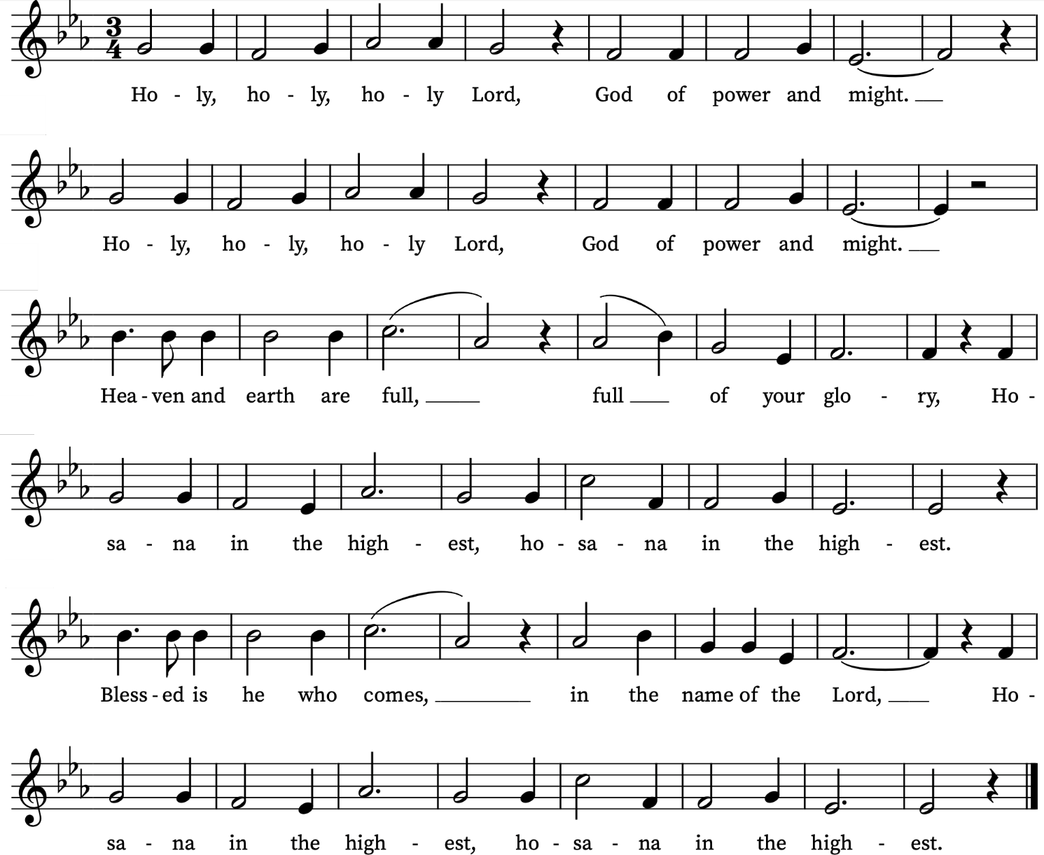
We sit or kneel

The Lord's Prayer

Trusting in the compassion of God, let us pray with confidence as our Saviour has taught us
Our Father, who art in heaven,
hallowed be thy name;
thy kingdom come; thy will be done,
on earth as it is in heaven.
Give us this day our daily bread.
And forgive us our trespasses,
as we forgive those who trespass against us.
And lead us not into temptation;
but deliver us from evil.
For thine is the kingdom,
the power and the glory,
for ever and ever. Amen
Breaking of the Bread
Revd Simon breaks the consecrated bread.
We break this bread to share in the body of Christ.
Though we are many, we are one body,
because we all share in one bread.

Agnus Dei
We all sing the Agnus Dei from Schubert’s German Mass
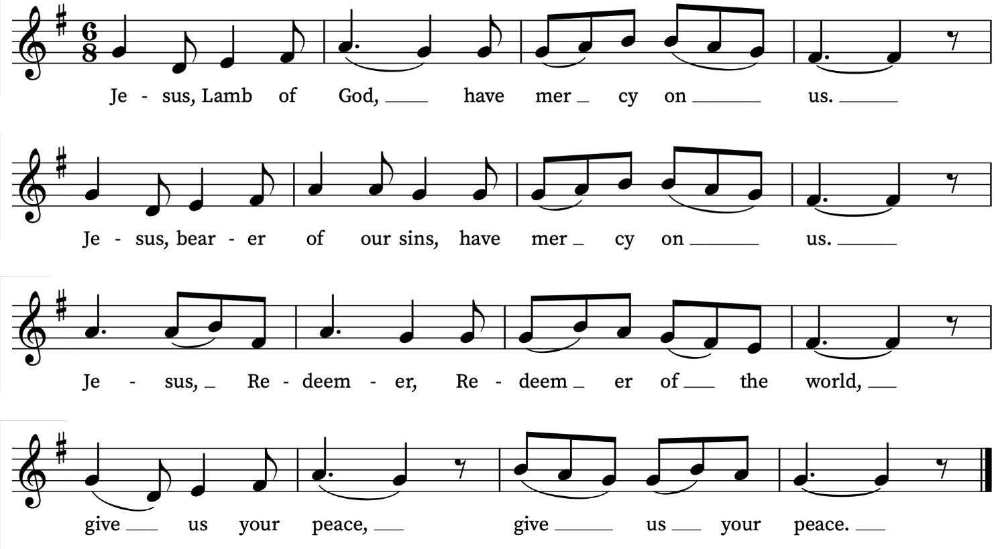

Giving of Communion
Revd Simon says:
God’s holy gifts for God’s holy people.
Jesus Christ is holy, Jesus Christ is Lord, to the glory of God the Father.
Everyone is invited to come forward to the altar rail to receive the sacrament or a blessing, after which we reply Amen.
If you would like to receive a blessing rather than communion, please bow your head. We are offering communion in both kinds, the bread (wafer) and the wine (in the cup or chalice). If you would prefer not to receive the wine from the chalice/cup please bow your head or simply leave the altar rail after receiving the wafer. Please do not intinct (dip your wafer in the chalice). Please return to your seats via the side chapels. If you need communion brought to you, please let a welcomer know. If you need a gluten-free wafer please let a welcomer know.
During the administration, the choir sings the Communion Anthem:
Jesu dulcis memoria – T.L. de Victoria
Jesu dulcis memoria  Dans vera cordis gaudia:  Sed super mel et omnia  Ejus dulcis præsentia.  Nil canitur suavius,  Nil auditur jucundius  Nil cogitatur dulcius  Quam Jesus Dei filius.  Jesu spes pænitentibus,  Quam pius es petentibus!  Quam bonus te quærentibus!  Sed quid invenientibus?  Nec lingua valet dicere,  Nec littera exprimere:  Expertus potest credere,  Quid sit Jesum diligere.  Sis Jesu nostrum gaudium  Qui es futurus præmium  Sit nostra in te gloria  Per cuncta semper sæcula.  Amen. | Jesus, sweet remembrance,  Granting the heart its true joys,  But above honey and all things  Is His sweet presence.  Nothing more pleasing can be sung,  Nothing gladder can be heard  Nothing sweeter can be thought  Than Jesus, son of God.  Jesus, hope of the penitent,  How merciful you are to those who ask,  How good to those who seek,  But O, what you are to those who find!  Tongue has no power to describe  Nor writings to express  But only belief can know by experience  What it is to love Jesus.  Be our joy, O Jesus,  Who will be the prize we win,  May all our glory be in you, always  And through all ages.  Amen.
Prayer after Communion
We pray together
Loving God, as a mother feeds her children at the breast,
you feed us in this sacrament with the food and drink of eternal life: help us who have tasted your goodness to grow in grace within the household of faith; through Jesus Christ our Lord. Amen.
Notices
We stand to sing
Final Hymn
Be thou my vision, O Lord of my heart,
be all else but naught to me, save that thou art;
be thou my best thought in the day and the night,
both waking and sleeping, thy presence my light.
Be thou my wisdom, be thou my true word,
be thou ever with me, and I with thee, Lord;
be thou my great Father, and I thy true son;
be thou in me dwelling, and I with thee one.
Be thou my breastplate, my sword for the fight;
be thou my whole armour, be thou my true might;
be thou my soul's shelter, be thou my strong tower:
O raise thou me heavenward, great Power of my power.
Riches I heed not, nor man's empty praise:
be thou mine inheritance now and always;
be thou and thou only the first in my heart;
O Sovereign of heaven, my treasure thou art.
High King of heaven, thou heaven's bright Sun,
O grant me its joys after victory is won;
great Heart of my own heart, whatever befall,
still be thou my vision, O Ruler of all.
Words: Irish, c. 8th century translated by Mary Byrne (1880-1931), versified by Eleanor Hull (1860-1935). Traditional Irish melody.

THE SENDING OUT

Giving of the Bible
A Children’s Bible is presented to Matilda’s parents, with these words
Receive this book.
It is the good news of God’s love.
Take it as your guide.
Revd Simon says to Matilda’s wider family, friends and supporters:
Will you do all that you can to help and support Olivia and Tom in the bringing up of Matilda?
With the help of God, we will.

Giving of a Lighted Candle
Revd Simon gives a lighted candle to Laura and to Delphina’s parents, and says:
God has delivered us from the dominion of darkness
and has given us a place with the saints in light.
You have received the light of Christ;
walk in this light all the days of your life.
Shine as a light in the world
to the glory of God the Father.

Blessing
Revd Simon blesses all those present:
May God, who in Christ gives us a spring of water
welling up to eternal life,
perfect in you the image of his glory;
and the blessing of God almighty,
+ the Father, Son and Holy Spirit
be upon you and remain with you always.
Amen.

Dismissal
Go in the light and peace of Christ.
Thanks be to God.
Please remain standing as the choir, servers clergy and newly baptized process out.
Organ Voluntary
Prelude and Fugue in C BWV 545 – J.S. Bach
Please come for refreshments in the church hall and green afterwards.
If you would like to pray with someone in confidence after the service, one of our clergy or a lay minister will be available in the South Chapel. You are welcome to ask for prayer for wholeness and healing, personal circumstances, or anything else that is on your heart. The St Alfege Chapel is available for private prayer and lighting candles.

Prayers for the week
We continue to pray for Christopher, Bishop of Southwark, as he retires, giving thanks for his dedication and service.
We pray for Delphina Dalton and Laura Navick who are being baptized today and we give thanks for the birth of Matilda Belton-King.
We pray for those in need: Bill Essex, William Higginson, Susan and Anthony Holland, Carole Hubble, Marion Kokott, James Markham, Sara Mauleverer, Lylian Meira, Vernon Mustoe, Nicola Orme, José Peixoto, Jean Smith, Mary Snell, Geoff Staden, Tina Stanley, and Pauline Youll.
We remember those who have died recently: Chris Hanson-Abbott, Luis Segui Gimeno, Roderick Johnson, Pontso Monareng and John Yeomans. We also remember Judy Winn, Frank Smith and John Greenacre on their year’s minds. We ask God’s comfort on all who are mourning the loss of loved ones.
If you wish to add names to the prayers for those in need or departed please contact David McEvoy dmcevoy@btinternet.com

Services this week
Sunday 26 July Eighth Sunday after Trinity
8.00am Holy Communion (BCP)
10.00am All Age Eucharist with Baptisms & Thanksgiving for the Gift of a Child
4.00pm Choral Evensong
Monday 27 July
8.30am Morning Prayer
Tuesday 28 July
8.30am Morning Prayer
Wednesday 29 July
8.30am Morning Prayer
11.00 Funeral of Chris Hanson-Abbott
Thursday 30 July
8.00am Holy Communion
Sunday 2 August Ninth Sunday after Trinity
10.00am Parish Eucharist.
2.30pm Baptism
Walk-in Wednesdays Every Wednesday 10am-12noon in the small hall.
Find Out More
You can find details of our regular services and our Church on our website: www.st-alfege.org.uk
Vicar: Revd Simon Winn
Curate: Revd Dr Tati Gutteridge (on maternity leave)
Church Office: office@st-alfege.org.uk
020 8853 0687 www.st-alfege.org.uk
Please take this service sheet home with you

Choral Evensong today
Please join us for Choral Evensong at 4pm today. Led by Revd Simon Winn, Vicar, with music by Widor, Bruckner, Trendell, Blair and S.S. Wesley.

Services in August 2026
From Sunday 2 August we follow our Summer pattern of services with a Parish Eucharist at 10am.
Children’s Church and the Choir are on holiday, returning on Sunday 6 September.
There is no 8am Holy Communion service on Sundays or Thursdays.
There is no Abide service on Sunday 2 August.
The Bellringers hold a Ringers’ Evensong service at 4pm on Sunday 30 August.

