

All Age Eucharist
with the Admission
of Children
to Holy Communion

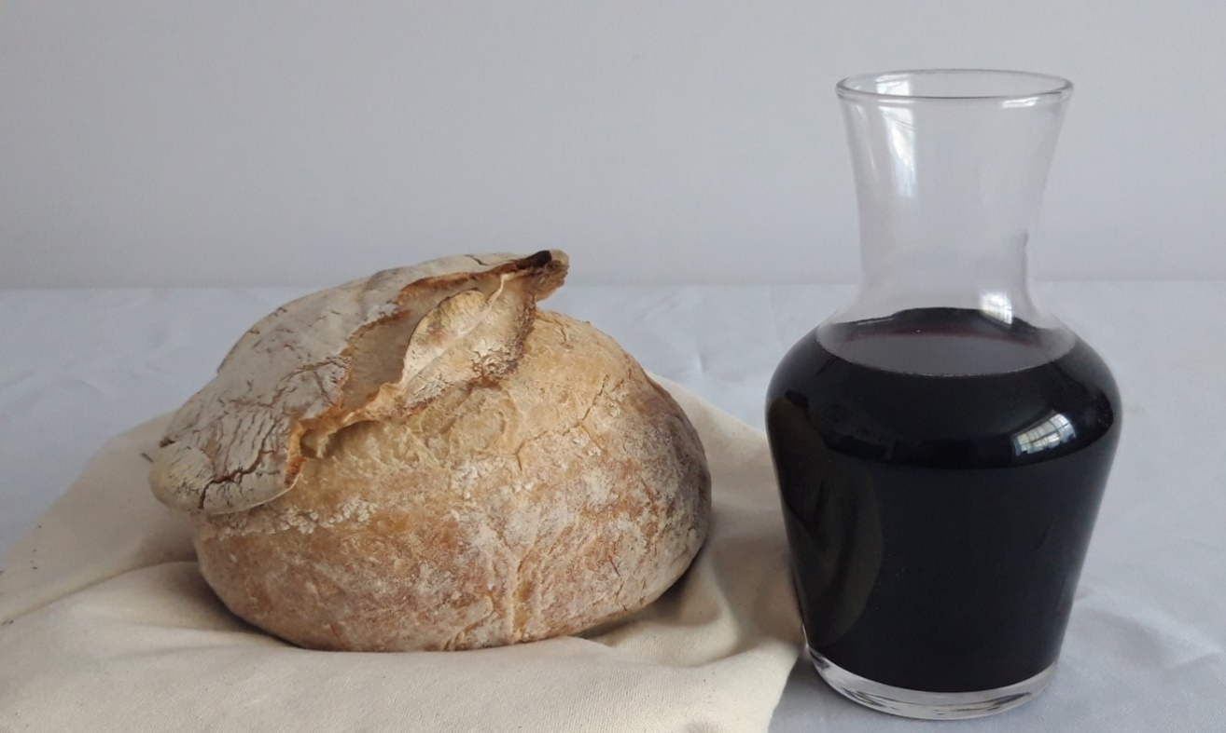

Sixth Sunday after Trinity
Sunday 12 July 2026
at 10am
Welcome to our worship.
During today’s service we welcome to communion Chidimma Aganya, Alba de Champchesnel, Morolake Konu-Oladunjoye, Tobias Menon, Tamilore Odusola, and Ethan Vivor, who share faithfully and regularly in our worship. A person is admitted to communion on the basis of their baptism, the sign and pledge of incorporation into the death and resurrection of Christ and the new life of the kingdom of God. They have been baptized, and today they receive the sacrament of the body and blood of Christ with us. They are taking a new step in the life to which God has called them in baptism and which we trust they will later affirm in confirmation. We welcome them and look forward to learning with and from them as we journey together on the Way of Christ.
The service is led by the Revd Simon Winn, Vicar of St Alfege, with members of Children’s Church. The choir is directed by Joshua Ryan, Director of Music and the organist is Benjamin Banks.
We join in singing the Kyrie, Gloria, Sanctus/Benedictus and the Agnus Dei from Franz Schubert’s German Mass.
There will be a collection during the Offertory hymn (the fourth hymn). If you prefer, we also have a card reader for electronic payments by the north door. You can also pay online using the following details: PCC of St Alfege, Greenwich Sort Code: 60-09-16 Account number: 25249304. Please also note that if you are a UK tax payer the church can claim 25% Gift Aid in addition to your donation therefore, if eligible and if you are setting up a standing order, please request a Gift Aid declaration form from the church office: office@st-alfege.org.uk

Please join us in the Hall after the service for refreshments.
Gathering and Welcome
We stand for the processional hymn
Processional Hymn
I come with joy, a child of God
forgiven, loved and free,
the life of Jesus to recall
in love laid down for me.
I come with Christians far and near
to find, as all are fed,
the new community of love
in Christ's communion bread.
As Christ breaks bread, and bids us share,
each proud division ends.
The love that made us, makes us one,
and strangers now are friends.
The Spirit of the risen Christ,
unseen, but ever near,
is in such friendship better known,
alive among us here.
Together met, together bound,
by all that God has done,
we’ll go with joy, to give the world
the love that makes us one.

Words: Brian A Wren (b. 1936)
Music: St Botolph
Revd Simon says
The grace of our Lord Jesus Christ, the love of God and the fellowship of the Holy Spirit be with you all.
And also with you.
Revd Simon welcomes us and introduces our service
Prayers of Penitence
The grace of God has dawned upon the world
with healing for all.
Let us come to Christ, in sorrow for our sins,
seeking healing and salvation.

We keep silence for reflection
Most merciful God,
Father of our Lord Jesus Christ,
we confess that we have sinned
in thought, word and deed.
We have not loved you with our whole heart.
We have not loved our neighbours as ourselves.
In your mercy
forgive what we have been,
help us to amend what we are,
and direct what we shall be;
that we may do justly,
love mercy,
and walk humbly with you, our God.
Amen.

Kyrie
We join in singing the Kyrie from Schubert’s German Mass
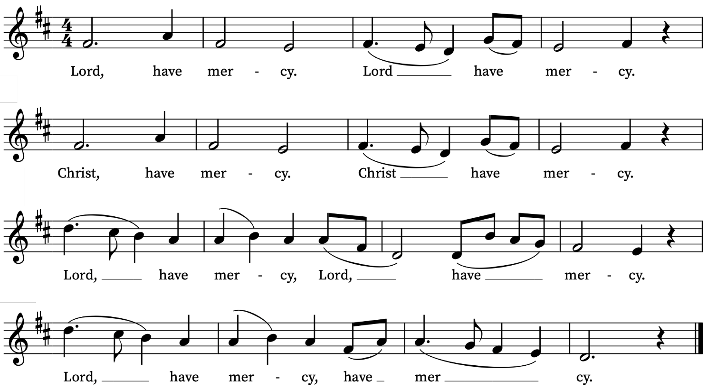
Revd Simon prays
Absolution
Through the cross of Christ,
God have mercy on you,
pardon you and set you free.
Know that you are forgiven and be at peace.
God strengthen you in all goodness
and keep you in life eternal. Amen.

Gloria in Excelsis
We sing the Gloria from Schubert’s German Mass
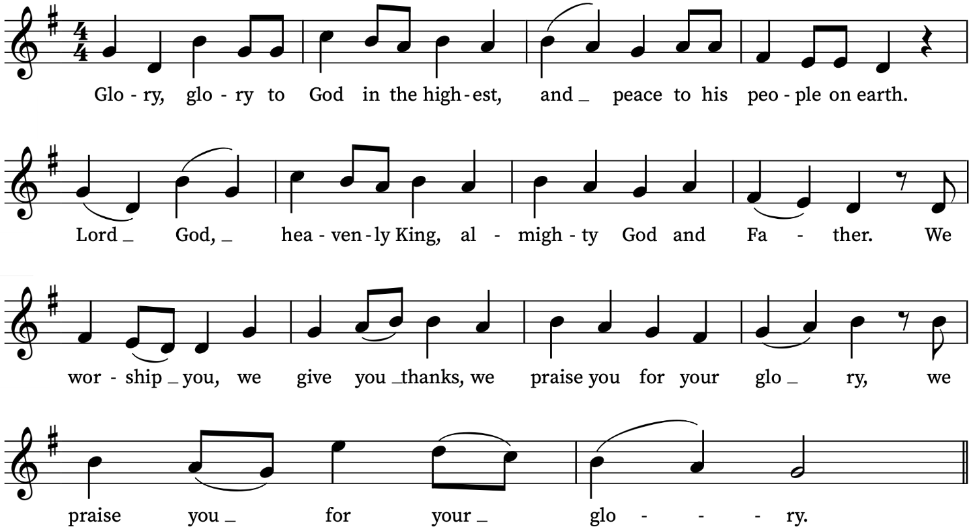
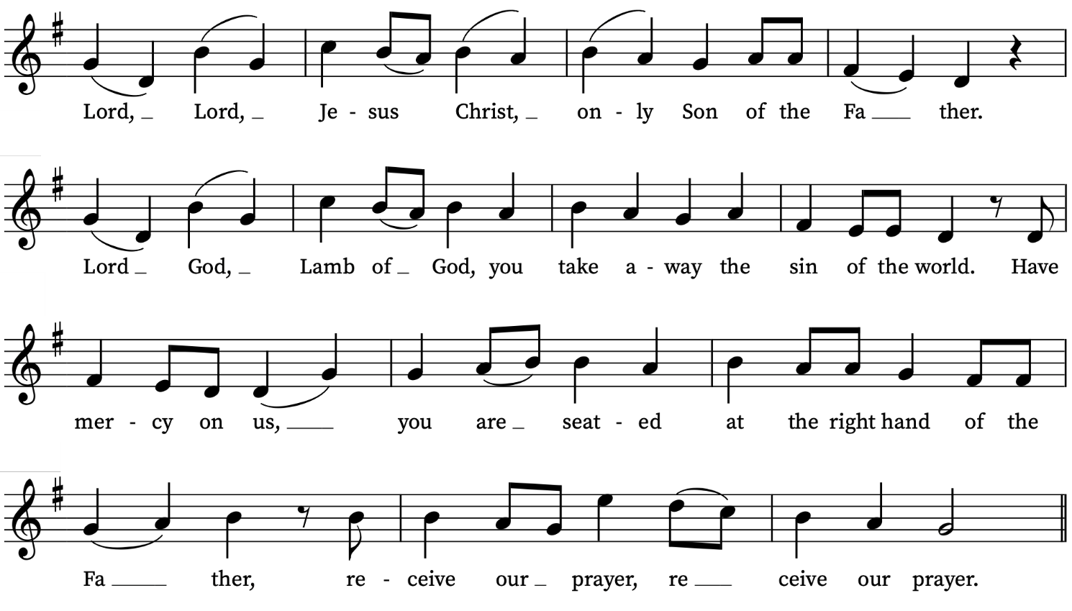

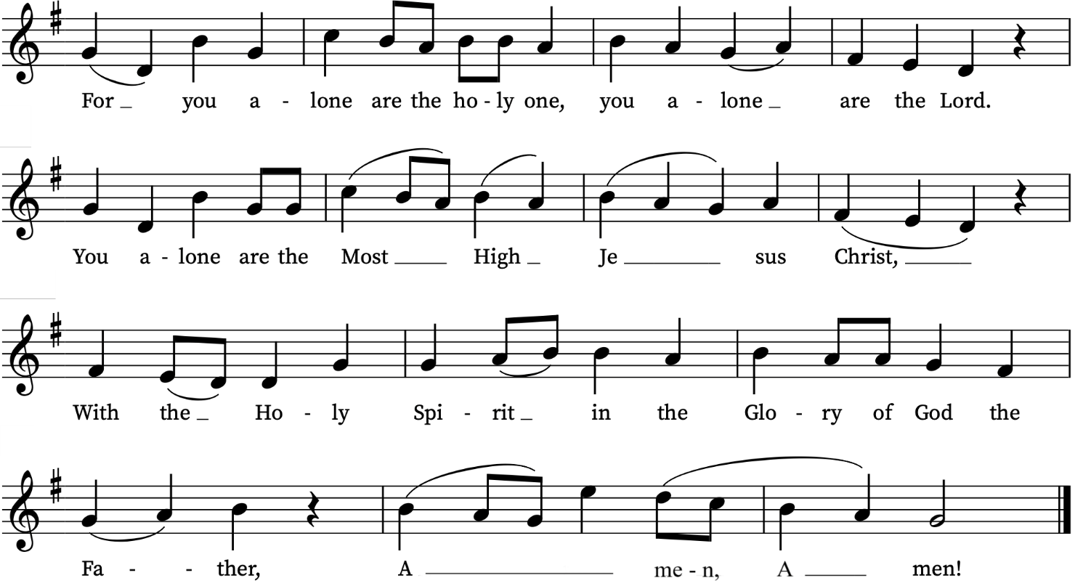

Collect
(The Church’s special prayer for today)
Creator God,
you made us all in your image:
may we discern you in all that we see,
and serve you in all that we do;
through Jesus Christ our Lord.
Amen.
The Liturgy of the Word
First Reading
Read by Naomi Ayodeji
A reading from the prophet Isaiah
Thanks be to God
Isaiah 55: 10-13
For as the rain and the snow come down from heaven,
and do not return there until they have watered the earth,
making it bring forth and sprout,
giving seed to the sower and bread to the eater,
so shall my word be that goes out from my mouth;
it shall not return to me empty,
but it shall accomplish that which I purpose,
and succeed in the thing for which I sent it.
For you shall go out in joy,
and be led back in peace;
the mountains and the hills before you
shall burst into song,
and all the trees of the field shall clap their hands.
Instead of the thorn shall come up the cypress;
instead of the brier shall come up the myrtle;
and it shall be to the Lord for a memorial,
for an everlasting sign that shall not be cut off.
At the end:
This is the word of the Lord
Thanks be to God
We stand to sing
Gradual Hymn
Be still, for the presence of the Lord, the Holy One is here;
Come bow before Him now, with reverence and fear.
In Him no sin is found, we stand on holy ground.
Be still, for the presence of the Lord, the Holy One is here.
Be still, for the glory of the Lord Is shining all around;
he burns with holy fire, with splendour he is crowned.
How awesome is the sight, our radiant King of light!
Be still, for the glory of the Lord Is shining all around.
Be still, for the power of the Lord Is moving in this place;
he comes to cleanse and heal, to minister his grace.
No work too hard for him, in faith receive from him.
Be still, for the power of the Lord Is moving in this place.
David J. Evans (b. 1957) Copyright 1986 Thankyou Music
We remain standing

Gospel Reading
Matthew 13: 1-9, 18-23
read by Jonathan Ekole
When the Gospel is announced, the reader says:
Hear the Gospel of our Lord Jesus Christ
according to Matthew
Glory to you, O Lord
Jesus went out of the house and sat beside the lake. Such great crowds gathered around him that he got into a boat and sat there, while the whole crowd stood on the beach. And he told them many things in parables, saying: ‘Listen! A sower went out to sow. And as he sowed, some seeds fell on the path, and the birds came and ate them up. Other seeds fell on rocky ground, where they did not have much soil, and they sprang up quickly, since they had no depth of soil. But when the sun rose, they were scorched; and since they had no root, they withered away. Other seeds fell among thorns, and the thorns grew up and choked them. Other seeds fell on good soil and brought forth grain, some a hundredfold, some sixty, some thirty. Let anyone with ears listen!’
Jesus said, 'Hear then the parable of the sower. When anyone hears the word of the kingdom and does not understand it, the evil one comes and snatches away what is sown in the heart; this is what was sown on the path. As for what was sown on rocky ground, this is the one who hears the word and immediately receives it with joy; yet such a person has no root, but endures only for a while, and when trouble or persecution arises on account of the word, that person immediately falls away. As for what was sown among thorns, this is the one who hears the word, but the cares of the world and the lure of wealth choke the word, and it yields nothing. But as for what was sown on good soil, this is the one who hears the word and understands it, who indeed bears fruit and yields, in one case a hundredfold, in another sixty, and in another thirty.’
Following the reading:
This is the Gospel of the Lord
Praise to you, O Christ
Please sit when invited
Sermon
Revd Simon Winn
Please stay seated as the choir sings the anthem
Anthem
The Lord bless you and keep you – John Rutter (b. 1945)
The Lord bless you and keep you; the Lord make His face to shine upon you and be gracious unto you. The Lord bless you and keep you; the Lord lift up the light of His countenance upon you and give you peace.
Numbers 6: 24-26
The Welcome
The young people and their parents and godparents come forward, and Revd Simon addresses them:
We are God’s pilgrim people. We share in the story of God’s love for the world, God’s love in Christ, calling us to himself, God’s love in the Spirit, giving strength for our journey of faith. We celebrate this love in word and song, we feed on Jesus in bread and wine and make him known through our life together. As the people of God in this place, we share the responsibility of encouraging one another in our worship and supporting one another in our discipleship, by our example and our prayers.
Today is an important stage in your Christian journey, which began at your baptism.
Chidimma, Alba, Morolake, Tobias, Tamilore, and Ethan, you love God, you follow Jesus, and you live the Christian life. Do you wish to receive Holy Communion and to share regularly in this meal?
They reply together: We do
Revd Simon addresses the parents and godparents:
Will you help these children to grow in faith and love and come to Confirmation?
They reply: We will
Revd Simon addresses the congregation:
Will you welcome these children as communicant members of Christ’s family, encourage them in their worship and support them by your friendship, your example and your prayers?
We all reply: We will
Revd Simon says: Chidimma, Alba, Morolake, Tobias, Tamilore, and Ethan, we welcome you in Jesus’ name to receive communion with us. May God bless you as you continue with us on your journey of faith.
We stand.
As a link with their baptism, the young people light candles from the Easter candle, and we proclaim our faith together in the words of the Creed:
The Creed
Do you believe and trust in God the Father,
source of all being and life,
the one for whom we exist?
We believe and trust in the Father.
Do you believe and trust in God the Son,
who took our human nature,
died for us and rose again?
We believe and trust in the Son.
Do you believe and trust in God the Holy Spirit,
who gives life to the people of God
and makes Christ known in the world?
We believe and trust in the Holy Spirit.
This is the faith of the Church.
This is our faith.
We believe and trust in one God,
Father, Son and Holy Spirit. Amen.
Hymn
Bind us together, Lord,
bind us together
with cords that cannot be broken.
Bind us together, Lord,
bind us together, Lord,
bind us together in love.
There is only one God,
there is only one King,
there is only one Body,
that is why we sing:
Bind us together, Lord …
Fit for the glory of God,
purchased by his precious Blood,
born with the right to be free:
Jesus the vict’ry has won.
Bind us together, Lord …
We are the fam’ly of God,
we are his promise divine,
we are his chosen desire,
we are the glorious new wine.
Bind us together, Lord …
Words and Music: Bob Gillman (b. 1946)
We sit
Prayers of Intercession
Led by Irene Bishop.
Each section will end with the bidding and response:
Lord, in your mercy
Hear our prayer.

At the end of the prayers:
Merciful Father,
accept these prayers,
for the sake of your Son,
our Saviour Jesus Christ. Amen.

The Liturgy of the Sacrament
We stand
The Peace
Revd Simon says
‘Where two or three are gathered together in my name,’
says the Lord, ‘there am I in the midst of them.’

The peace of the Lord be always with you.
And also with you
Let us offer one another a sign of peace.
We remain standing to sing the Offertory Hymn. A collection will be taken during the hymn to support the mission and ministry of St Alfege Church. You may also give at the end of the service using the contactless card readers at the west and north doors. If you are a UK taxpayer, please complete a gift aid envelope with your donation.
Offertory Hymn
God is here, as we his people
meet to offer praise and prayer,
may we find in fuller measure
what it is in Christ we share.
Here, as in the world around us,
all our varied skills and arts
wait the coming of His Spirit
into open minds and hearts
Here are symbols to remind us
of our lifelong need of grace;
here are table, font and pulpit,
here the cross has central place.
Here in honesty of preaching,
here in silence, as in speech,
here in newness and renewal
God the Spirit comes to each.
Here our children find a welcome
in the Shepherd's flock and fold;
here as bread and wine are taken,
Christ sustains us as of old.
Here the servants of the Servant
seek in worship to explore
what it means in daily living
to believe and to adore.
Lord of all, of Church and Kingdom,
in an age of change and doubt,
keep us faithful to the gospel,
help us work your purpose out.
Here, in this day's dedication,
all we have to give, receive;
we who cannot live without you,
we adore you, we believe.
Words: Fred Pratt Green (1903-2000) Music: Abbot’s Leigh
We remain standing
The Preparation of the Bread and Wine
The young people bring gifts of bread and wine to the altar and lead these prayers:
With this bread that we bring
we shall remember Jesus.
With this wine that we bring
we shall remember Jesus.
Bread for his body, wine for his blood,
gifts from God to his table we bring.
We shall remember Jesus.
We remain standing

The Eucharistic Prayer

Revd Simon says:
The Lord be with you
and also with you.
Lift up your hearts
We lift them to the Lord.
Let us give thanks to the Lord our God
It is right to give thanks and praise.
It is right to praise you, Father, Lord of all creation;
in your love you made us for yourself.
When we turned away you did not reject us,
but came to meet us in your Son.
You embraced us as your children
and welcomed us to sit and eat with you.
In Christ you shared our life
that we might live.in him and he in us.
He opened his arms of love upon the cross
and made for all the perfect sacrifice for sin.
On the night he was betrayed,
at supper with his friends
he took bread, and gave you thanks;
he broke it and gave it to them, saying;
Take, eat; this is my body which is given for you;
do this in remembrance of me.
Father, we do this in remembrance of him:
his body is the bread of life.
At the end of supper, taking the cup of wine,
he gave you thanks, and said:
Drink this, all of you; this is my blood of the new covenant,
which is shed for you for the forgiveness of sins;
do this in remembrance of me.
Father, we do this in remembrance of him:
his blood is shed for all.
As we proclaim his death and celebrate his rising in glory,
send your Holy Spirit that this bread and this wine
may be to us the body and blood of your dear Son.
As we eat and drink these holy gifts
make us one in Christ, our risen Lord.
With your whole Church throughout the world
we offer you this sacrifice of praise
and lift our voice to join the eternal song of heaven

Sanctus and Benedictus
We all sing the Sanctus and Benedictus from Schubert’s German Mass
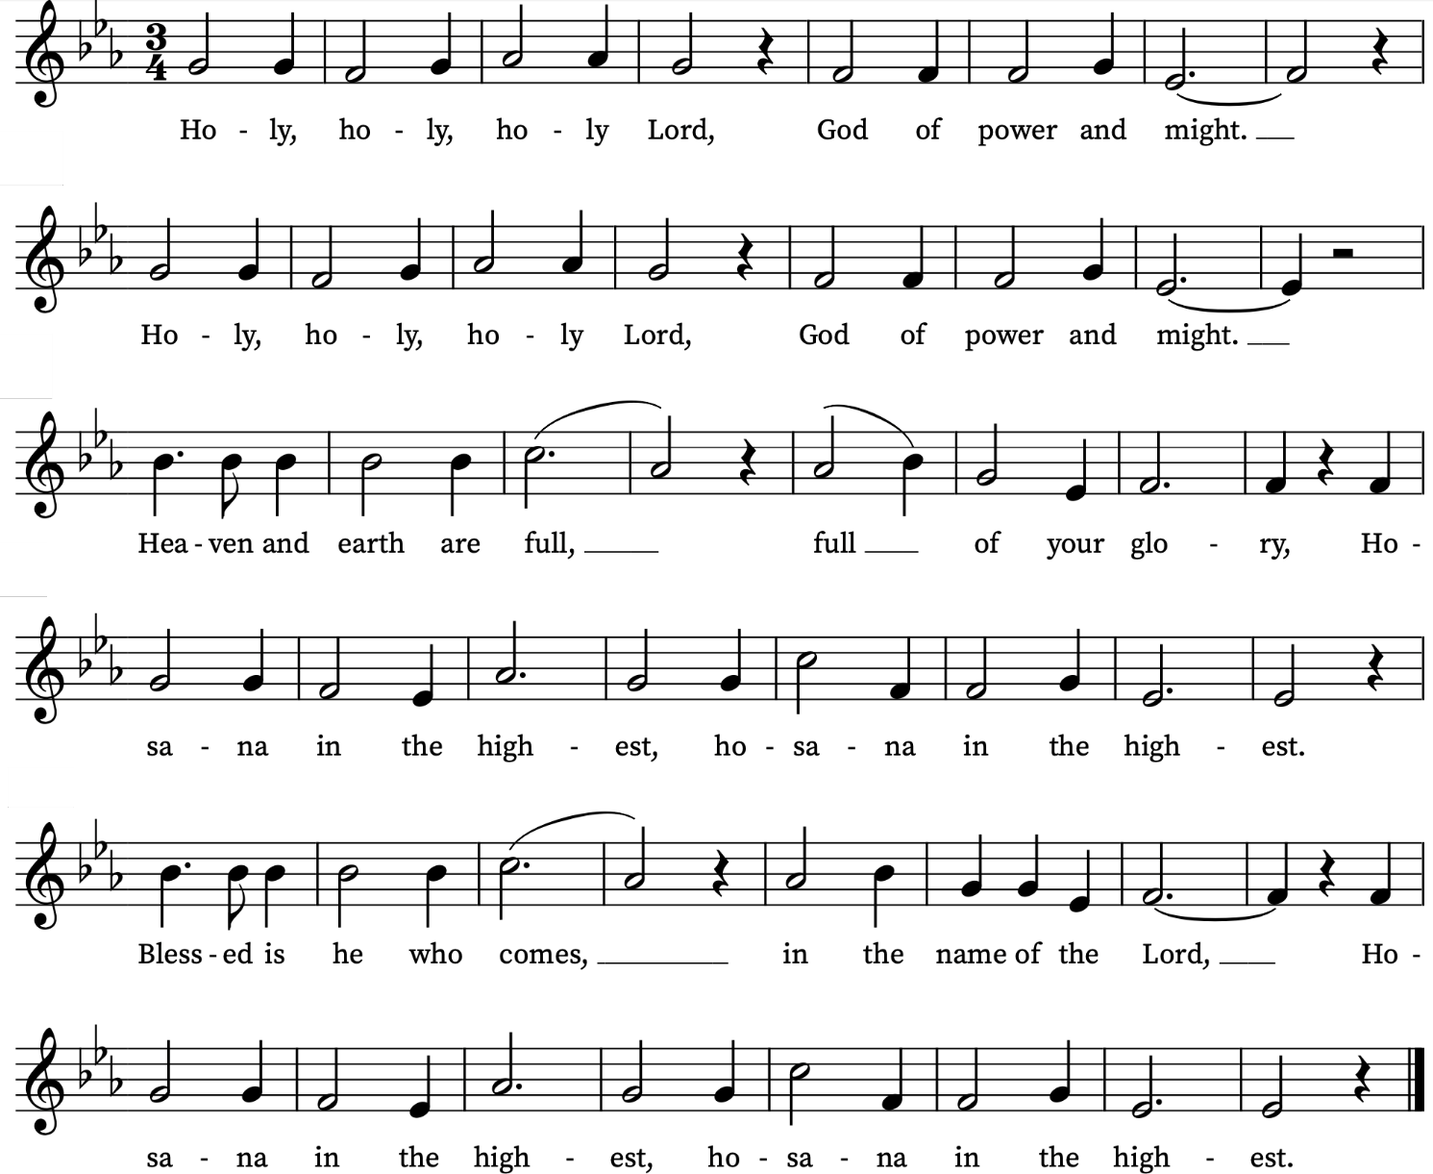
We sit or kneel

The Lord’s Prayer
Being made one by the power of the Spirit,
let us pray with confidence as our Saviour has taught us
Our Father, who art in heaven,
hallowed be thy name;
thy kingdom come;
thy will be done,
on earth as it is in heaven.
Give us this day our daily bread.
And forgive us our trespasses,
as we forgive those who trespass against us.
and lead us not into temptation;
but deliver us from evil.
For thine is the kingdom,
the power and the glory,
for ever and ever. Amen.
Breaking of the Bread
Revd Simon breaks the consecrated bread.
We break this bread to share in the body of Christ.
Though we are many, we are one body, because we all share in one bread.

Agnus Dei
We all sing the Agnus Dei from Schubert’s German Mass
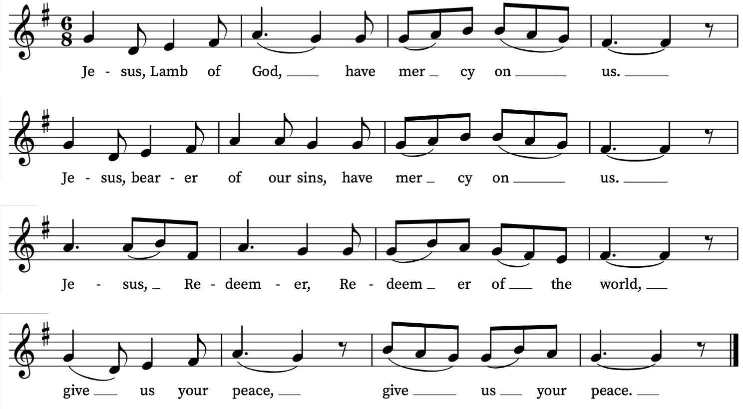
Giving of Communion
Revd Simon says:
God’s holy gifts for God’s holy people.
Jesus Christ is holy, Jesus Christ is Lord, to the glory of God the Father.

Distribution of Communion
Everyone is invited to receive the sacrament or a blessing after which we reply Amen.
The young people admitted to communion come forward to receive first.
Please come forward as directed by a welcomer. If you need communion brought to you, please let a welcomer know. If you would like to receive a blessing rather than communion, please bow your head.
Please let a welcomer know if you need a gluten-free wafer.
We are offering communion in both kinds, the bread (wafer) and the wine (in the cup or chalice). If you would prefer not to receive the wine from the chalice/cup please bow your head or simply leave the altar rail after receiving the wafer. Please do not intinct (dip your wafer in the chalice).
Please return to your seats via the side chapels.
During the administration of Communion the choir will sing the following anthem
Behold the tabernacle of God – William Harris
Behold, the tabernacle of God is with men,
and the Spirit of God dwelleth within you;
for the temple of God is holy.
Which temple you are: for the love of whom you do this day
celebrate the joys of the temple with a season of festivity.
Alleluia.
Prayer after Communion
Revd Simon prays:
God of our pilgrimage,
you have led us to the living water:
refresh and sustain us
as we go forward on our journey,
in the name of Jesus Christ our Lord. Amen.
We all pray:

Almighty God,
we thank you for feeding us
with the body and blood of your Son, Jesus Christ.
Through him we offer you our souls and bodies
to be a living sacrifice.
Send us out
in the power of your Spirit
to live and work
to your praise and glory.
Amen.
Notices
We stand to sing
Final Hymn
Praise the Lord! ye heav'ns adore him;
praise him angels, in the height;
sun and moon, rejoice before him;
praise him, all ye stars of light.
Praise the Lord! for he has spoken;
worlds his mighty voice obeyed;
laws which never shall be broken
for their guidance he has made.
Praise the Lord! for he is glorious;
never shall his promise fail;
God has made his saints victorious;
sin and death shall not prevail.
Praise the God of our salvation!
hosts on high his pow'r proclaim;
heav'n, and earth, and all creation,
laud and magnify his name.
Words: Foundling Hospital Collection, c. 1796 (Psalm 148)
Music: Austria - Josef Haydn (1732-1809)
Commission
The young people admitted to communion come forward and re-light their candles. Revd Simon says:
God has touched us with his love
and nourished us at his table.
As God’s pilgrim people,
may we continue to explore the Way of Christ,
and grow in friendship with God,
in love for his people,
and in serving others.
The young people admitted to communion lead the following response:
To a troubled world
peace from Christ.
To a searching world
love from Christ.
To a waiting world
hope from Christ.
Blessing
Revd Simon gives the Blessing.
The Spirit of truth lead you into all truth,
give you grace to confess that Jesus Christ is Lord,
and strengthen you to proclaim the word and works of God;
and the blessing of God almighty,
the Father, the Son, and the Holy Spirit,
be with you and remain with you always. Amen.

We are sent out with these words:
Go in peace to love and serve the Lord
In the name of Christ. Amen
The organ voluntary is played as the choir, servers, young people admitted to communion and clergy depart:
Tuba Tune in D major – C.S. Lang
You are welcome to remain to listen or to leave quietly.
If you would like to pray with someone after the service, one of our clergy or a lay minister will be available in the South Chapel. You are welcome to ask for prayer for wholeness and healing, personal circumstances, or anything else that is on your heart. The St Alfege Chapel is available for private prayer and lighting candles.

Please join us in the hall for tea and coffee after the service

Material used in this service comes from Common Worship © The Archbishops’ Council, 2000.
Photograph: David McEvoy

Prayers for the week
We pray for those being admitted to Communion today: Chidimma, Alba, Morolake, Tobias, Tamilore, and Ethan.
We pray for those in need: Bill Essex, William Higginson, Susan and Anthony Holland, Carole Hubble, Marion Kokott, James Markham, Sara Mauleverer, Lylian Meira, Vernon Mustoe, Nicola Orme, Jean Smith, Geoff Staden, Tina Stanley, and Pauline Youll.
We remember those who have died recently, including George Bancroft, Delroy Donegal, Chris Hanson-Abbott, Mary Kinnison, Luis Segui Gimeno, and Pontso Monareng. We ask God’s comfort on all mourning the loss of loved ones.
If you wish to add names to the prayers for those in need or departed please contact David McEvoy dmcevoy@btinternet.com

Services this week
Sunday 12 July Sixth Sunday after Trinity
8.00am Holy Communion (BCP)
10.00am All Age Eucharist with Admission to Communion
Monday 13 July
8.30am Morning Prayer
Tuesday 14 July
8.30am Morning Prayer
Wednesday 15 July
8.30am Morning Prayer
Thursday 16 July
8.00am Holy Communion
Sunday 19 July Seventh Sunday after Trinity
8.00am Holy Communion (BCP)
10.00am Sung Eucharist.

Walk-In Wednesdays
Every Wednesday 10am to 12noon in the Frank Smith Room in the hall. Drop in for a cuppa and a chat.

Welcome to Children's Church!
Join us on Sundays in the Church Hall for a morning of fun, friendship, and faith! All families with children are welcome. We ask that a parent or carer accompanies their child/children.
Activities include:
- Bible stories;
- praying together;
- sing-along songs;
- creative crafts;
- Holy Communion together.
Our usual schedule is:
- Registration from 9.55 to 10.05;
- Worship from 10.05 to 10.15;
- Bible Time from 10.15 to 10.35;
- Fun Activities from 10.35 to 11.00.
For more details please speak to Alison Wood or Moira Searle. Please check the Children’s Church board at the back of church and chat to them in the Hall over tea/coffee after the service. Alternatively contact the church office: office@st-alfege.org.uk or 020 8853 0687.

Supporting St Alfege Church
Please do make a gift to support the life and ministry of St Alfege Church –during the collection in the service or by using our card reader at the North and West Doors. Please complete a Gift Aid envelope (if you are eligible) whether you donate by cash or card. You can also use this QR code to donate. It costs £7,300 per week to run St Alfege Church.
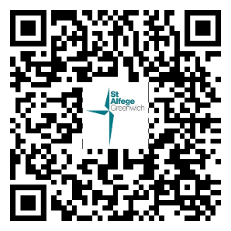
Find out more
You can find details of our regular services and our Church on our website: www.st-alfege.org.uk
Vicar: Revd Simon Winn
Curate: Revd Dr Tati Gutteridge (on maternity leave)
Church Office: office@st-alfege.org.uk
020 8853 0687 www.st-alfege.org.uk

Please take this order of service home with you today

