
x

Sung Eucharist
Fifth Sunday after Trinity
5 July 2026
Welcome to our services of Holy Communion. Revd Simon Winn is presiding at 8am and 10am. We welcome Rowena Worthington from Embrace the Middle East as preacher at both services. Children’s Church meet in the hall at 10am.
Readings
Zechariah 9: 9-12
Psalm 145: 8-15
Romans 7: 15-25a
Matthew 11: 16-19, 25-30
Hymns
64 All ye who seek for sure relief
143 Jesus shall reign where’er the sun
105 All creatures of our God and King (omit verses 4 & 6)
246 Just as I am, without one plea
Collect
Almighty and everlasting God, by whose Spirit the whole body of the Church is governed and sanctified: hear our prayer which we offer for all your faithful people, that in their vocation and ministry they may serve you in holiness and truth to the glory of your name; through our Lord and Saviour Jesus Christ, who is alive and reigns with you, in the unity of the Holy Spirit, one God, now and for ever. Amen
Prayer after Communion
Grant, O Lord, we beseech you, that the course of this world may be so peaceably ordered by your governance, that your Church may joyfully serve you in all godly quietness; through Jesus Christ our Lord. Amen
Kyrie
We join in singing the Kyrie from Schubert’s German Mass:
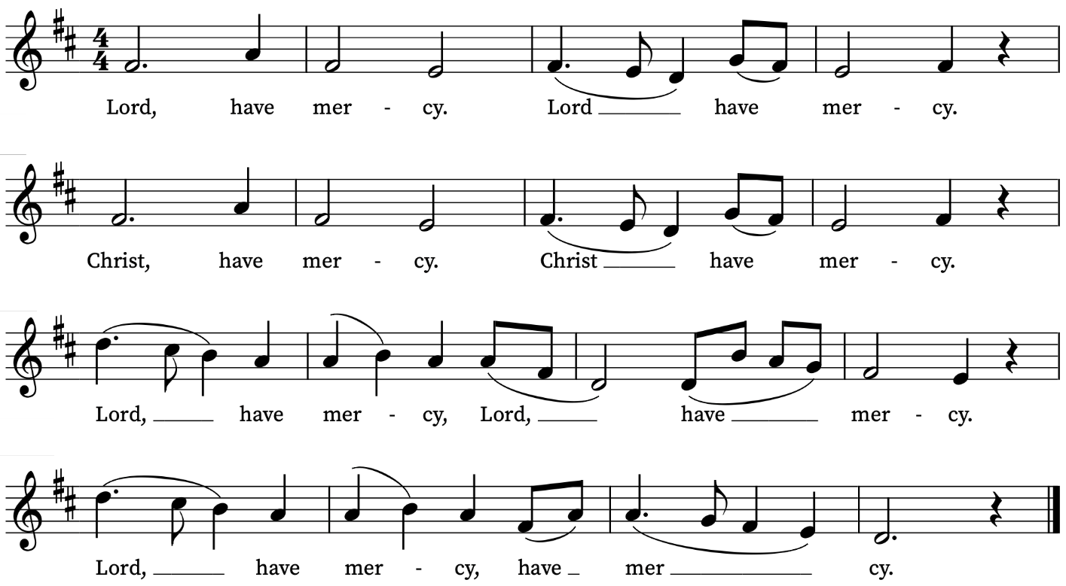
First Reading
Zechariah 9: 9-12
A reading from the Prophet Zechariah
Rejoice greatly, O daughter Zion!
Shout aloud, O daughter Jerusalem!
Lo, your king comes to you;
triumphant and victorious is he,
humble and riding on a donkey,
on a colt, the foal of a donkey.
He will cut off the chariot from Ephraim
and the warhorse from Jerusalem;
and the battle-bow shall be cut off,
and he shall command peace to the nations;
his dominion shall be from sea to sea,
and from the River to the ends of the earth.
As for you also, because of the blood of my covenant with you,
I will set your prisoners free from the waterless pit.
Return to your stronghold, O prisoners of hope;
today I declare that I will restore to you double.
This is the Word of the Lord
Thanks be to God
Psalm 145: 8-14
8 The Lord is gracious and merciful : long-suffering and of great goodness.
9 The Lord is loving unto every man : and his mercy is over all his works.
10 All thy works praise thee, O Lord : and thy saints give thanks unto thee.
11 They shew the glory of thy kingdom : and talk of thy power;
12 That thy power, thy glory, and mightiness of thy kingdom : might be known unto men.
13 Thy kingdom is an everlasting kingdom : and thy dominion endureth throughout all ages.
14 The Lord upholdeth all such as fall : and lifteth up all those that are down.

Second Reading
Romans 7: 15-25a
A reading from Paul’s Letter to the Romans
I do not understand my own actions. For I do not do what I want, but I do the very thing I hate. Now if I do what I do not want, I agree that the law is good. But in fact it is no longer I that do it, but sin that dwells within me. For I know that nothing good dwells within me, that is, in my flesh. I can will what is right, but I cannot do it. For I do not do the good I want, but the evil I do not want is what I do. Now if I do what I do not want, it is no longer I that do it, but sin that dwells within me.
So I find it to be a law that when I want to do what is good, evil lies close at hand. For I delight in the law of God in my inmost self, but I see in my members another law at war with the law of my mind, making me captive to the law of sin that dwells in my members. Wretched man that I am! Who will rescue me from this body of death? Thanks be to God through Jesus Christ our Lord!
This is the Word of the Lord
Thanks be to God

Gospel Reading
Matthew 11: 16-19, 25-30
Hear the Gospel of our Lord Jesus Christ according to Matthew
Glory be to thee, O Lord
Jesus said, ‘But to what will I compare this generation? It is like children sitting in the market-places and calling to one another,
“We played the flute for you, and you did not dance;
we wailed, and you did not mourn.”
For John came neither eating nor drinking, and they say, “He has a demon”; the Son of Man came eating and drinking, and they say, “Look, a glutton and a drunkard, a friend of tax-collectors and sinners!” Yet wisdom is vindicated by her deeds.’
At that time Jesus said, ‘I thank you, Father, Lord of heaven and earth, because you have hidden these things from the wise and the intelligent and have revealed them to infants; yes, Father, for such was your gracious will. All things have been handed over to me by my Father; and no one knows the Son except the Father, and no one knows the Father except the Son and anyone to whom the Son chooses to reveal him.
‘Come to me, all you that are weary and are carrying heavy burdens, and I will give you rest. Take my yoke upon you, and learn from me; for I am gentle and humble in heart, and you will find rest for your souls. For my yoke is easy, and my burden is light.’
This is the Gospel of the Lord
Praise be to thee, O Christ

Today’s Music
Mass setting: Missa O Quam Gloriosum – T.L. de Victoria
Anthem
Rejoice in the Lord alway – Henry Purcell
Rejoice in the Lord alway: and again I say, Rejoice.
Let your moderation be known unto all men. The Lord is at hand.
Be careful for nothing;
but in ev’rything by prayer and supplication with thanksgiving
let your requests be made known unto God.
And the peace of God, which passeth all understanding,
shall keep your hearts and minds through Jesus Christ our Lord.
Philippians 4:4-7
Communion
Agnus Dei from Missa O Quam Gloriosum – T.L. de Victoria
O salutaris hostia – Edward Elgar
O salutaris hostia  Que celli pandis ostium  Bella premunt hostilia  Da robur fer auxilium  Uni trinoque domino  Sit sempiterna gloria  Qui vitam sine termino  Nobis donet in patria. Amen. | O Saving Victim opening wide  The gate of heaven to all below.  Our foes press on from every side;  Thine aid supply, Thy strength bestow  To Thy great name be endless praise  Immortal Godhead, One in Three;  Oh, grant us endless length of days,  In our true native land with Thee. Amen
Organ Postlude
Fantasia BWV 562 – J.S. Bach

Prayers for the week
We pray for those in need: Bill Essex, William Higginson, Susan and Anthony Holland, Carole Hubble, Marion Kokott, James Markham, Sara Mauleverer, Lylian Meira, Vernon Mustoe, Nicola Orme, Jean Smith, Geoff Staden, Tina Stanley, and Pauline Youll.
We remember those who have died recently, including Joe Bennett, George Bancroft, Joel Coleman, Delroy Donegal (praying for his wife Pat and all his family), Chris Hanson-Abbott, Mary Kinnison, Luis Segui Gimeno, Bruno Michel, and Pontso Monareng. We remember Patricia Norris on her year’s mind. We ask God’s comfort on all mourning the loss of loved ones.
If you wish to add names to the prayers for those in need or departed please contact David McEvoy dmcevoy@btinternet.com
Supporting St Alfege Church
Please do make a gift to support the life and ministry of St Alfege Church – during the collection in the service or by using a card reader at the North and West Doors. Please complete a Gift Aid envelope (if you are eligible) whether you donate by cash or card. You can also use this QR code to donate.  Abide  Please do join us for our Abide service at 5.30pm this evening. Abide is a contemplative service with music in the Taizé tradition. | 
Services this week
Sunday 5 July Fifth Sunday after Trinity
8am Holy Communion (Book of Common Prayer)
10am Sung Eucharist
5.30pm Abide, a contemplative service with music from the Taizé tradition
Monday 6 July
8.30am Morning Prayer
Tuesday 7 July
8.30am Morning Prayer
Wednesday 8 July
8.30am Morning Prayer
Thursday 9 July
8am Holy Communion
Sunday 12 July Sixth Sunday after Trinity
8am Holy Communion (Book of Common Prayer)
10am All Age Eucharist with Admission to Holy Communion

Walk-in Wednesdays
Every Wednesday 10am-12noon in the small hall
Contact us
Vicar: Revd Simon Winn
Curate: Revd Dr Tati Gutteridge (on maternity leave)
Church Office: 020 8853 0687
Email: office@st-alfege.org.uk Website: www.st-alfege.org.uk
Safeguarding Team
Karen Hansen Lead Safeguarding Officer 07866 932 894
Carole Moses Safeguarding Officer 07889 396 671
Irene Bishop Safeguarding Officer 020 8698 2658
safeguarding@st-alfege.org.uk

