
x

Sung Eucharist
Fourth Sunday after Trinity
28 June 2026
Welcome to our services of Holy Communion. We welcome Revd Dr John Philpott-Howard as president and preacher at the 8am and 10am services. Children’s Church members join us for the service at 10am.
Readings
Jeremiah 28: 5-9
Psalm 89: 1-4, 15-18
Romans 6: 12-23
Matthew 10: 40-42
Hymns
99 O God, our help in ages past
249 Take my life, and let it be
118 Firmly I believe and truly
184 Jerusalem the golden
Collect
O God, the protector of all who trust in you, without whom nothing is strong, nothing is holy: increase and multiply upon us your mercy; that with you as our ruler and guide, we may so pass through things temporal that we lose not our hold on things eternal; grant this, heavenly Father, for our Lord Jesus Christ’s sake, who is alive and reigns with you, in the unity of the Holy Spirit, one God, now and for ever. Amen
Prayer after Communion
Eternal God, comfort of the afflicted and healer of the broken,
you have fed us at the table of life and hope: teach us the ways of gentleness and peace, that all the world may acknowledge the kingdom of your Son Jesus Christ our Lord.
Amen
Kyrie
We join in singing the Kyrie from Schubert’s German Mass:
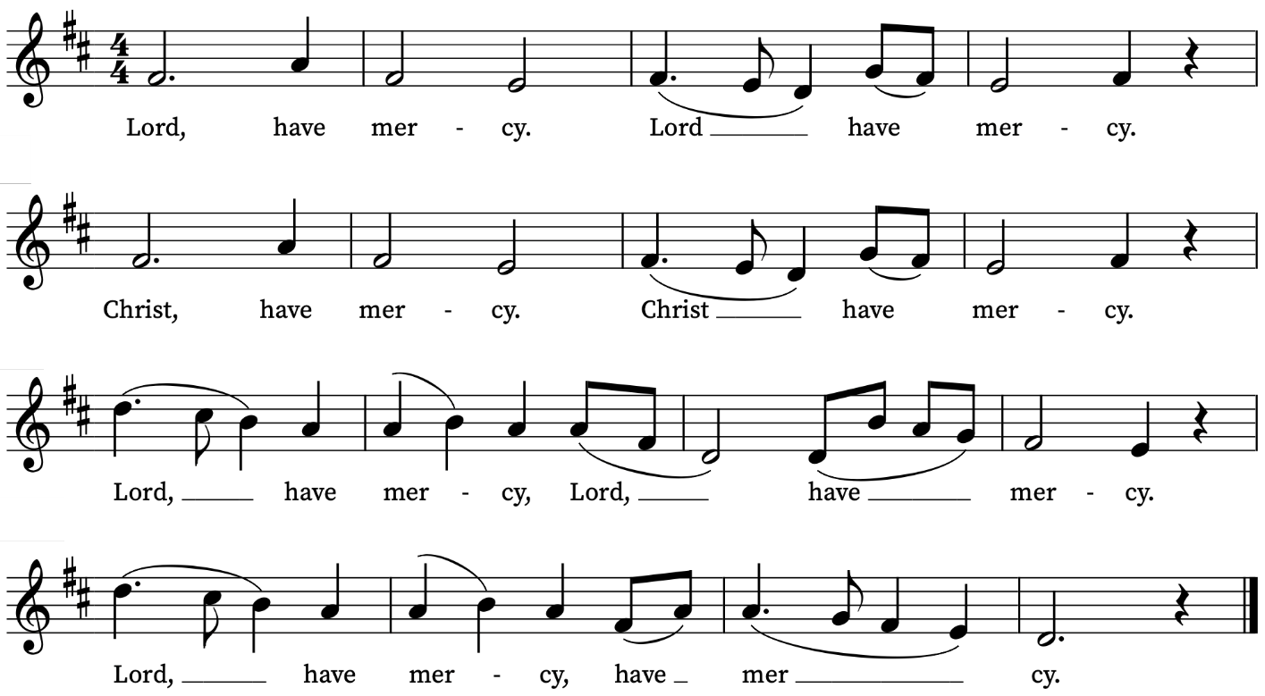
First Reading
Jeremiah 28: 5-9
A reading from the Prophet Jeremiah
Then the prophet Jeremiah spoke to the prophet Hananiah in the presence of the priests and all the people who were standing in the house of the Lord; and the prophet Jeremiah said, ‘Amen! May the Lord do so; may the Lord fulfil the words that you have prophesied, and bring back to this place from Babylon the vessels of the house of the Lord, and all the exiles. But listen now to this word that I speak in your hearing and in the hearing of all the people. The prophets who preceded you and me from ancient times prophesied war, famine, and pestilence against many countries and great kingdoms. As for the prophet who prophesies peace, when the word of that prophet comes true, then it will be known that the Lord has truly sent the prophet.’
This is the Word of the Lord
Thanks be to God
Psalm 89: 1-4, 16-19
Misericordias Domini
My song shall be alway of the loving-kindness of the Lord : with my mouth will I ever be shewing thy truth from one generation to another.
2 For I have szzaid, Mercy shall be set up for ever : thy truth shalt thou stablish in the heavens.
3 I have made a covenant with my chosen : I have sworn unto David my servant;
4 Thy seed will I stablish for ever : and set up thy throne from one generation to another.
16 Blessed is the people, O Lord, that can rejoice in thee : they shall walk in the light of thy countenance.
17 Their delight shall be daily in thy Name : and in thy righteousness shall they make their boast.
18 For thou art the glory of their strength : and in thy loving-kindness thou shalt lift up our horns.
19 For the Lord is our defence : the Holy One of Israel is our King.
Second Reading
Romans 6: 12-23
A reading from Paul’s Letter to the Romans
Therefore, do not let sin exercise dominion in your mortal bodies, to make you obey their passions. No longer present your members to sin as instruments of wickedness, but present yourselves to God as those who have been brought from death to life, and present your members to God as instruments of righteousness. For sin will have no dominion over you, since you are not under law but under grace.
What then? Should we sin because we are not under law but under grace? By no means! Do you not know that if you present yourselves to anyone as obedient slaves, you are slaves of the one whom you obey, either of sin, which leads to death, or of obedience, which leads to righteousness? But thanks be to God that you, having once been slaves of sin, have become obedient from the heart to the form of teaching to which you were entrusted, and that you, having been set free from sin, have become slaves of righteousness. I am speaking in human terms because of your natural limitations. For just as you once presented your members as slaves to impurity and to greater and greater iniquity, so now present your members as slaves to righteousness for sanctification.
When you were slaves of sin, you were free in regard to righteousness. So what advantage did you then get from the things of which you now are ashamed? The end of those things is death. But now that you have been freed from sin and enslaved to God, the advantage you get is sanctification. The end is eternal life. For the wages of sin is death, but the free gift of God is eternal life in Christ Jesus our Lord.
This is the Word of the Lord
Thanks be to God

Gospel Reading
Matthew 10: 40-42
Hear the Gospel of our Lord Jesus Christ according to Matthew
Glory be to thee, O Lord
‘Whoever welcomes you welcomes me, and whoever welcomes me welcomes the one who sent me. Whoever welcomes a prophet in the name of a prophet will receive a prophet’s reward; and whoever welcomes a righteous person in the name of a righteous person will receive the reward of the righteous; and whoever gives even a cup of cold water to one of these little ones in the name of a disciple—truly I tell you, none of these will lose their reward.’
This is the Gospel of the Lord
Praise be to thee, O Christ
Today’s Music
Mass setting: Communion service in A flat – Basil Harwood
Anthem
Greater love – John Ireland
Many waters cannot quench love, neither can the floods drown it. Love is strong as death.
Greater love hath no man than this - that a man lay down his life for his friends. Who his own self bare our sins in his own body on the tree, that we, being dead to sins, should live unto righteousness.
Ye are washed, ye are sanctified, ye are justified in the name of the Lord Jesus. Ye are a chosen generation, a royal priesthood, a holy nation, that ye should shew forth the praises of him who hath called you out of darkness into his marvellous light.
I beseech you, brethren, by the mercies of God, that ye present your bodies a living sacrifice, holy, acceptable unto God, which is your service.
Song of Solomon 8:7,6; John 15:13; 1 Peter 2:24; 1 Corinthians 6:11; 1 Peter 2:9; Romans 12:1
Communion
Agnus Dei from Communion Service in A flat – Basil Harwood
O salutaris hostia – Thomas Tallis
O salutaris hostia
Que celli pandis ostium
Bella premunt hostilia
Da robur fer auxilium
Uni trinoque domino
Sit sempiterna gloria
Qui vitam sine termino
Nobis donet in patria. Amen.
O Saving Victim opening wide
The gate of heaven to all below.
Our foes press on from every side;
Thine aid supply, Thy strength bestow
To Thy great name be endless praise
Immortal Godhead, One in Three;
Oh, grant us endless length of days,
In our true native land with Thee. Amen.
Organ Postlude
Processional – Frank Bridge
Prayers for the week
We pray for those in need: Delroy Donegal, Bill Essex, William Higginson, Susan and Anthony Holland, Carole Hubble, Marion Kokott, James Markham, Sara Mauleverer, Lylian Meira, Vernon Mustoe, Nicola Orme, Jean Smith, Tina Stanley, and Pauline Youll.
We remember those who have died recently, including Joe Bennett, George Bancroft, Joel Coleman, Mary Kinnison, Jana Georgieva, Luis Segui Gimeno, Bruno Michel, Pontso Monareng, Peter Saunders and Richard Winn. We also remember Stephen Caruso on his first year’s mind. We ask God’s comfort on all mourning the loss of loved ones.
If you wish to add names to the prayers for those in need or departed please contact David McEvoy dmcevoy@btinternet.com
Supporting St Alfege Church
Please do make a gift to support the life and ministry of St Alfege Church – during the collection in the service or by using a card reader at the North and West Doors. Please complete a Gift Aid envelope (if you are eligible) whether you donate by cash or card. You can also use this QR code to donate.  Choral Evensong  Join us for Choral Evensong this evening at 4pm. Led by Revd Mark Hatcher with music by Bairstow, Bullock, Smith, Stanford, and Clemens non Papa. | 
Services this week
Sunday 28 June Fourth Sunday after Trinity
8am Holy Communion (Book of Common Prayer)
10am Sung Eucharist
4.00pm Choral Evensong
Monday 29 June
8.30am Morning Prayer
Tuesday 30 June
8.30am Morning Prayer
Wednesday 1 July
8.30am Morning Prayer
Thursday 2 July
8am Holy Communion
Sunday 5 July Fifth Sunday after Trinity
8am Holy Communion (Book of Common Prayer)
10am Sung Eucharist
5.30pm Abide, a contemplative service with music from the Taizé tradition.
Walk-in Wednesdays
Every Wednesday 10am-12noon in the small hall
Contact us
Vicar: Revd Simon Winn
Curate: Revd Dr Tati Gutteridge (on maternity leave)
Church Office: 020 8853 0687
Email: office@st-alfege.org.uk Website: www.st-alfege.org.uk
Safeguarding Team
Karen Hansen Lead Safeguarding Officer 07866 932 894
Carole Moses Safeguarding Officer 07889 396 671
Irene Bishop Safeguarding Officer 020 8698 2658
safeguarding@st-alfege.org.uk

