

Sung Eucharist
Third Sunday after Trinity
21 June 2026
Welcome to our services of Holy Communion. Revd Dr Robert Tobin is presiding and preaching at 8am. Revd Simon Winn, Vicar, is presiding and preaching at 10am. Children’s Church meet in the hall at 10am.
Readings
Jeremiah 20: 7-13
Psalm 69: 14-20
Romans 6: 1b-11
Matthew 10: 24-39
Hymns
220 Fight the good fight with all thy might
224 Lead us, heavenly Father, lead us
230 O for a heart to praise my God
117 Praise to the Holiest in the height
Collect
Almighty God, you have broken the tyranny of sin and have sent the Spirit of your Son into our hearts whereby we call you Father: give us grace to dedicate our freedom to your service,
that we and all creation may be brought to the glorious liberty of the children of God; through Jesus Christ your Son our Lord, who is alive and reigns with you, in the unity of the Holy Spirit, one God, now and for ever. Amen
Prayer after Communion
O God, whose beauty is beyond our imagining and whose power we cannot comprehend: show us your glory as far as we can grasp it, and shield us from knowing more than we can bear until we may look upon you without fear; through Jesus Christ our Saviour. Amen
Kyrie
We join in singing the Kyrie from Schubert’s German Mass:
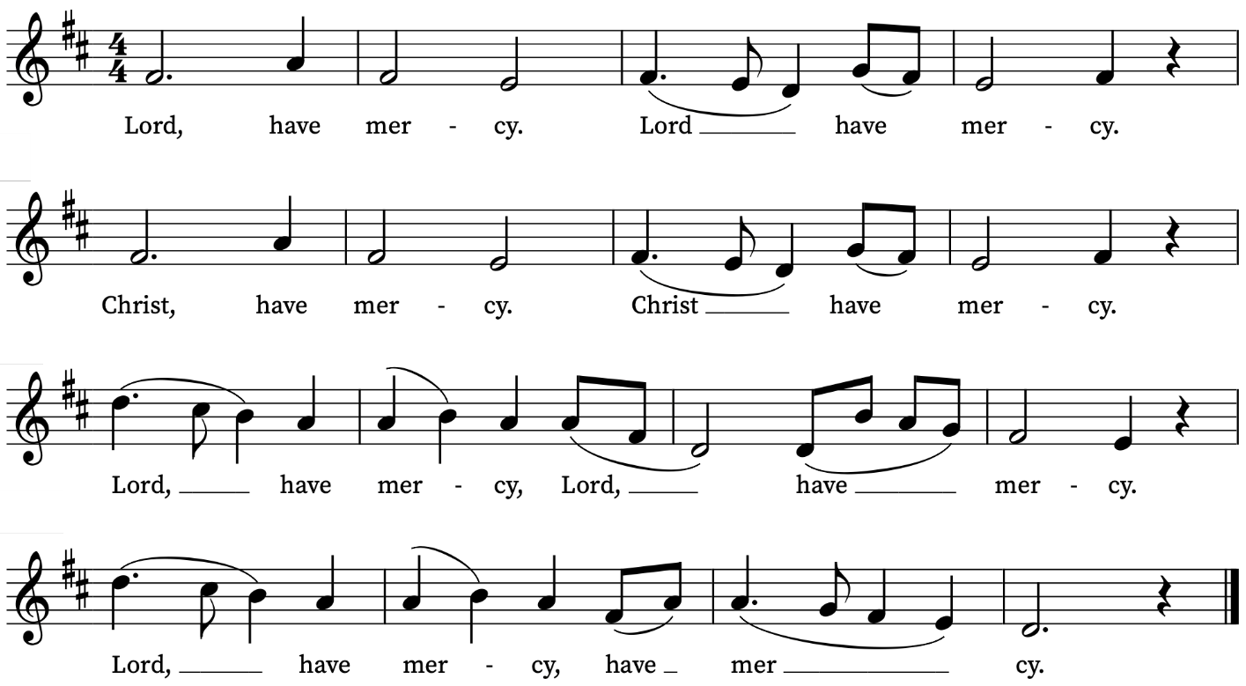
First Reading
Jeremiah 20: 7-13
A reading from the Prophet Jeremiah
O Lord, you have enticed me,
and I was enticed;
you have overpowered me,
and you have prevailed.
I have become a laughing-stock all day long;
everyone mocks me.
For whenever I speak, I must cry out,
I must shout, ‘Violence and destruction!’
For the word of the Lord has become for me
a reproach and derision all day long.
If I say, ‘I will not mention him,
or speak any more in his name’,
then within me there is something like a burning fire
shut up in my bones;
I am weary with holding it in,
and I cannot.
For I hear many whispering:
‘Terror is all around!
Denounce him! Let us denounce him!’
All my close friends
are watching for me to stumble.
‘Perhaps he can be enticed,
and we can prevail against him,
and take our revenge on him.’
But the Lord is with me like a dread warrior;
therefore my persecutors will stumble,
and they will not prevail.
They will be greatly shamed,
for they will not succeed.
Their eternal dishonour
will never be forgotten.
O Lord of hosts, you test the righteous,
you see the heart and the mind;
let me see your retribution upon them,
for to you I have committed my cause.
Sing to the Lord;
praise the Lord!
For he has delivered the life of the needy
from the hands of evildoers.
This is the Word of the Lord
Thanks be to God
Psalm 69: 13-19
13 But, Lord, I make my prayer unto thee : in an acceptable time.
14 Hear me, O God, in the multitude of thy mercy : even in the truth of thy salvation.
15 Take me out of the mire, that I sink not : O let me be delivered from them that hate me, and out of the deep waters.
16 Let not the water-flood drown me, neither let the deep swallow me up : and let not the pit shut her mouth upon me.
17 Hear me, O Lord, for thy loving-kindness is comfortable : turn thee unto me according to the multitude of thy mercies.
18 And hide not thy face from thy servant, for I am in trouble : O haste thee, and hear me.
19 Draw nigh unto my soul, and save it : O deliver me, because of mine enemies.
Second Reading
Romans 6: 1b-11
A reading from Paul’s Letter to the Romans
Should we continue in sin in order that grace may abound? By no means! How can we who died to sin go on living in it? Do you not know that all of us who have been baptized into Christ Jesus were baptized into his death? Therefore we have been buried with him by baptism into death, so that, just as Christ was raised from the dead by the glory of the Father, so we too might walk in newness of life.
For if we have been united with him in a death like his, we will certainly be united with him in a resurrection like his. We know that our old self was crucified with him so that the body of sin might be destroyed, and we might no longer be enslaved to sin. For whoever has died is freed from sin. But if we have died with Christ, we believe that we will also live with him. We know that Christ, being raised from the dead, will never die again; death no longer has dominion over him. The death he died, he died to sin, once for all; but the life he lives, he lives to God. So you also must consider yourselves dead to sin and alive to God in Christ Jesus.
This is the Word of the Lord
Thanks be to God
Gospel Reading
Matthew 10: 24-39
Hear the Gospel of our Lord Jesus Christ according to Matthew
Glory be to thee, O Lord
Jesus said: ‘A disciple is not above the teacher, nor a slave above the master; it is enough for the disciple to be like the teacher, and the slave like the master. If they have called the master of the house Beelzebul, how much more will they malign those of his household!
‘So have no fear of them; for nothing is covered up that will not be uncovered, and nothing secret that will not become known. What I say to you in the dark, tell in the light; and what you hear whispered, proclaim from the housetops. Do not fear those who kill the body but cannot kill the soul; rather fear him who can destroy both soul and body in hell. Are not two sparrows sold for a penny? Yet not one of them will fall to the ground unperceived by your Father. And even the hairs of your head are all counted. So do not be afraid; you are of more value than many sparrows.
‘Everyone therefore who acknowledges me before others, I also will acknowledge before my Father in heaven; but whoever denies me before others, I also will deny before my Father in heaven.
‘Do not think that I have come to bring peace to the earth; I have not come to bring peace, but a sword.
For I have come to set a man against his father,
and a daughter against her mother,
and a daughter-in-law against her mother-in-law;
and one’s foes will be members of one’s own household.
Whoever loves father or mother more than me is not worthy of me; and whoever loves son or daughter more than me is not worthy of me; and whoever does not take up the cross and follow me is not worthy of me. Those who find their life will lose it, and those who lose their life for my sake will find it.
This is the Gospel of the Lord
Praise be to thee, O Christ
Today’s Music
Mass setting: Missa Susanne un jour – Orlando di Lasso
Anthem
Surgens Jesus – Peter Philips
Surgens Jesus, Dominus noster stans in medio discipulorum suorum dixit: pax vobis. Alleluia.
Gavisi sunt discipuli viso Domino, Alleluia.
The risen Jesus, our Lord, standing in the midst of his disciples,
said: Peace be with you. Alleluia.
The disciples were glad when they saw the Lord. Alleluia.
John 20: 19b, 20b (from Cantiones Sacrae, 1612)
Communion
Agnus Dei from Missa Susanne un jour – Orlando di Lasso
Jesu, grant me this I pray (Gibbons) – arr. E.C. Bairstow
Jesu, grant me this, I pray
Ever in thy heart to stay;
Let me evermore abide
Hidden in thy wounded side
If the world or Satan lay
Tempting snares about my way
I am safe when I abide
In thy heart and wounded side
If the flesh, more dangerous still
Tempt my soul to deeds of ill
Naught I fear when I abide
In thy heart and wounded side
Death will come one day to me;
Jesu, cast me not from thee:
Dying let me still abide
In thy heart and wounded side
Organ Postlude
Fugue in A flat minor WoO 8 – Johannes Brahms
Prayers for the week
We pray for those in need: Delroy Donegal, Bill Essex, William Higginson, Susan and Anthony Holland, Carole Hubble, Marion Kokott, James Markham, Sara Mauleverer, Lylian Meira, Vernon Mustoe, Nicola Orme, Philip Simms, Jean Smith, Tina Stanley, and Pauline Youll.
We remember those who have died recently, including Joe Bennett, George Bancroft, Joel Coleman, Anthony Durham, Mary Kinnison, Jana Georgieva, Luis Segui Gimeno, Bruno Michel, Pontso Monareng, Peter Saunders and Richard Winn. We ask God’s comfort on all mourning the loss of loved ones.
If you wish to add names to the prayers for those in need or departed please contact David McEvoy dmcevoy@btinternet.com
Supporting St Alfege Church
Please do make a gift to support the life and ministry of St Alfege Church – during the collection in the service or by using a card reader at the North and West Doors. Please complete a Gift Aid envelope (if you are eligible) whether you donate by cash or card. You can also use this QR code to donate. | 
Services this week
Sunday 21 June Third Sunday after Trinity
8am Holy Communion (Book of Common Prayer)
10am Sung Eucharist
Monday 22 June
8.30am Morning Prayer
Tuesday 23 June
8.30am Morning Prayer
Wednesday 24 June
8.30am Morning Prayer
Thursday 25 June
Please note that there is no 8am service of Holy Communion today.
Sunday 28 June Fourth Sunday after Trinity
8am Holy Communion (Book of Common Prayer)
10am Sung Eucharist
4.00pm Choral Evensong
Walk-in Wednesdays
Every Wednesday 10am-12noon in the small hall
Contact us
Vicar: Revd Simon Winn
Curate: Revd Dr Tati Gutteridge (on maternity leave)
Church Office: 020 8853 0687
Email: office@st-alfege.org.uk Website: www.st-alfege.org.uk
Safeguarding Team
Karen Hansen Lead Safeguarding Officer 07866 932 894
Carole Moses Safeguarding Officer 07889 396 671
Irene Bishop Safeguarding Officer 020 8698 2658
safeguarding@st-alfege.org.uk

