

Sung Eucharist
Second Sunday after Trinity
14 June 2026
Welcome to our services of Holy Communion. Revd Mark Hatcher, Honorary Associate Priest, is presiding and preaching at 8am and preaching at 10am. Revd Stephen Nshimye is presiding at 10am. Revd Simon Winn is leading Children’s Church today.
Readings
Exodus 19: 2-8a
Psalm 116: 1, 10-17
Romans 5: 1-8
Matthew 9:35 – 10:8
Hymns
100 All people that on earth do dwell
233 O thou who camest from above
173 City of God, how broad and far
131 Love divine, all loves excelling
Collect
Lord, you have taught us that all our doings without love are nothing worth: send your Holy Spirit and pour into our hearts that most excellent gift of love, the true bond of peace and of all virtues, without which whoever lives is counted dead before you. Grant this for your only Son Jesus Christ’s sake, who is alive and reigns with you, in the unity of the Holy Spirit, one God, now and for ever. Amen
Prayer after Communion
Loving Father, we thank you for feeding us at the supper of your Son: sustain us with your Spirit, that we may serve you here on earth until our joy is complete in heaven, and we share in the eternal banquet with Jesus Christ our Lord. . Amen
Kyrie
We join in singing the Kyrie from Schubert’s German Mass:
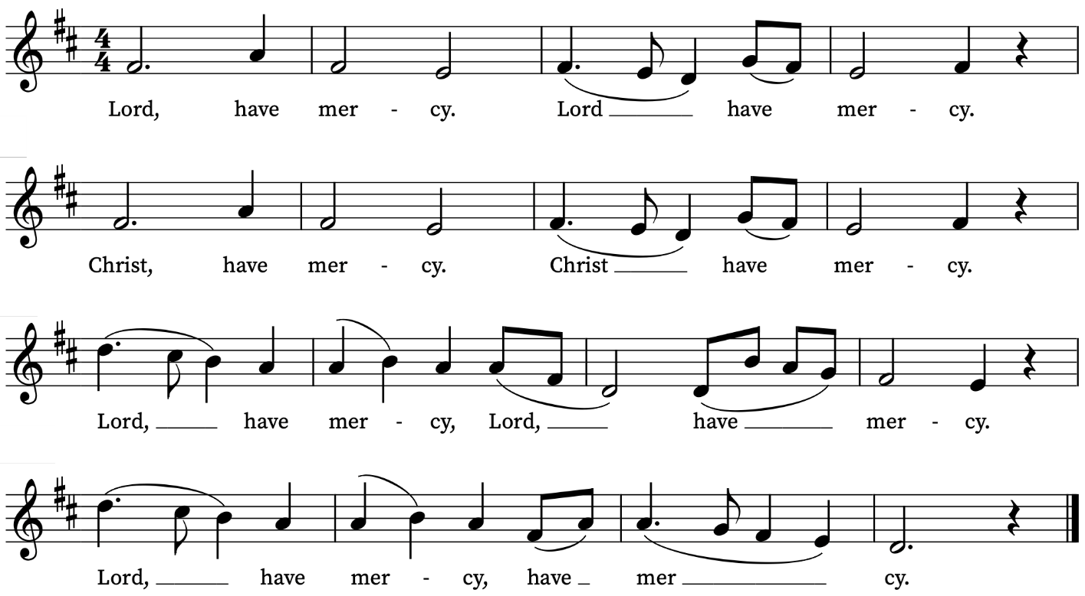
First Reading
Exodus 19: 2-8a
A reading from the Book of Exodus
They had journeyed from Rephidim, entered the wilderness of Sinai, and camped in the wilderness; Israel camped there in front of the mountain. Then Moses went up to God; the Lord called to him from the mountain, saying, ‘Thus you shall say to the house of Jacob, and tell the Israelites: You have seen what I did to the Egyptians, and how I bore you on eagles’ wings and brought you to myself. Now therefore, if you obey my voice and keep my covenant, you shall be my treasured possession out of all the peoples. Indeed, the whole earth is mine, but you shall be for me a priestly kingdom and a holy nation. These are the words that you shall speak to the Israelites.’

So Moses came, summoned the elders of the people, and set before them all these words that the Lord had commanded him. The people all answered as one: ‘Everything that the Lord has spoken we will do.’
This is the Word of the Lord
Thanks be to God
Psalm 116: 1, 11-16
Dilexi, quoniam
I am well pleased : that the Lord hath heard the voice of my prayer.
11 What reward shall I give unto the Lord : for all the benefits that he hath done unto me?
12 I will receive the cup of salvation : and call upon the Name of the Lord.
13 I will pay my vows now in the presence of all his people : right dear in the sight of the Lord is the death of his saints.
14 Behold, O Lord, how that I am thy servant : I am thy servant, and the son of thine handmaid; thou hast broken my bonds in sunder.
15 I will offer to thee the sacrifice of thanksgiving : and will call upon the Name of the Lord.
16 I will pay my vows unto the Lord, in the sight of all his people : in the courts of the Lord's house, even in the midst of thee, O Jerusalem. Praise the Lord.

Second Reading
Romans 5: 1-8
A reading from Paul’s Letter to the Romans
Therefore, since we are justified by faith, we have peace with God through our Lord Jesus Christ, through whom we have obtained access to this grace in which we stand; and we boast in our hope of sharing the glory of God. And not only that, but we also boast in our sufferings, knowing that suffering produces endurance, and endurance produces character, and character produces hope, and hope does not disappoint us, because God’s love has been poured into our hearts through the Holy Spirit that has been given to us.
For while we were still weak, at the right time Christ died for the ungodly. Indeed, rarely will anyone die for a righteous person—though perhaps for a good person someone might actually dare to die. But God proves his love for us in that while we still were sinners Christ died for us.
This is the Word of the Lord
Thanks be to God

Gospel Reading
Matthew 9:35 – 10:9
Hear the Gospel of our Lord Jesus Christ according to Matthew
Glory be to thee, O Lord
Then Jesus went about all the cities and villages, teaching in their synagogues, and proclaiming the good news of the kingdom, and curing every disease and every sickness. When he saw the crowds, he had compassion for them, because they were harassed and helpless, like sheep without a shepherd. Then he said to his disciples, ‘The harvest is plentiful, but the labourers are few; therefore ask the Lord of the harvest to send out labourers into his harvest.’
Then Jesus summoned his twelve disciples and gave them authority over unclean spirits, to cast them out, and to cure every disease and every sickness. These are the names of the twelve apostles: first, Simon, also known as Peter, and his brother Andrew; James son of Zebedee, and his brother John; Philip and Bartholomew; Thomas and Matthew the tax-collector; James son of Alphaeus, and Thaddaeus; Simon the Cananaean, and Judas Iscariot, the one who betrayed him.
These twelve Jesus sent out with the following instructions: ‘Go nowhere among the Gentiles, and enter no town of the Samaritans, but go rather to the lost sheep of the house of Israel. As you go, proclaim the good news, “The kingdom of heaven has come near.” Cure the sick, raise the dead, cleanse the lepers, cast out demons. You received without payment; give without payment.
This is the Gospel of the Lord
Praise be to thee, O Christ

Today’s Music
Mass setting: (Gloria, Sanctus/Benedictus and Agnus Dei):
Missa brevis Sancti Joannis de Deo – Joseph Haydn
Anthem
O be joyful in the Lord – Benjamin Britten
O be joyful in the Lord, all ye lands: serve the Lord with gladness, and come before his presence with a song. Be ye sure that the Lord, he is God: it is he that hath made us, and not we ourselves; we are his people, the sheep of his pasture. O go your way into his gates with thanksgiving, and into his courts with praise: be thankful unto him, and speak good of his Name. For the Lord is gracious, his mercy is everlasting: and his truth endureth from generation to generation. Glory be to the Father, and to the Son, and to the Holy Ghost; As it was in the beginning, is now, and ever shall be: world without end. Amen.
Psalm 100
Communion
Agnus Dei from Missa brevis Sancti Joannis de Deo – Joseph Haydn
Panis angelicus – César Franck
Panis angelicus  fit panis hominum;  Dat panis cœlicus  figuris terminum:  O res mirabilis!  Manducat Dominum  pauper, servus et humilis. | The bread of angels  becomes bread of men;  The bread of heaven  puts an end to all symbols:  O thing most wonderful!  The Lord becomes our food  poor, a servant, and humble.
Organ Postlude
Annunciation from Ancient Sunlight – Judith Bingham
Prayers for the week
We pray for those in need: Delroy Donegal, Bill Essex, Susan and Anthony Holland, Carole Hubble, Marion Kokott, James Markham, Sara Mauleverer, Lylian Meira, Vernon Mustoe, Nicola Orme, Philip Simms, Jean Smith, Tina Stanley, and Pauline Youll.
We remember those who have died recently, including Joe Bennett, George Bancroft, Joel Coleman, Anthony Durham, Mary Kinnison, Doreen McAree, Jana Georgieva, Luis Segui Gimeno, Bruno Michel, Peter Saunders and Richard Winn. We ask God’s comfort on all mourning the loss of loved ones.
If you wish to add names to the prayers for those in need or departed please contact David McEvoy dmcevoy@btinternet.com
Supporting St Alfege Church
Please do make a gift to support the life and ministry of St Alfege Church – during the collection in the service or by using a card reader at the North and West Doors. Please complete a Gift Aid envelope (if you are eligible) whether you donate by cash or card. You can also use this QR code to donate. | 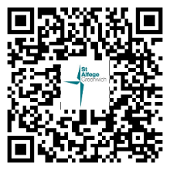
Services this week
Sunday 14 June Second Sunday after Trinity
8am Holy Communion (Book of Common Prayer)
10am Sung Eucharist
Monday 15 June
8.30am Morning Prayer
Tuesday 16 June
8.30am Morning Prayer
Wednesday 17 June
8.30am Morning Prayer
Thursday 18 June
8.00am Holy Communion
Sunday 21 June Third Sunday after Trinity
8am Holy Communion (Book of Common Prayer)
10am Sung Eucharist
Walk-in Wednesdays
Every Wednesday 10am-12noon in the small hall
Advanced Notice
There will be no service of Holy Communion at 8am on Thursday 25 November.
Contact us
Vicar: Revd Simon Winn
Curate: Revd Dr Tati Gutteridge (on maternity leave)
Church Office: 020 8853 0687
Email: office@st-alfege.org.uk Website: www.st-alfege.org.uk
Safeguarding Team
Karen Hansen Lead Safeguarding Officer 07866 932 894
Carole Moses Safeguarding Officer 07889 396 671
Irene Bishop Safeguarding Officer 020 8698 2658
safeguarding@st-alfege.org.uk

