

Sung Eucharist
Trinity Sunday
31 May 2026
Welcome to our services of Holy Communion. Revd Simon Winn, Vicar, is presiding and preaching at 8am and presiding at 10am. We welcome Natalie Walters as preacher at 10am. Natalie is head of Justice, Peace, and Integrity of Creation at the Diocese of Southwark.
Readings
Isaiah 40: 12-17, 27-31
Psalm 8
2 Corinthians 13: 11-13
Matthew 28: 16-20
Hymns
199 Immortal, invisible
94 Father, most holy
263 Lord enthroned in heavenly splendour
95 Holy, holy, holy, Lord God almighty
Collect
Almighty and everlasting God, you have given us your servants grace, by the confession of a true faith, to acknowledge the glory of the eternal Trinity and in the power of the divine majesty to worship the Unity: keep us steadfast in this faith, that we may evermore be defended from all adversities; through Jesus Christ your Son our Lord, who is alive and reigns with you, in the unity of the Holy Spirit, one God, now and for ever. Amen
Prayer after Communion
Almighty and eternal God, you have revealed yourself as Father, Son and Holy Spirit, and live and reign in the perfect unity of love: hold us firm in this faith, that we may know you in all your ways and evermore rejoice in your eternal glory,
who are three Persons yet one God, now and for ever. Amen
Kyrie
We join in singing the Kyrie from Schubert’s German Mass:
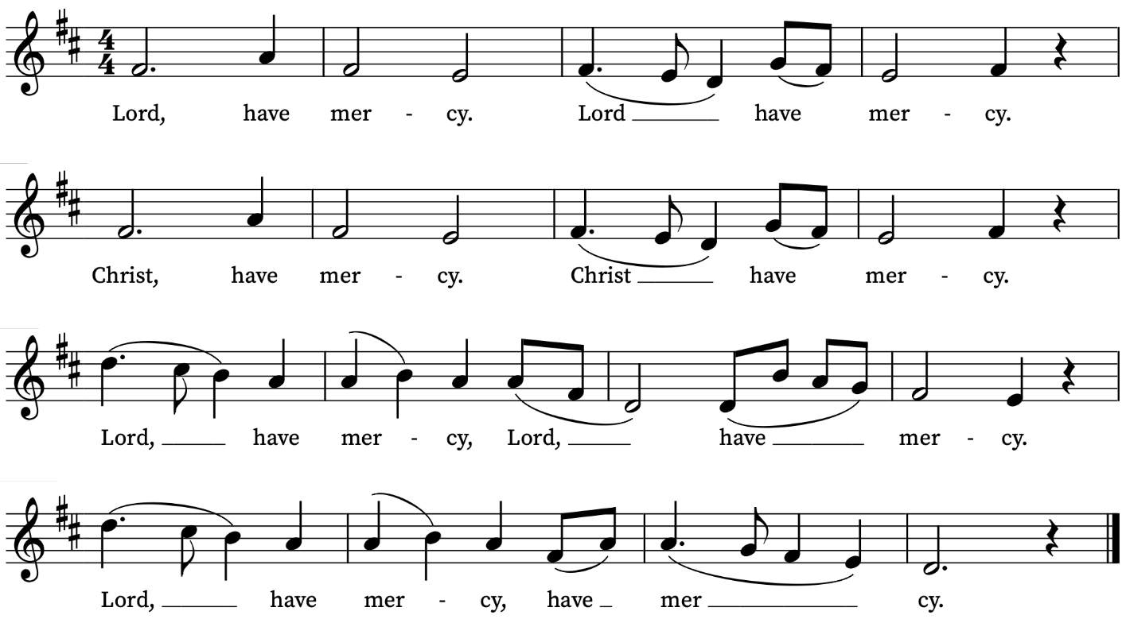
First Reading
Isaiah 40: 12-17, 27-31
A reading from the Prophet Isaiah
Who has measured the waters in the hollow of his hand
and marked off the heavens with a span,
enclosed the dust of the earth in a measure,
and weighed the mountains in scales
and the hills in a balance?
Who has directed the spirit of the Lord,
or as his counsellor has instructed him?
Whom did he consult for his enlightenment,
and who taught him the path of justice?
Who taught him knowledge,
and showed him the way of understanding?
Even the nations are like a drop from a bucket,
and are accounted as dust on the scales;
see, he takes up the isles like fine dust.
Lebanon would not provide fuel enough,
nor are its animals enough for a burnt-offering.
All the nations are as nothing before him;
they are accounted by him as less than nothing and emptiness.
Why do you say, O Jacob,
and speak, O Israel,
‘My way is hidden from the Lord,
and my right is disregarded by my God’?
Have you not known? Have you not heard?
The Lord is the everlasting God,
the Creator of the ends of the earth.
He does not faint or grow weary;
his understanding is unsearchable.
He gives power to the faint,
and strengthens the powerless.
Even youths will faint and be weary,
and the young will fall exhausted;
but those who wait for the Lord shall renew their strength,
they shall mount up with wings like eagles,
they shall run and not be weary,
they shall walk and not faint.
This is the Word of the Lord
Thanks be to God
Psalm 8
Domine, Dominus noster
O Lord our Governor, how excellent is thy Name in all the world : thou that hast set thy glory above the heavens!
2 Out of the mouth of very babes and sucklings hast thou ordained strength, because of thine enemies : that thou mightest still the enemy and the avenger.
3 For I will consider thy heavens, even the works of thy fingers : the moon and the stars, which thou hast ordained.
4 What is man, that thou art mindful of him : and the son of man, that thou visitest him?
5 Thou madest him lower than the angels : to crown him with glory and worship.
6 Thou makest him to have dominion of the works of thy hands : and thou hast put all things in subjection under his feet;
7 All sheep and oxen : yea, and the beasts of the field;
8 The fowls of the air, and the fishes of the sea : and whatsoever walketh through the paths of the seas.
9 O Lord our Governor : how excellent is thy Name in all the world!
Second Reading
2 Corinthians 13: 11-13
A reading from Paul’s Second Letter to the Corinthians
Finally, brothers and sisters, farewell. Put things in order, listen to my appeal, agree with one another, live in peace; and the God of love and peace will be with you. Greet one another with a holy kiss. All the saints greet you.
The grace of the Lord Jesus Christ, the love of God, and the communion of the Holy Spirit be with all of you.
This is the Word of the Lord
Thanks be to God

Gospel Reading
Matthew 28: 16-20
Hear the Gospel of our Lord Jesus Christ according to Matthew
Glory be to thee, O Lord
Now the eleven disciples went to Galilee, to the mountain to which Jesus had directed them. When they saw him, they worshipped him; but some doubted. And Jesus came and said to them, ‘All authority in heaven and on earth has been given to me. Go therefore and make disciples of all nations, baptizing them in the name of the Father and of the Son and of the Holy Spirit, and teaching them to obey everything that I have commanded you. And remember, I am with you always, to the end of the age.’
This is the Gospel of the Lord
Praise be to thee, O Christ
Today’s Music
Mass setting: (Gloria, Sanctus/Benedictus and Agnus Dei):
Missa Capella Regalis – Anthony Caesar
Anthem
As truly as God is our Father – William Mathias (1934-1992)
As truly as God is our Father, so just as truly is he our Mother.
In our Father, God Almighty, we have our being;
In our merciful Mother we are remade and restored.
Our fragmented lives are knit together.
And by giving and yielding ourselves, through grace,
To the Holy Spirit we are made whole.
It is I, the strength and goodness of Fatherhood.
It is I, the wisdom of Motherhood.
It is I, the light and grace of holy love.
It is I, the Trinity.
I am the sovereign goodness in all things.
It is I who teach you to love.
It is I who teach you to desire.
It is I who am the reward of all true desiring.
All shall be well, and all manner of thing shall be well. Amen.
Words: Julian of Norwich (c1342-1413)
Communion
Agnus Dei from Missa Capella Regalis – Anthony Caesar
Honor, virtus et potestas – Thomas Tallis
Honor virtus et potestas et imperium
Sit trinitati in unitate
Unitati in trinitate
In perenni saeculorum tempore
Gloria Patri et Filio et Spiritui Sancto
in perenni saeculorum tempore
Honour, power, might and dominion
be to the Trinity in Unity,
to the Unity in Trinity,
throughout everlasting ages.
Gloria Patri et Filio et Spiritui Sancto
in perenni saeculorum tempore.
Organ Postlude Prelude in E flat major BWV 552i –
J.S. Bach

Choral Evensong tonight Sunday 31 May at 4pm
Led by Peter Kinnison, Reader. With music by Messiaen, Bach, Ebdon, Sumsion, Stainer and Tournemire

Prayers for the week
We pray for those in need: Helen Delap, Dan Delap, Delroy Donegal, Bill Essex, Susan and Anthony Holland, Carole Hubble, Marion Kokott, Sara Mauleverer, Lylian Meira, Vernon Mustoe, Nicola Orme, Philip Simms, Jean Smith, Tina Stanley, and Pauline Youll.
We remember those who have died recently, including Joe Bennett, Joel Coleman, Anthony Durham, Brenda Eva (née Price), Mary Kinnison, Doreen McAree, Jana Georgieva, Luis Segui Gimeno and Richard Winn. We also remember baby Felix Holdgate on his year’s mind, asking God’s comfort on Leo and Kai. We ask God’s blessing and comfort on all mourning the loss of loved ones.
If you wish to add names to the prayers for those in need or departed please contact David McEvoy dmcevoy@btinternet.com
Supporting St Alfege Church
Please do make a gift to support the life and ministry of St Alfege Church – during the collection in the service or by using a card reader at the North and West Doors. Please complete a Gift Aid envelope (if you are eligible) whether you donate by cash or card. You can also use this QR code to donate. | 
Services this week
Sunday 31 May Trinity Sunday
8am Holy Communion (Book of Common Prayer)
10am Sung Eucharist
4.00pm Choral Evensong
Monday 1 June
8.30am Morning Prayer
Tuesday 2 June
8.30am Morning Prayer
Wednesday 3 June
8.30am Morning Prayer
Thursday 4 June
8.00am Holy Communion
Sunday 7 June First Sunday after Trinity
8am Holy Communion (Book of Common Prayer)
10am Sung Eucharist
5.30pm Abide, a contemplative service with music from the Taizé tradition. The theme will be God’s presence in the whole of creation. The service will be outdoors weather permitting.
Walk-in Wednesdays
Every Wednesday 10am-12noon in the small hall
Contact us
Vicar: Revd Simon Winn
Curate: Revd Dr Tati Gutteridge (on maternity leave)
Church Office: 020 8853 0687
Email: office@st-alfege.org.uk Website: www.st-alfege.org.uk
Safeguarding Team
Karen Hansen Lead Safeguarding Officer 07866 932 894
Carole Moses Safeguarding Officer 07889 396 671
Irene Bishop Safeguarding Officer 020 8698 2658
safeguarding@st-alfege.org.uk

