

Sung Eucharist
Pentecost
24 May 2026
Welcome to our services of Holy Communion. We welcome Revd Laura Faturoti as president and Jack Lyons-Allen, ordinand, as preacher at our 8am and 10am services.
Readings
Acts 2: 1-21
Psalm 104: 24-34, 35b
1 Corinthians 12: 3b-13
John 7: 37-39
Hymns
156 Come down, O love divine
Holy Spirit, gift bestower (on page 5 of this sheet)
515 There’s a spirit in the air
233 O thou who camest from above
Collect
God, who as at this time taught the hearts of your faithful people by sending to them the light of your Holy Spirit:
grant us by the same Spirit to have a right judgement in all things and evermore to rejoice in his holy comfort;
through the merits of Christ Jesus our Saviour, who is alive and reigns with you, in the unity of the Holy Spirit, one God, now and for ever. Amen
Prayer after Communion
Faithful God, who fulfilled the promises of Easter by sending us your Holy Spirit and opening to every race and nation the way of life eternal: open our lips by your Spirit,
that every tongue may tell of your glory; through Jesus Christ our Lord. Amen
Kyrie
We join in singing the Kyrie from Schubert’s German Mass:
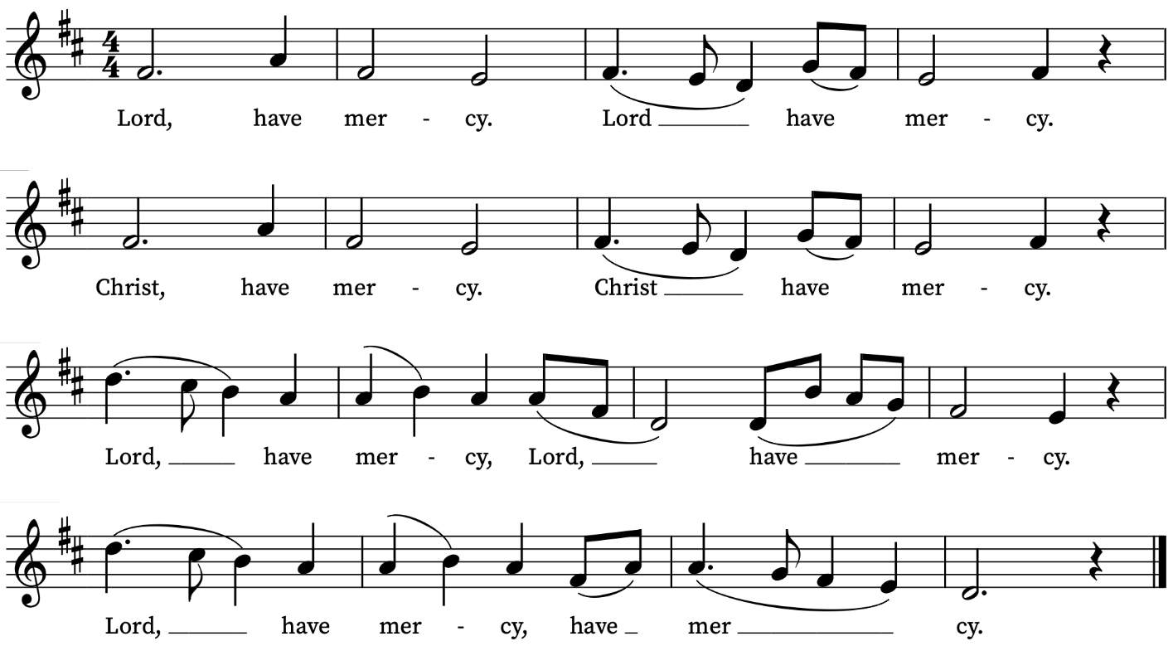
First Reading
Acts 2: 1-21
A reading from the Acts of the Apostles
When the day of Pentecost had come, they were all together in one place. And suddenly from heaven there came a sound like the rush of a violent wind, and it filled the entire house where they were sitting. Divided tongues, as of fire, appeared among them, and a tongue rested on each of them. All of them were filled with the Holy Spirit and began to speak in other languages, as the Spirit gave them ability.
Now there were devout Jews from every nation under heaven living in Jerusalem. And at this sound the crowd gathered and was bewildered, because each one heard them speaking in the native language of each. Amazed and astonished, they asked, ‘Are not all these who are speaking Galileans? And how is it that we hear, each of us, in our own native language? Parthians, Medes, Elamites, and residents of Mesopotamia, Judea and Cappadocia, Pontus and Asia, Phrygia and Pamphylia, Egypt and the parts of Libya belonging to Cyrene, and visitors from Rome, both Jews and proselytes, Cretans and Arabs—in our own languages we hear them speaking about God’s deeds of power.’ All were amazed and perplexed, saying to one another, ‘What does this mean?’ But others sneered and said, ‘They are filled with new wine.’
But Peter, standing with the eleven, raised his voice and addressed them: ‘Men of Judea and all who live in Jerusalem, let this be known to you, and listen to what I say. Indeed, these are not drunk, as you suppose, for it is only nine o’clock in the morning. No, this is what was spoken through the prophet Joel:
“In the last days it will be, God declares,
that I will pour out my Spirit upon all flesh,
and your sons and your daughters shall prophesy,
and your young men shall see visions,
and your old men shall dream dreams.
Even upon my slaves, both men and women,
in those days I will pour out my Spirit;
and they shall prophesy.
And I will show portents in the heaven above
and signs on the earth below,
blood, and fire, and smoky mist.
The sun shall be turned to darkness
and the moon to blood,
before the coming of the Lord’s great and glorious day.
Then everyone who calls on the name of the Lord shall be saved.”
This is the Word of the Lord
Thanks be to God

Psalm 104: 24-34, 35b
24 O Lord, how manifold are thy works : in wisdom hast thou made them all; the earth is full of thy riches.
25 So is the great and wide sea also : wherein are things creeping innumerable, both small and great beasts.
26 There go the ships, and there is that Leviathan: whom thou hast made to take his pastime therein.
27 These wait all upon thee : that thou mayest give them meat in due season.
28 When thou givest it them they gather it : and when thou openest thy hand they are filled with good.
29 When thou hidest thy face they are troubled : when thou takest away their breath they die, and are turned again to their dust.
30 When thou lettest thy breath go forth they shall be made : and thou shalt renew the face of the earth.
31 The glorious majesty of the Lord shall endure for ever : the Lord shall rejoice in his works.
32 The earth shall tremble at the look of him : if he do but touch the hills, they shall smoke.
33 I will sing unto the Lord as long as I live : I will praise my God while I have my being.
34 And so shall my words please him : my joy shall be in the Lord.
35 Praise thou the Lord, O my soul, praise the Lord.

Second Reading
1 Corinthians 12: 3b-13
A reading from the First Letter to the Corinthians
No one can say ‘Jesus is Lord’ except by the Holy Spirit.
Now there are varieties of gifts, but the same Spirit; and there are varieties of services, but the same Lord; and there are varieties of activities, but it is the same God who activates all of them in everyone. To each is given the manifestation of the Spirit for the common good. To one is given through the Spirit the utterance of wisdom, and to another the utterance of knowledge according to the same Spirit, to another faith by the same Spirit, to another gifts of healing by the one Spirit, to another the working of miracles, to another prophecy, to another the discernment of spirits, to another various kinds of tongues, to another the interpretation of tongues. All these are activated by one and the same Spirit, who allots to each one individually just as the Spirit chooses.
For just as the body is one and has many members, and all the members of the body, though many, are one body, so it is with Christ. For in the one Spirit we were all baptized into one body—Jews or Greeks, slaves or free—and we were all made to drink of one Spirit.
This is the Word of the Lord
Thanks be to God

Gradual Hymn
Holy Spirit, gift-bestower,
breathe into our hearts today.
Flowing water, dove that hovers,
Holy Spirit, guide our way.
Love inspirer, joy releaser,
Spirit, take our fears away.
Reconciler, peace restorer,
move among us while we pray.
Holy Spirit, Christ proclaimer,
wisdom bringer, light our way.
Fire that dances, wind that whispers,
Holy Spirit, come today.
Ease disturber, comfort bearer,
move among us while we pray.
Truth revealer, faith confirmer,
rest within our hearts today.

Words: Catherine Williams (b.1956)
Music: “Yr hun gan”

Gospel Reading
John 7: 37-39
Hear the Gospel of our Lord Jesus Christ according to John
Glory be to thee, O Lord
On the last day of the festival, the great day, while Jesus was standing there, he cried out, ‘Let anyone who is thirsty come to me, and let the one who believes in me drink. As the scripture has said, “Out of the believer’s heart shall flow rivers of living water.”’
Now he said this about the Spirit, which believers in him were to receive; for as yet there was no Spirit, because Jesus was not yet glorified.
This is the Gospel of the Lord
Praise be to thee, O Christ

Today’s Music
Mass setting: (Gloria, Sanctus/Benedictus and Agnus Dei):
Krönungsmesse – W.A. Mozart
Anthem
Loquebantur variis linguis – Thomas Tallis
Loquebantur variis linguis apostoli, Alleluia,
magnalia Dei, Alleluia.
Repleti sunt omnes Spiritu Sancto, et ceperunt loqui
magnalia Dei, Alleluia. Gloria Patri et Filio,
et Spiritui Sancto. Alleluia.
Gloria Patri et Filio et Spiritu Sancto: alleluia.
The apostles spoke in tongues of the greatness of God: alleluia.
They were all filled with the Holy Spirit and began to speak: alleluia.
Glory be to the Father, and to the Son, and to the Holy Spirit: alleluia.
Acts 2: 4
Communion
Agnus Dei from Krönungsmesse – W.A. Mozart
If ye love me – Thomas Tallis
If ye love me, keep my commandments. And I will pray the Father, and he shall give you another comforter, that he may 'bide with you forever; E'en the spirit of truth.
John 14: 15-17
Organ Postlude
Komm, Heiliger Geist BWV 651 – J.S. Bach

Prayers for the week
We pray for those in need: Helen Delap, Dan Delap, Delroy Donegal, Bill Essex, Susan and Anthony Holland, Carole Hubble, Marion Kokott, Sara Mauleverer, Lylian Meira, Vernon Mustoe, Nicola Orme, Philip Simms, Jean Smith, Tina Stanley, and Pauline Youll.
We remember those who have died recently, including Joe Bennett, Ian Clark, Joel Coleman, Anthony Durham, Brenda Eva (née Price), Mary Kinnison, Doreen McAree, Jana Georgieva, Luis Segui Gimeno and Richard Winn. We also remember Philip Norris on his year’s mind. We ask God’s blessing and comfort on all mourning the loss of loved ones.
If you wish to add names to the prayers for those in need or departed please contact David McEvoy dmcevoy@btinternet.com
Supporting St Alfege Church
Please do make a gift to support the life and ministry of St Alfege Church – during the collection in the service or by using a card reader at the North and West Doors. Please complete a Gift Aid envelope (if you are eligible) whether you donate by cash or card. You can also use this QR code to donate. | 

Services this week
Sunday 24 May Pentecost
8am Holy Communion (Book of Common Prayer)
10am Sung Eucharist
Monday 25 May
8.30am Morning Prayer
Tuesday 26 May
8.30am Morning Prayer
1.00pm Funeral of Ian Clark
Wednesday 27 May
8.30am Morning Prayer
Thursday 28 May
8.00am Holy Communion
Sunday 31 May Trinity Sunday
8am Holy Communion (Book of Common Prayer)
10am Sung Eucharist
4.00pm Choral Evensong
Walk-in Wednesdays
Every Wednesday 10am-12noon in the small hall
Contact us
Vicar: Revd Simon Winn
Curate: Revd Dr Tati Gutteridge (on maternity leave)
Church Office: 020 8853 0687
Email: office@st-alfege.org.uk Website: www.st-alfege.org.uk
Safeguarding Team
Karen Hansen Lead Safeguarding Officer 07866 932 894
Carole Moses Safeguarding Officer 07889 396 671
Irene Bishop Safeguarding Officer 020 8698 2658
safeguarding@st-alfege.org.uk

Pentecost commission
Handheld candles are lit. The celebrant introduces the commission:
For fifty days we have celebrated the victory of our Lord Jesus Christ over the powers of sin and death. We have proclaimed God’s mighty acts and we have prayed that the power that was at work when God raised Jesus from the dead might be at work in us.
As part of God’s Church here in Greenwich, I call upon you to live out what you proclaim.
Empowered by the Holy Spirit, will you dare to walk into God’s future, trusting him to be your guide?
By the Spirit’s power, we will.
Will you dare to embrace each other and grow together
in love?
We will.
Will you dare to share your riches in common and minister to each other in need?
We will.
Will you dare to pray for each other until your hearts beat with the longings of God?
We will.
Will you dare to carry the light of Christ into the world’s dark places?
We will.
The Easter Candle is extinguished.

