

Sung Eucharist
Sixth Sunday of Easter
10 May 2026
Welcome to our services of Holy Communion. Revd Simon Winn, Vicar, is presiding and preaching at 8am and preaching at 10am. Revd Stephen Nshimye is presiding at 10am. Please join us for the church’s Annual General Meeting after the 10am service in the Hall.
Readings
Acts 7: 22-31
Psalm 66: 7-18
1 Peter 3: 13-22
John 14: 15-21
Hymns
332 Christ is made the sure foundation (verses 5-9)
234 Thine for ever, God of love
431 We have a Gospel to proclaim
Great is thy faithfulness On page 5 of this sheet
Collect
God our redeemer, you have delivered us from the power of darkness and brought us into the kingdom of your Son: grant, that as by his death he has recalled us to life, so by his continual presence in us he may raise us to eternal joy; through Jesus Christ your Son our Lord, who is alive and reigns with you, in the unity of the Holy Spirit, one God, now and for ever. Amen
Prayer after Communion
God our Father, whose Son Jesus Christ gives the water of eternal life: may we thirst for you, the spring of life and source of goodness, through him who is alive and reigns, now and for ever. Amen
Kyrie
We join in singing the Kyrie from Schubert’s German Mass:
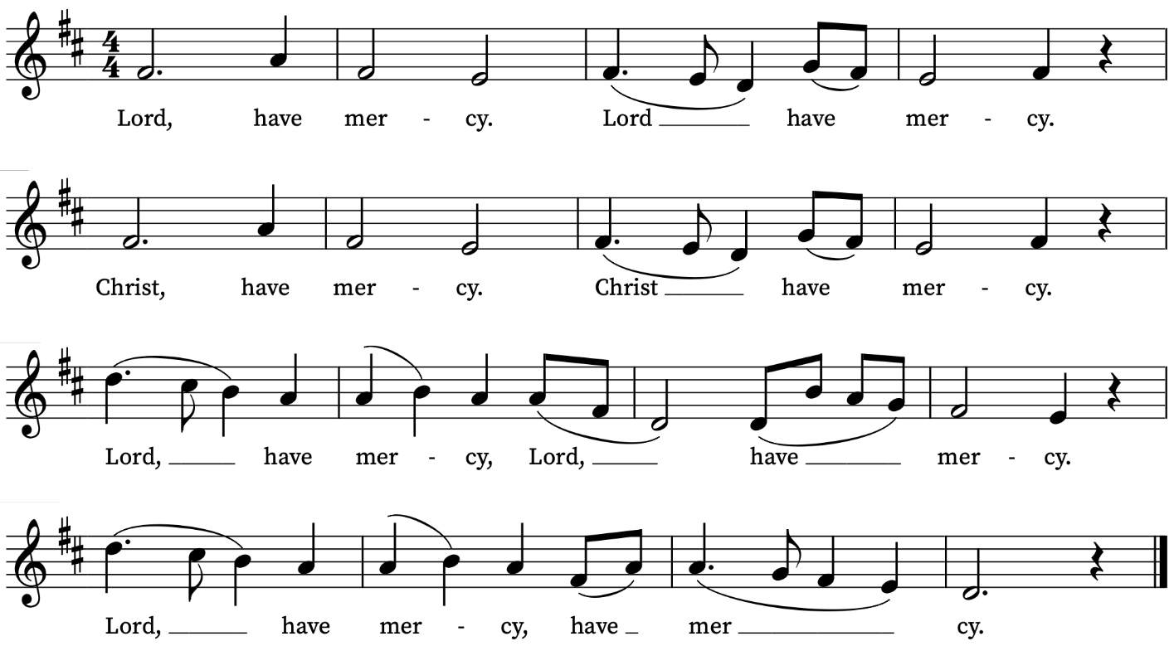
First Reading
Acts 17: 22-31
A reading from the Acts of the Apostles
Then Paul stood in front of the Areopagus and said, ‘Athenians, I see how extremely religious you are in every way. For as I went through the city and looked carefully at the objects of your worship, I found among them an altar with the inscription, “To an unknown god.” What therefore you worship as unknown, this I proclaim to you. The God who made the world and everything in it, he who is Lord of heaven and earth, does not live in shrines made by human hands, nor is he served by human hands, as though he needed anything, since he himself gives to all mortals life and breath and all things. From one ancestor he made all nations to inhabit the whole earth, and he allotted the times of their existence and the boundaries of the places where they would live, so that they would search for God and perhaps grope for him and find him—though indeed he is not far from each one of us. For “In him we live and move and have our being”; as even some of your own poets have said,
“For we too are his offspring.”
Since we are God’s offspring, we ought not to think that the deity is like gold, or silver, or stone, an image formed by the art and imagination of mortals. While God has overlooked the times of human ignorance, now he commands all people everywhere to repent, because he has fixed a day on which he will have the world judged in righteousness by a man whom he has appointed, and of this he has given assurance to all by raising him from the dead.’
This is the Word of the Lord
Thanks be to God
Psalm 67: 7- 18
7 O praise our God, ye people : and make the voice of his praise to be heard;
8 Who holdeth our soul in life : and suffereth not our feet to slip.
9 For thou, O God, hast proved us : thou also hast tried us, like as silver is tried.
10 Thou broughtest us into the snare : and laidest trouble upon our loins.
11 Thou sufferedst men to ride over our heads : we went through fire and water, and thou broughtest us out into a wealthy place.
12 I will go into thine house with burnt-offerings: and will pay thee my vows, which I promised with my lips, and spake with my mouth, when I was in trouble.
13 I will offer unto thee fat burnt-sacrifices, with the incense of rams : I will offer bullocks and goats.
14 O come hither, and hearken, all ye that fear God : and I will tell you what he hath done for my soul.
15 I called unto him with my mouth : and gave him praises with my tongue.
16 If I incline unto wickedness with mine heart : the Lord will not hear me.
17 But God hath heard me : and considered the voice of my prayer.
18 Praised be God, who hath not cast out my prayer : nor turned his mercy from me.
Second Reading
1 Peter 3: 13-22
A reading from the First Letter of Peter
Now who will harm you if you are eager to do what is good? But even if you do suffer for doing what is right, you are blessed. Do not fear what they fear, and do not be intimidated, but in your hearts sanctify Christ as Lord. Always be ready to make your defence to anyone who demands from you an account of the hope that is in you; yet do it with gentleness and reverence. Keep your conscience clear, so that, when you are maligned, those who abuse you for your good conduct in Christ may be put to shame. For it is better to suffer for doing good, if suffering should be God’s will, than to suffer for doing evil. For Christ also suffered for sins once for all, the righteous for the unrighteous, in order to bring you to God. He was put to death in the flesh, but made alive in the spirit, in which also he went and made a proclamation to the spirits in prison, who in former times did not obey, when God waited patiently in the days of Noah, during the building of the ark, in which a few, that is, eight people, were saved through water. And baptism, which this prefigured, now saves you—not as a removal of dirt from the body, but as an appeal to God for a good conscience, through the resurrection of Jesus Christ, who has gone into heaven and is at the right hand of God, with angels, authorities, and powers made subject to him.
This is the Word of the Lord
Thanks be to God

Gospel Reading
John 14: 15-22
Hear the Gospel of our Lord Jesus Christ according to John
Glory be to thee, O Lord
Jesus said ‘If you love me, you will keep my commandments. And I will ask the Father, and he will give you another Advocate, to be with you for ever. This is the Spirit of truth, whom the world cannot receive, because it neither sees him nor knows him. You know him, because he abides with you, and he will be in you.
‘I will not leave you orphaned; I am coming to you. In a little while the world will no longer see me, but you will see me; because I live, you also will live. On that day you will know that I am in my Father, and you in me, and I in you. They who have my commandments and keep them are those who love me; and those who love me will be loved by my Father, and I will love them and reveal myself to them.’ Judas (not Iscariot) said to him, ‘Lord, how is it that you will reveal yourself to us, and not to the world?’
This is the Gospel of the Lord
Praise be to thee, O Christ
Final Hymn
Great is thy faithfulness, O God my Father,
there is no shadow of turning with thee;
thou changest not, thy compassions they fail not;
as thou hast been thou for ever wilt be.
Great is thy faithfulness! Great is thy faithfulness!
Morning by morning new mercies I see;
all I have needed thy hand hath provided,
great is thy faithfulness, Lord unto me!

Summer and winter, and springtime and harvest,
sun, moon and stars in their courses above,
join with all nature in manifold witness
to thy great faithfulness, mercy and love.
Great is thy faithfulness! Great is thy faithfulness!
Morning by morning new mercies I see;
all I have needed thy hand hath provided,
great is thy faithfulness, Lord unto me!
Pardon for sin and a peace that endureth,
thine own dear presence to cheer and to guide;
strength for today and bright hope for tomorrow,
blessings all mine, with ten thousand beside!
Great is thy faithfulness …
Words: Thomas Obadiah Chisholm (1866-1960)
Music: William Marion Runyan (1870-1957)
Today’s Music
Mass setting: (Gloria, Sanctus/Benedictus and Agnus Dei):
Mass of the Quiet Hour – George Oldroyd
Anthem
In resurrectione tua Domine – William Byrd
In resurrectione tua, Domine, Alleluya, laetentur coeli et exultet terra, Alleluya.
At thy resurrection, O Lord, alleluia, let the heavens give praise and the earth rejoice, alleluia.
Communion
Agnus Dei from Mass of the Quiet Hour – George Oldroyd
I give you a new commandment – John Shephard
A new commandment I give unto you, that you love one another; as I have loved you, that you also love one another. By this shall all men know that ye are my disciples, if ye have love, if you have love for one another. John 13: 34-35
Organ Postlude
Signum ignis – Thomas Tallis
Prayers for the week
We rejoice with Ben and Helen Crompton on the safe delivery of a daughter, Elizabeth.
We pray for those in need: Helen Delap, Dan Delap, Delroy Donegal, Susan and Anthony Holland, Carole Hubble, Marion Kokott, Sara Mauleverer, Lylian Meira, Vernon Mustoe, Jim Odell, Nicola Orme, Penny Saunders, Jean Smith, Tina Stanley, Richard Winn, and Pauline Youll.
We remember those who have died recently, including Joe Bennett, Ian Clark, Joel Coleman, Anthony Durham, Brenda Eva (née Price), Doreen McAree and Jessica Springbett. We ask God’s blessing and comfort on all mourning the loss of loved ones.
If you wish to add names to the prayers for those in need or departed please contact David McEvoy dmcevoy@btinternet.com
Supporting St Alfege Church
Please do make a gift to support the life and ministry of St Alfege Church – during the collection in the service or by using a card reader at the North and West Doors. Please complete a Gift Aid envelope (if you are eligible) whether you donate by cash or card. You can also use this QR code to donate.  Ascension Day Thursday 14 May at 8pm  Sung Eucharist in the Chapel of the Old Royal Naval College. Revd Dr Robert Tobin is presiding and David McEvoy, Reader, is preaching. With a combined choir from St Alfege Church and the ORNC Chapel. | 
Services this week
Sunday 10 May Sixth Sunday of Easter
8am Holy Communion (Book of Common Prayer)
10am Sung Eucharist
Church Annual General Meeting in the Hall after the 10am service
Monday 11 May
8.30am Morning Prayer
Tuesday 12 May
8.30am Morning Prayer
Wednesday 13 May
8.30am Morning Prayer
Thursday 14 May Ascension Day
8.00am Holy Communion
8.00pm Choral Eucharist in the Chapel of the Old Royal Naval College
Sunday 17 May Seventh Sunday of Easter
8am Holy Communion (Book of Common Prayer)
10am Sung Eucharist
Walk-in Wednesdays
Every Wednesday 10am-12noon in the small hall
Contact us
Vicar: Revd Simon Winn
Curate: Revd Dr Tati Gutteridge (on maternity leave)
Church Office: 020 8853 0687
Email: office@st-alfege.org.uk Website: www.st-alfege.org.uk
Safeguarding Team
Karen Hansen Lead Safeguarding Officer 07866 932 894
Carole Moses Safeguarding Officer 07889 396 671
Irene Bishop Safeguarding Officer 020 8698 2658
safeguarding@st-alfege.org.uk

