

Sung Eucharist
Fifth Sunday of Easter
3 May 2026
Welcome to our services of Holy Communion. Revd Simon Winn, Vicar is presiding and preaching at 8am and 10am.
Readings
Acts 7: 55-60
Psalm 31: 1-5, 15-16
1 Peter 2: 2-10
John 14: 1-14
Hymns
122 How sweet the name of Jesus sounds
128 Thou art the way, by thee alone
170 The church’s one foundation is Jesus Christ her Lord
214 Guide me O thou great Redeemer
Collect
Almighty God, who through your only-begotten Son Jesus Christ have overcome death and opened to us the gate of everlasting life: grant that, as by your grace going before us
you put into our minds good desires, so by your continual help we may bring them to good effect; through Jesus Christ our risen Lord, who is alive and reigns with you, in the unity of the Holy Spirit, one God, now and for ever. Amen
Prayer after Communion
Eternal God, whose Son Jesus Christ is the way, the truth, and the life: grant us to walk in his way, to rejoice in his truth, and to share his risen life; who is alive and reigns, now and for ever. Amen
Kyrie
We join in singing the Kyrie from Schubert’s German Mass:
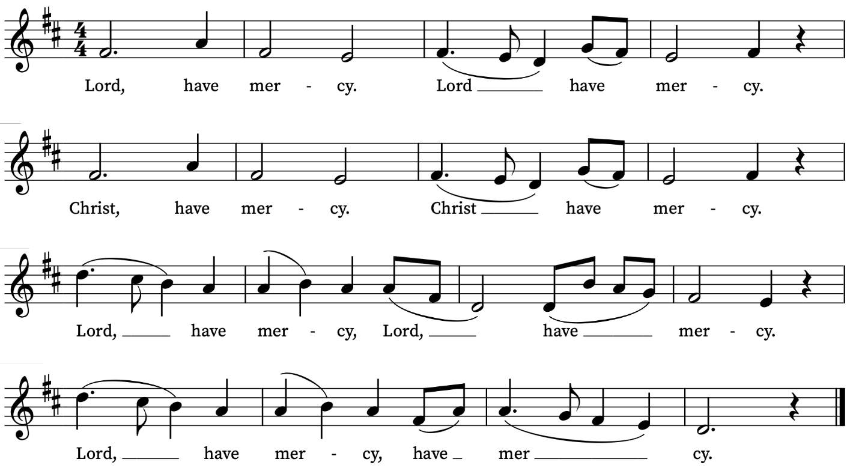
New Testament Reading
Acts 7: 55-60
A reading from the Acts of the Apostles
But filled with the Holy Spirit, Stephen gazed into heaven and saw the glory of God and Jesus standing at the right hand of God. ‘Look,’ he said, ‘I see the heavens opened and the Son of Man standing at the right hand of God!’ But they covered their ears, and with a loud shout all rushed together against him. Then they dragged him out of the city and began to stone him; and the witnesses laid their coats at the feet of a young man named Saul. While they were stoning Stephen, he prayed, ‘Lord Jesus, receive my spirit.’ Then he knelt down and cried out in a loud voice, ‘Lord, do not hold this sin against them.’ When he had said this, he died.
This is the Word of the Lord
Thanks be to God
Psalm 31: 1-5, 15-16
In te, Domine, speravi
In thee, O Lord, have I put my trust : let me never be put to confusion, deliver me in thy righteousness.
2 Bow down thine ear to me : make haste to deliver me.
3 And be thou my strong rock, and house of defence : that thou mayest save me.
4 For thou art my strong rock, and my castle : be thou also my guide, and lead me for thy Name's sake.
5 Draw me out of the net that they have laid privily for me : for thou art my strength.
15 For I have heard the blasphemy of the multitude : and fear is on every side, while they conspire together against me, and take their counsel to take away my life.
16 But my hope hath been in thee, O Lord : I have said, Thou art my God.
Epistle
1 Peter 2: 2-10
A reading from the First Letter of Peter
Like newborn infants, long for the pure, spiritual milk, so that by it you may grow into salvation— if indeed you have tasted that the Lord is good.
Come to him, a living stone, though rejected by mortals yet chosen and precious in God’s sight, and like living stones, let yourselves be built into a spiritual house, to be a holy priesthood, to offer spiritual sacrifices acceptable to God through Jesus Christ. For it stands in scripture:
‘See, I am laying in Zion a stone,
a cornerstone chosen and precious;
and whoever believes in him will not be put to shame.’
To you then who believe, he is precious; but for those who do not believe,
‘The stone that the builders rejected
has become the very head of the corner’,
and
‘A stone that makes them stumble,
and a rock that makes them fall.’
They stumble because they disobey the word, as they were destined to do.
But you are a chosen race, a royal priesthood, a holy nation, God’s own people, in order that you may proclaim the mighty acts of him who called you out of darkness into his marvellous light.
Once you were not a people,
but now you are God’s people;
once you had not received mercy,
but now you have received mercy.
This is the Word of the Lord
Thanks be to God
Gospel Reading
John 14: 1-14
Hear the Gospel of our Lord Jesus Christ according to John
Glory be to thee, O Lord
‘Do not let your hearts be troubled. Believe in God, believe also in me. In my Father’s house there are many dwelling-places. If it were not so, would I have told you that I go to prepare a place for you? And if I go and prepare a place for you, I will come again and will take you to myself, so that where I am, there you may be also. And you know the way to the place where I am going.’ Thomas said to him, ‘Lord, we do not know where you are going. How can we know the way?’ Jesus said to him, ‘I am the way, and the truth, and the life. No one comes to the Father except through me. If you know me, you will know my Father also. From now on you do know him and have seen him.’
Philip said to him, ‘Lord, show us the Father, and we will be satisfied.’ Jesus said to him, ‘Have I been with you all this time, Philip, and you still do not know me? Whoever has seen me has seen the Father. How can you say, “Show us the Father”? Do you not believe that I am in the Father and the Father is in me? The words that I say to you I do not speak on my own; but the Father who dwells in me does his works. Believe me that I am in the Father and the Father is in me; but if you do not, then believe me because of the works themselves. Very truly, I tell you, the one who believes in me will also do the works that I do and, in fact, will do greater works than these, because I am going to the Father. I will do whatever you ask in my name, so that the Father may be glorified in the Son. If in my name you ask me for anything, I will do it.
This is the Gospel of the Lord
Praise be to thee, O Christ

Today’s Music
Mass setting (Gloria, Sanctus/Benedictus and Agnus Dei):
Missa Sine Nomine a 4 – G.P. da Palestrina
Anthem
Haec dies a 4 – G.P. da Palestrina
Haec dies quam fecit Dominus:
exultemus et laetemur in ea,
Alleluia.
This is the day the Lord has made:
let us rejoice and be glad in it,
Alleluia.
(Psalm 118:24)
Communion
Agnus Dei from Missa Quarta – G.P. da Palestrina
O taste and see – Ralph Vaughan Williams
Organ Postlude
Transports de joie (L’Ascension) – Olivier Messiaen

Prayers for the week
We pray for those in need: Helen Delap, Dan Delap, Delroy Donegal, Susan and Anthony Holland, Carole Hubble, Sara Mauleverer, Lylian Meira, Vernon Mustoe, Jim Odell, Nicola Orme, Penny Saunders, Jessica Springbett, Jean Smith, Tina Stanley, Richard Winn, and Pauline Youll.
We remember those who have died recently, including Ian Clark, Joel Coleman, Anthony Durham, Brenda Eva (née Price), Lesley Hodsdon, Jeff Hurst, Peter King, Roger Matthews, Doreen McAree, and Richard Pulkowski. We remember Ray Jordan and Matthew Kinnison on their year’s minds and we ask God’s blessing on Isha, Lamin and Keon as they remember baby Gabriel who died on 1st May last year aged 7 months. We ask God’s blessing and comfort on all mourning the loss of loved ones.
If you wish to add names to the prayers for those in need or departed please contact David McEvoy dmcevoy@btinternet.com
Supporting St Alfege Church
Please do make a gift to support the life and ministry of St Alfege Church – during the collection in the service or by using a card reader at the North and West Doors. Please complete a Gift Aid envelope (if you are eligible) whether you donate by cash or card. You can also use this QR code to donate. | 

Services this week
Sunday 3 May Fifth Sunday of Easter
8am Holy Communion (Book of Common Prayer)
10am Sung Eucharist
5.30pm Abide, a contemplative service with music in the Taizé tradition.
Monday 4 May
8.30am Morning Prayer
Tuesday 5 May
8.30am Morning Prayer
Wednesday 6 May
8.30am Morning Prayer
Thursday 7 May
8.00am Holy Communion
Sunday 10 May Sixth Sunday of Easter
8am Holy Communion (Book of Common Prayer)
10am Sung Eucharist
Walk-in Wednesdays
Every Wednesday 10am-12noon in the small hall
Contact us
Vicar: Revd Simon Winn
Curate: Revd Dr Tati Gutteridge (on maternity leave)
Church Office: 020 8853 0687
Email: office@st-alfege.org.uk Website: www.st-alfege.org.uk
Safeguarding Team
Karen Hansen Lead Safeguarding Officer 07866 932 894
Carole Moses Safeguarding Officer 07889 396 671
Irene Bishop Safeguarding Officer 020 8698 2658
safeguarding@st-alfege.org.uk

