

Parish Eucharist
Feast of St Alfege/Patronal Festival
19 April 2026
Welcome to our services of Holy Communion. Revd Mark Hatcher is presiding and preaching at 8am and preaching at 10am. Revd Simon Winn, Vicar is presiding at 10am.
Readings
Isaiah 43: 1-7
Psalm 3
Hebrews 5: 1-4
Matthew 16: 24-26
Hymns
305 For all the saints (omit verses 4,5,6) (Tune: Sine Nomine)
238 Blest are the pure in heart
Hymn to Alfege (on page 5 of this sheet)
202 Let all the world
Collect
Merciful God, who raised up your servant Alfege to be a pastor of your people and gave him grace to suffer for justice and true religion: grant that we who celebrate his martyrdom may know the power of the risen Christ in our hearts and share his peace in lives offered to your service. Through Jesus Christ our Lord. Amen
Prayer after Communion
Eternal God, who gave us this holy meal in which we have celebrated the glory of the cross and the victory of your martyr Alfege: by our communion with Christ in his saving death and resurrection, give us with all your saints the courage to conquer evil and so to share the fruit of the tree of life; through Jesus Christ our Lord. Amen
Kyrie
We join in singing the Kyrie from Schubert’s German Mass:
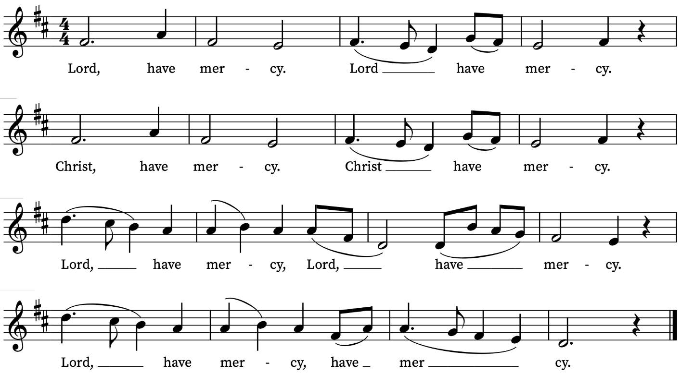
Old Testament Reading
Isaiah 43: 1-7
A reading from the Prophet Isaiah
But now thus says the Lord,
he who created you, O Jacob,
he who formed you, O Israel:
Do not fear, for I have redeemed you;
I have called you by name, you are mine.
When you pass through the waters, I will be with you;
and through the rivers, they shall not overwhelm you;
when you walk through fire you shall not be burned,
and the flame shall not consume you.
For I am the Lord your God,
the Holy One of Israel, your Saviour.
I give Egypt as your ransom,
Ethiopia and Seba in exchange for you.
Because you are precious in my sight,
and honoured, and I love you,
I give people in return for you,
nations in exchange for your life.
Do not fear, for I am with you;
I will bring your offspring from the east,
and from the west I will gather you;
I will say to the north, ‘Give them up’,
and to the south, ‘Do not withhold;
bring my sons from far away
and my daughters from the end of the earth—
everyone who is called by my name,
whom I created for my glory,
whom I formed and made.’
This is the Word of the Lord
Thanks be to God
Psalm 3
Domine, quid multiplicati?
Lord, how are they increased that trouble me! : many are they that rise against me.
2 Many one there be that say of my soul : There is no help for him in his God.
3 But thou, O Lord, art my defender : thou art my worship, and the lifter up of my head.
4 I did call upon the Lord with my voice : and he heard me out of his holy hill.
5 I laid me down and slept, and rose up again : for the Lord sustained me.
6 I will not be afraid for ten thousands of the people : that have set themselves against me round about.
7 Up, Lord, and help me, O my God : for thou smitest all mine enemies upon the cheek-bone; thou hast broken the teeth of the ungodly.
8 Salvation belongeth unto the Lord : and thy blessing is upon thy people.
New Testament Reading
Hebrews 5: 1-4
A reading from the Letter to the Hebrews
Every high priest chosen from among mortals is put in charge of things pertaining to God on their behalf, to offer gifts and sacrifices for sins. He is able to deal gently with the ignorant and wayward, since he himself is subject to weakness; and because of this he must offer sacrifice for his own sins as well as for those of the people. And one does not presume to take this honour, but takes it only when called by God, just as Aaron was.
This is the Word of the Lord
Thanks be to God
Gospel Reading
Matthew 16: 24-26
Hear the Gospel of our Lord Jesus Christ according to Matthew
Glory be to thee, O Lord
Then Jesus told his disciples, ‘If any want to become my followers, let them deny themselves and take up their cross and follow me. For those who want to save their life will lose it, and those who lose their life for my sake will find it. For what will it profit them if they gain the whole world but forfeit their life? Or what will they give in return for their life?
This is the Gospel of the Lord
Praise be to thee, O Christ
Offertory Hymn
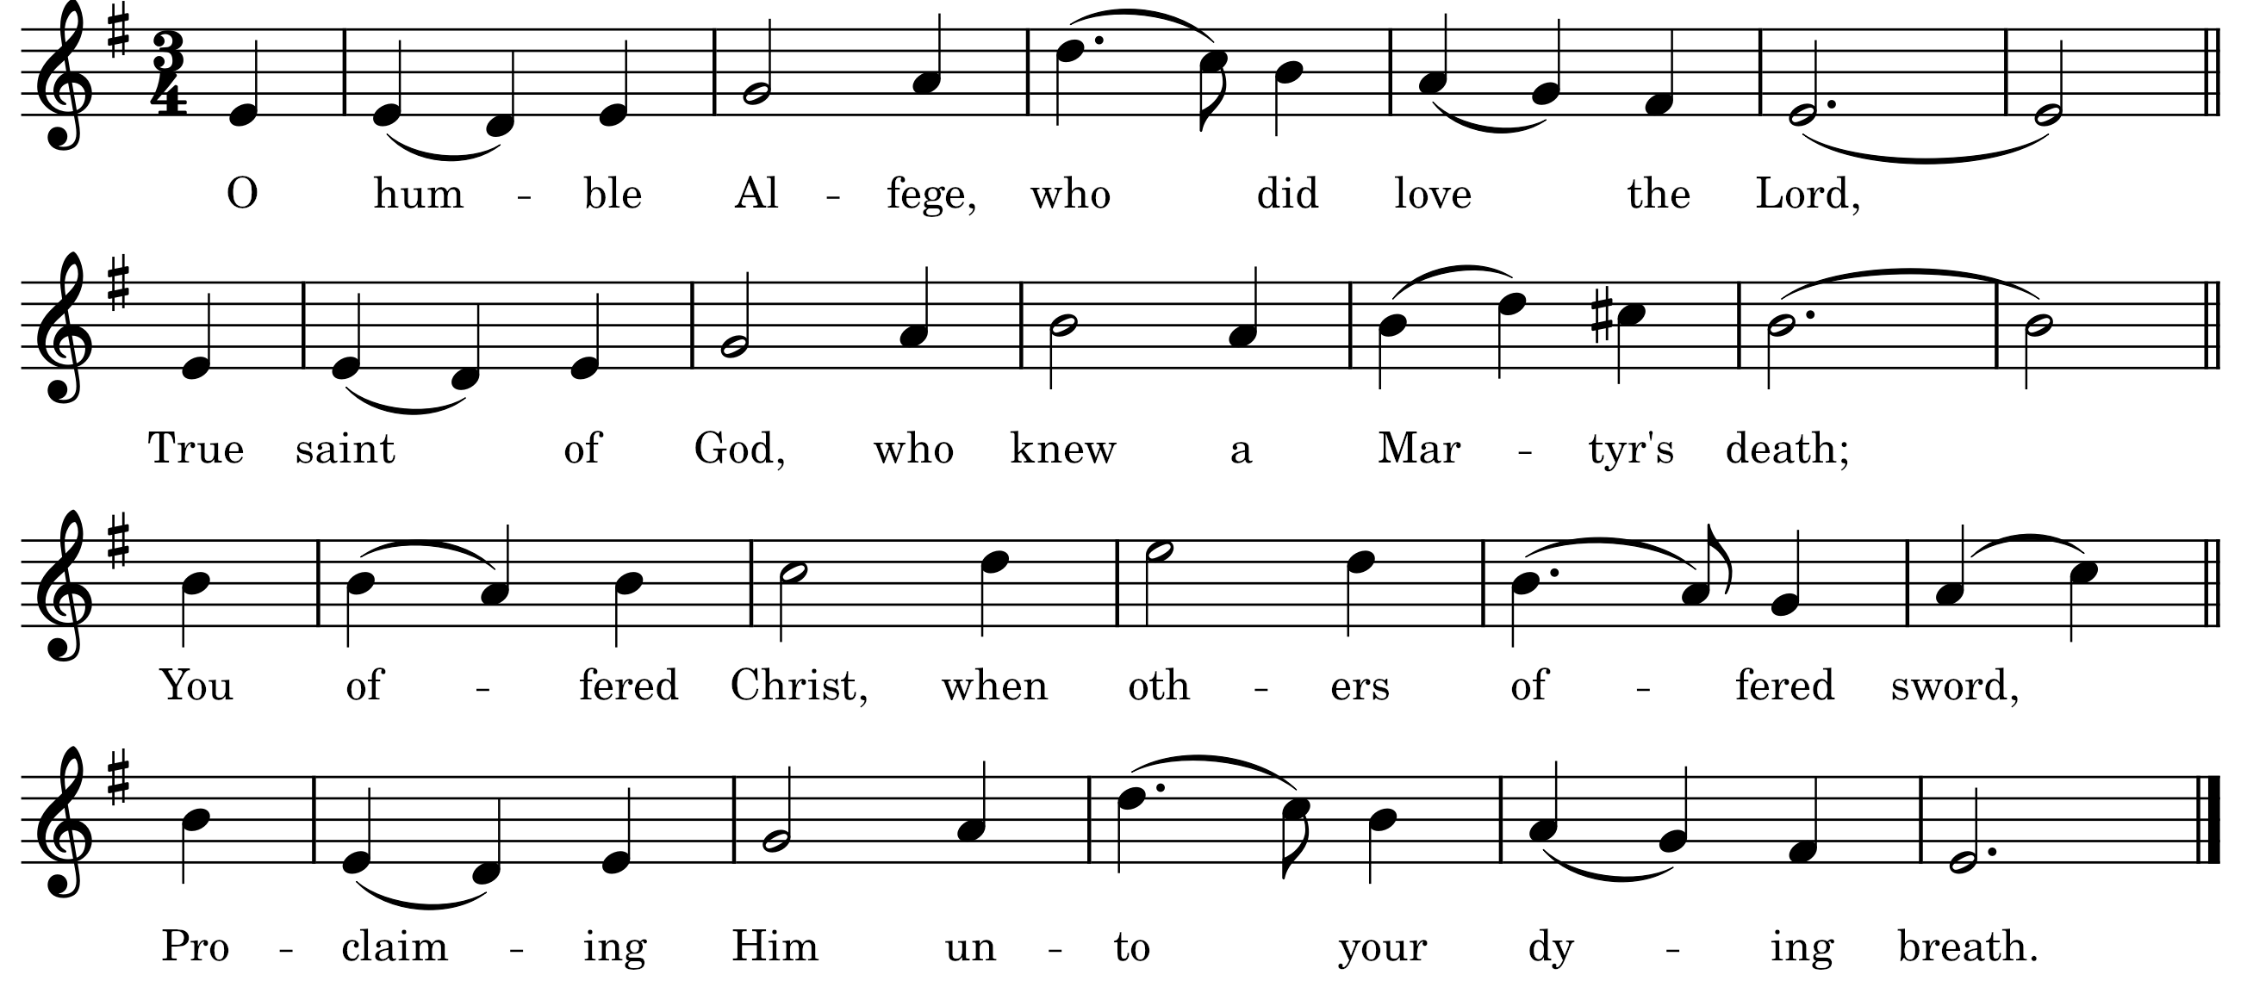
Archbishop of the faithful in our land,
Great priest of God, in face of pagan shame;
Far down the years your sacrifice shall stand,
A model for the faith we dare to claim.
The gold you gave outshines all wealth of Man,
And Viking’s greed could not defile your way;
Thus, blind with riches, press’d they ransom’s plan,
While knowing not that Christ would have the day.
With bones and axes struck they from the earth
The saint who earthly ransom would not pay;
Yet no mere blade could e’er destroy your worth,
The spirit lives, though mortal man they slay.
Here stands your church in witness of that day,
A living tribute to a life of love;
Grant us, your people, strength to serve and pray,
Then, Alfege, dwell with you in heav’n above!
Words and Music: Antony Baldwin

Today’s Music
Mass setting (Gloria, Sanctus/Benedictus and Agnus Dei):
Spatzenmesse, K. 220 – W.A. Mozart
Anthem
Te Deum in B-flat major – C.V. Stanford
We praise thee, O God; we acknowledge thee to be the Lord.
All the earth doth worship thee, the Father everlasting.
To thee all angels cry aloud, the heavens and all the powers therein.
To thee cherubin and seraphin continually do cry, Holy, Holy, Holy, Lord God of Sabaoth; Heaven and earth are full of the majesty of thy glory.
The glorious company of the apostles praise thee. The goodly fellowship of the prophets praise thee. The noble army of martyrs praise thee.
The holy Church throughout all the world doth acknowledge thee:
the Father of an infinite majesty; thine honourable, true and only Son;
also the Holy Ghost the Comforter. Thou art the King of glory, O Christ.
Thou art the everlasting Son of the Father. When thou tookest upon thee to deliver man, thou didst not abhor the Virgin’s womb.
When thou hadst overcome the sharpness of death, thou didst open the kingdom of heaven to all believers. Thou sittest at the right hand of God, in the glory of the Father. We believe that thou shalt come to be our judge. We therefore pray thee, help thy servants, whom thou hast redeemed with thy precious blood. Make them to be numbered with thy saints in glory everlasting. O Lord, save thy people and bless thine heritage. Govern them and lift them up for ever. Day by day we magnify thee; and we worship thy name, ever world without end. Vouchsafe, O Lord, to keep us this day without sin. O Lord, have mercy upon us, have mercy upon us. O Lord, let thy mercy lighten upon us, as our trust is in thee. O Lord, in thee have I trusted; let me never be confounded.
Communion
Agnus Dei from Spatzenmesse – W.A. Mozart
Organ Postlude
Offertoire sur “O filii et filiae” – Alexandre Guilmant
Prayers for the week
We pray for Maria Bela De Luca Gattai being baptized here this afternoon
We pray for those in need: Ian Clark, Helen Delap, Dan Delap, Delroy Donegal, Susan and Anthony Holland, Carole Hubble, Sara Mauleverer, Lylian Meira, Vernon Mustoe, Jim Odell, Nicola Orme, Jessica Springbett, Jean Smith, Tina Stanley, and Pauline Youll.
We remember those who have died recently, including Christopher Follett, Lesley Hodsdon, Jeff Hurst, Peter King, Roger Matthews, Doreen McAree, Richard Pulkowski, and 14-year-old Eghosa Ogbebor, murdered in Woolwich in Holy Week. We ask God’s blessing and comfort on all mourning the loss of loved ones.
If you wish to add names to the prayers for those in need or departed please contact David McEvoy dmcevoy@btinternet.com
Marathon Sunday
Please note that the London Marathon takes place next Sunday, 26 April. Many roads will be closed. Please check your travel arrangements in advance.

Supporting St Alfege Church
Please do make a gift to support the life and ministry of St Alfege Church – during the collection in the service or by using a card reader at the North and West Doors. Please complete a Gift Aid envelope (if you are eligible) whether you donate by cash or card. You can also use this QR code to donate. | 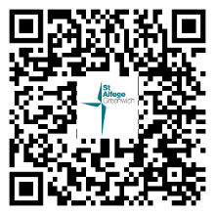

Services this week
Sunday 19 April Feast of St Alfege
8am Holy Communion (Book of Common Prayer)
10am Sung Eucharist
2.30pm Baptism of Maria Bela de Luca Gattai
Monday 20 April
8.30am Morning Prayer
Tuesday 21 April
8.30am Morning Prayer
Wednesday 22 April
8.30am Morning Prayer
Thursday 23 April
8.00am Holy Communion
Sunday 26 April Fourth Sunday of Easter
8am Holy Communion (Book of Common Prayer)
10am Sung Eucharist
4.00pm Choral Evensong
Please note that this is Marathon Sunday. Please check your travel arrangements in advance.
Walk-in Wednesdays
Every Wednesday 10am-12noon in the small hall
Contact us
Vicar: Revd Simon Winn
Curate: Revd Dr Tati Gutteridge (on maternity leave)
Church Office: 020 8853 0687
Email: office@st-alfege.org.uk Website: www.st-alfege.org.uk
Safeguarding Team
Karen Hansen Lead Safeguarding Officer 07866 932 894
Carole Moses Safeguarding Officer 07889 396 671
Irene Bishop Safeguarding Officer 020 8698 2658
safeguarding@st-alfege.org.uk

