

All Age Eucharist
with Baptisms
Mothering Sunday

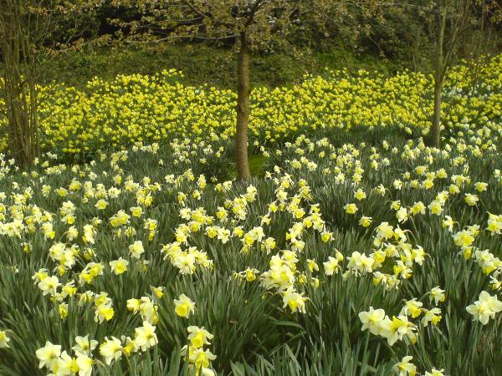

Sunday 15 March 2026
at 10am

Welcome to our all age Eucharist as we celebrate Mothering Sunday and the Baptism of Keeley Taylor, Valentin Gutteridge and Hugo Newman.
Baptism marks the beginning of a journey with God which continues for the rest of our lives, the first step in response to God's love. For all involved, particularly the candidates but also parents, godparents and sponsors, it is a joyful moment when we rejoice in what God has done for us in Christ, making serious promises and declaring the faith.
Our service is led by our Vicar, Revd Simon Winn and Dr Susan Pawlby is preaching. Members of our Children’s Church will be reading and helping with the service.
You will find everything you need for the service in this booklet. Please join in the words in bold.
The Mass setting is German Mass by Franz Schubert. St Alfege Choir is directed by Director of Music Joshua Ryan with Assistant Organist Ben Banks.
During the service we will take a collection to support the life and mission of our church. You can also use the card reader by the West and North door for electronic payments.
You can also pay online using the following details: PCC of St Alfege, Greenwich Sort Code: 60-09-16 Account number: 25249304. Please also note that if you are a UK tax payer the church can claim 25% Gift Aid in addition to your donation therefore, if eligible and if you are setting up a standing order, please request a Gift Aid declaration form from the church office: office@st-alfege.org.uk You can also use this QR code to donate.
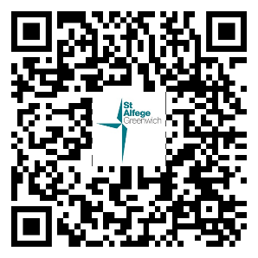
Please join us in the Hall after the service for refreshments.
Please stand as the choir, servers and clergy process into church.
THE GATHERING
Processional Hymn
I come with joy, a child of God
forgiven, loved and free,
the life of Jesus to recall
in love laid down for me.
I come with Christians far and near
to find, as all are fed,
the new community of love
in Christ's communion bread.
As Christ breaks bread, and bids us share,
each proud division ends.
The love that made us, makes us one,
and strangers now are friends.
The Spirit of the risen Christ,
unseen, but ever near,
is in such friendship better known,
alive among us here.
Together met, together bound,
by all that God has done,
we’ll go with joy, to give the world
the love that makes us one.

Words: Brian A Wren (b. 1936)
Music: St Botolph

The Greeting
Revd Simon welcomes us and says
The grace of our Lord Jesus Christ, the love of God
and the fellowship of the Holy Spirit be with you all
and also with you.
Confession and Forgiveness
Let us call to mind our sin, our failure to value the love of others and our failure to love as Christ has loved us.
We keep silence for reflection

Your love gives us life from the moment of conception.
But we fail to live as your children.
Lord have mercy.
Lord have mercy.
You call us to do good. But we seek our own good.
Christ have mercy.
Christ have mercy.
You hear us when we cry for help.
But we ignore the cries of others.
Lord have mercy.
Lord have mercy.
Revd Simon prays
May the Father forgive you by the death of the Son and strengthen you to live in the power of the Spirit all your days.
Amen.

THE LITURGY OF THE WORD

The Collect
The Church’s special prayer for this day
Let us pray.
God of love, passionate and strong,
tender and careful:
watch over us and hold us
all the days of our life;
through Jesus Christ our Lord. Amen.
Please sit for the first reading

First Reading
Exodus 3: 13-14
read by members of Children’s Church
Before the reading:
A reading from the book of Exodus
Moses said to God, ‘If I come to the Israelites and say to them, “The God of your ancestors has sent me to you”, and they ask me, “What is his name?” what shall I say to them?’ God said to Moses, ‘I am who I am.’ He said further, ‘Thus you shall say to the Israelites, “I am has sent me to you.”’
At the end:
This is the word of the Lord Thanks be to God

Please stand for the Gradual Hymn

Gradual Hymn
Breathe on me, Breath of God,
fill me with life anew,
that as you love, so may I love,
and do what you would do.
Breathe on me, Breath of God,
until my heart is pure;
until my will is one with yours,
to do and to endure.
Breathe on me, Breath of God,
fulfil my heart’s desire,
until this earthly part of me
glows with your fire divine.
Breathe on me, Breath of God,
so shall I never die,
but live with you the perfect life
of your eternity.
Words: Charles Lockhart (1745-1815)
Music: Edwin Hatch (1835-1889)

Gospel Reading
John 19: 25b - 27
read by members of Children’s Church
Hear the Gospel of our Lord Jesus Christ according to John
Glory to you, O Lord
Standing near the cross of Jesus were his mother, and his mother’s sister, Mary the wife of Clopas, and Mary Magdalene. When Jesus saw his mother and the disciple whom he loved standing beside her, he said to his mother, ‘Woman, here is your son.’ Then he said to the disciple, ‘Here is your mother.’ And from that hour the disciple took her into his own home.
This is the Gospel of the Lord
Praise to you, O Christ
Sermon
Dr Susan Pawlby, Developmental Psychologist
We sit when invited

Song
Children’s Church will sing If I were a butterfly
If I were a butterfly I’d thank you Lord for giving me wings
And if I were a robin in a tree I’d thank you Lord that I could sing.
And if I were a fish in the sea I’d wiggle my tail and I’d giggle with glee
Chorus
But…I just thank you, Father for making me, me.
For you gave me a heart and you gave me a smile.
You gave me Jesus and you made me your child.
And I just thank you, Father, for making me.
If I were an elephant I’d thank you Lord by raising my trunk.
And if I were a kangaroo I’d just hop right up to you.
And if I were an octopus I’d thank you Lord for my good looks.
Chorus
If I were a wiggly worm I’d thank you Lord that I could squirm.
And if I were a crocodile I’d thank you Lord for my big smile.
And if I were a fuzzy wuzzy bear I’d thank you Lord for my fuzzy wuzzy hair.
Chorus

THE LITURGY OF BAPTISM
The candidates, parents and godparents assemble around the font. The rest of the congregation remain seated.
Revd Simon says

Our Lord Jesus Christ has told us
that to enter the kingdom of heaven
we must be born again of water and the Spirit,
and has given us Baptism as the sign and seal
of this new birth.
Here we are washed by the Holy Spirit and made clean.
Here we are clothed with Christ,
dying to sin that we may live his risen life.
As children of God, we have a new dignity
and God calls us to fullness of life.
Revd Simon addresses the congregation:
We thank God for Keeley, Valentin and Hugo
who have come to be baptized today.
Christ loves them and welcomes them into his Church.
So I ask you all:
People of God, will you welcome this candidates and these children and uphold them in their new life in Christ?
With the help of God, we will.

Revd Simon addresses the parents and godparents:
God knows each of us by name and we are his. Parents and godparents, you speak for Valentin and Hugo today.
Will you pray for them,
and help them to follow Christ?
We will.
Revd Simon asks Keeley:
Do you wish to be baptized?
I do.
The Decision
Revd Simon addresses Keeley, and the children through their parents and godparents.
We all wander far from God and lose our way:
Christ comes to find us and welcomes us home.
In baptism we respond to his call.
Do you turn to Christ?
I turn to Christ.
Do you repent of your sins?
I repent of my sins.
Do you renounce evil?
I renounce evil.
Signing with the Cross
Revd Simon makes the sign of the cross with holy oil on the candidates’ foreheads, saying:
Christ claims you for his own.
Receive the sign of his cross.
Revd Simon says:
Do not be ashamed of Christ.
You are his for ever.
Stand bravely with him
against all the powers of evil,
and remain faithful to Christ to the end of your life.
May almighty God deliver you from the powers of
darkness, and lead you in the light and obedience of Christ. Amen.
Prayer over the Water

Revd Simon stands before the water of Baptism and says:
Praise God who made heaven and earth
who keeps his promise for ever.
Let us give thanks to the Lord our God.
It is right to give thanks and praise.
Almighty God, whose Son Jesus Christ was baptized in the river Jordan: we thank you for the gift of water to cleanse and revive us.
We thank you that through the waters of the Red Sea:
you led your people out of slavery to freedom in the promised land.
We thank you that through the deep waters of death
you brought your Son, and raised him to life in triumph.
Bless this water, that your servants who are
washed in it may be made one with Christ in
his death and in his resurrection, to be
cleansed and delivered from all sin.
Send your Holy Spirit upon them,
bring them to new birth in the household of faith,
and raise them with Christ to full and eternal life;
for all might, majesty, authority, and power are yours,
now and for ever.
Amen.

Profession of Faith
Revd Simon addresses the congregation:
Let us affirm,
together with these who are being baptized,
our common faith in Jesus Christ.
Do you believe and trust in God the Father,
source of all being and life,
the one for whom we exist?
I believe and trust in him.
Do you believe and trust in God the Son,
who took our human nature,
died for us and rose again?
I believe and trust in him.
Do you believe and trust in God the Holy Spirit,
who gives life to the people of God
and makes Christ known in the world?
I believe and trust in him.
This is the faith of the Church.
This is our faith.
We believe and trust in one God,
Father, Son and Holy Spirit.
Revd Simon says to Keeley:
Keeley is this your faith?
Keeley answers in her own words, or says:
This is my faith.

Baptism
Revd Simon and Revd Tati pour water on the candidates, saying:
N, I baptize you
in the name of the Father, and of the Son,
and of the Holy Spirit.
Amen.
Revd Simon says:
May God, who has received you by Baptism
into his Church, pour upon you the riches of his grace,
that within the company of Christ's pilgrim people
you may daily be renewed by his anointing Spirit,
and come to the inheritance of the saints in glory.
Amen.

Welcome
There is one Lord, one faith, one baptism:
Keeley, Valentin and Hugo, by one Spirit we are all baptized into one body.
We welcome you into the fellowship of faith;
we are children of the same heavenly Father;
we welcome you.
Candidates, parents and godparents sit down.

The choir sings the Anthem:

Justus ut palma – Colin Mawby
Justus ut palma florebit: sicut cedrus Libani multiplicabitur in domo Domini.
(The just shall flourish like the palm tree; he shall grow up like the cedar of Lebanon)
How amiable are they tabernacles, O Lord of hosts!
My soul longeth, yea, even fainteth for the courts of the Lord.
My heart and my flesh crieth out for the living God.
Blessed are they that dwell in thy house.
Blessed is the man whose strength is in thee, O Lord of hosts!
Blessed is the man that trusteth in thee.
Psalm 92:13; Psalm 84:1,2,4,5,12

Blessing and Distribution of Flowers
Lord Jesus, who grew up in an earthly home in trust and obedience to earthly parents: Visit and bless all the homes of our parish. May we share in the knowledge of your love and be brought into the joy of your heavenly kingdom. Amen.
Father, bless these small gifts of flowers, that they may be channels of your love to those who give and receive them, and bind them ever more closely to yourself and to each other. Amen.
The children distribute the posies to the congregation as music is played. Then we stand.

Revd Simon introduces the Peace in these or other suitable words:
The Peace
We are all one in Christ Jesus.
We belong to him through faith,
heirs of the promise of the Spirit of peace.
The peace of the Lord be always with you
and also with you.
Revd Simon says:
Let us offer one another a sign of peace.
All may exchange a sign of peace.

THE LITURGY OF THE EUCHARIST
Offertory Hymn
A collection for the ministry and mission of our church will be taken during the hymn. You may also donate later using our electronic card readers at the West and North Doors.
I danced in the morning when the world was begun,
and I danced in the moon and the stars and the sun,
and I came down from heaven and I danced on the earth,
at Bethlehem I had my birth.
Refrain:
"Dance, then, wherever you may be,
I am the Lord of the Dance," said he,
“and I'll lead you all, wherever you may be,
and I’ll lead you all in the dance," said he.
I danced for the scribe and the Pharisee,
but they would not dance and they wouldn't follow me.
I danced for the fishermen, for James and John;
they came with me and the dance went on. [Refrain]
I danced on the Sabbath and I cured the lame;
the holy people, said it was a shame.
They whipped and they stripped and they hung me on high,
and they left me there on a cross to die. [Refrain]
I danced on a Friday when the sky turned black;
it's hard to dance with the devil on your back.
They buried my body, and they thought I'd gone,
but I am the dance, and I still go on. [Refrain]

They cut me down and I leapt up high;
I am the life that'll never, never die;
I'll live in you if you'll live in me;
I am the Lord of the Dance, said he.

Refrain:
"Dance, then, wherever you may be,
I am the Lord of the Dance," said he,
“and I'll lead you all, wherever you may be,
and I’ll lead you all in the dance," said he.
Words: Sydney Carter (1915-2004)
Music: Lord of the Dance. Traditional American melody adapted by Sydney Carter
Offertory Prayer
Blessed be God, by whose grace creation is renewed,
by whose love heaven is opened, by whose mercy we offer our sacrifice of praise.
Blessed be God for ever.
We remain standing

The Eucharistic Prayer
The Lord be with you
and also with you.
Lift up your hearts
We lift them to the Lord.
Let us give thanks to the Lord our God
It is right to give thanks and praise.
It is right to praise you, Father, Lord of all creation;
in your love you made us for yourself.
When we turned away you did not reject us,
but came to meet us in your Son.
You embraced us as your children
and welcomed us to sit and eat with you.
In Christ you shared our life
that we might live in him and he in us.
He opened his arms of love upon the cross
and made for all the perfect sacrifice for sin.
On the night he was betrayed,
at supper with his friends
he took bread, and gave you thanks;
he broke it and gave it to them, saying;
Take, eat; this is my body which is given for you;
do this in remembrance of me.
Father, we do this in remembrance of him:
his body is the bread of life.
At the end of supper, taking the cup of wine,
he gave you thanks, and said:
Drink this, all of you; this is my blood of the new covenant,
which is shed for you for the forgiveness of sins;
do this in remembrance of me.
Father, we do this in remembrance of him:
his blood is shed for all.
As we proclaim his death and celebrate his rising in glory,
send your Holy Spirit that this bread and this wine
may be to us the body and blood of your dear Son.
As we eat and drink these holy gifts
make us one in Christ, our risen Lord.
With your whole Church throughout the world
we offer you this sacrifice of praise
and lift our voice to join the eternal song of heaven:
We all sing the Sanctus and Benedictus from Schubert’s German Mass
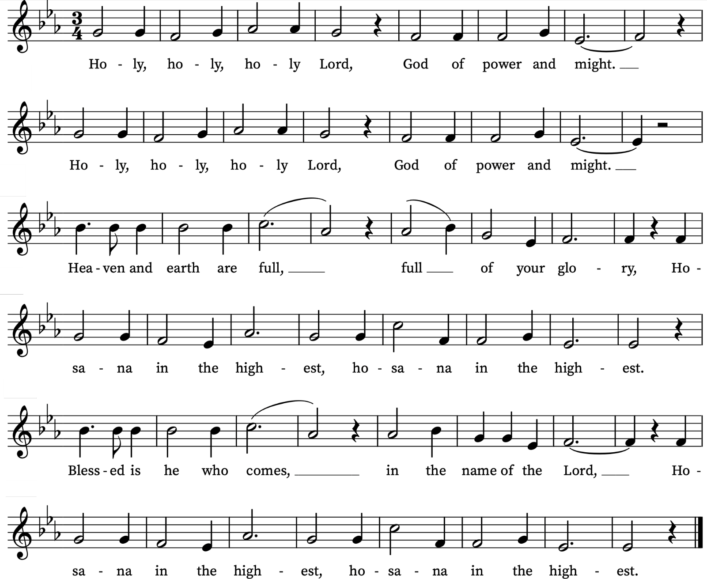

We sit

The Lord's Prayer

Trusting in the compassion of God, let us pray with confidence as our Saviour has taught us
Our Father, who art in heaven,
hallowed be thy name;
thy kingdom come; thy will be done,
on earth as it is in heaven.
Give us this day our daily bread.
And forgive us our trespasses,
as we forgive those who trespass against us.
And lead us not into temptation;
but deliver us from evil.
For thine is the kingdom,
the power and the glory,
for ever and ever. Amen
Breaking of the Bread
Revd Simon breaks the consecrated bread.
We break this bread to share in the body of Christ.
Though we are many, we are one body,
because we all share in one bread.

Giving of Communion
Come to this table, not because you must,
but because you may;
Not because you are strong,
but because you are weak;
Not because you have arrived
but because you are still on a journey;

Come because you love the Lord a little
and want to love him more.
Above all come because he loves you
and gave himself for you.
Everyone is invited to come forward to the altar rail to receive the sacrament or a blessing, after which we reply Amen.
If you would like to receive a blessing rather than communion, please bow your head. We are offering communion in both kinds, the bread (wafer) and the wine (in the cup or chalice). If you would prefer not to receive the wine from the chalice/cup please bow your head or simply leave the altar rail after receiving the wafer. Please do not intinct (dip your wafer in the chalice). Please return to your seats via the side chapels. If you need communion brought to you, please let a welcomer know. If you need a gluten-free wafer please let a welcomer know.
During the administration, the choir sings the Communion Anthems:
Agnus Dei, from German Mass – Franz Schubert
How lovely are thy dwelling places from German Requiem – Johannes Brahms
How lovely are thy dwellings fair, O Lord of Hosts,
My soul ever longeth and fainteth
for the blest courts of the Lord
my heart and flesh do cry to God, to the living God,
O blest are they that in Thy house are dwelling,
they ever praise Thee, O Lord.
From Psalm 84: 1, 2, 4
We pray together
Prayer after Communion
Loving God, as a mother feeds her children at the breast,
you feed us in this sacrament with the food and drink of eternal life: help us who have tasted your goodness to grow in grace within the household of faith; through Jesus Christ our Lord. Amen.

Notices
We stand to sing
Final Hymn
Blessed assurance, Jesus is mine!
O what a foretaste of glory divine!
Heir of salvation, purchase of God;
born of his Spirit, washed in his blood.
Refrain:
This is my story, this is my song,
praising my Saviour all the day long.
This is my story, this is my song,
praising my Saviour all the day long.
Perfect submission, perfect delight,
visions of rapture burst on my sight;
angels descending, bring from above
echoes of mercy, whispers of love.
Refrain
Perfect submission, all is at rest,
I in my Saviour am happy and blest;
watching and waiting, looking above,
filled with his goodness, lost in his love.
Refrain
Words: Frances Jane van Alstyne (Fanny J. Crosby) (1820-1915)
Music: Phoebe Palmer Knapp (1839-1908)

THE SENDING OUT

Giving of a Lighted Candle
Revd Simon gives Keeley and the children’s parents a lighted candle, and says:
God has delivered us from the dominion of darkness
and has given us a place with the saints in light.
You have received the light of Christ;
walk in this light all the days of your life.
Shine as a light in the world
to the glory of God the Father.
Blessing
Revd Simon blesses all those present:
The God of all hope fill you with all joy and peace in believing;
and the blessing of God almighty,
the Father, the Son, and the Holy Spirit,
be upon you and remain with you always.
Amen.

Dismissal
Go in the light and peace of Christ.
Thanks be to God.
Please remain standing as the choir, servers and clergy depart.
Organ Voluntary
Kyrie, Gott heiliger Geist, BWV 671 – J. S. Bach
Please come for refreshments in the church hall and green afterwards.
If you would like to pray with someone in confidence after the service, one of our clergy or a lay minister will be available in the South Chapel. You are welcome to ask for prayer for wholeness and healing, personal circumstances, or anything else that is on your heart. The St Alfege Chapel is available for private prayer and lighting candles.

Welcome to Children's Church!
Join us on Sundays in the Church Hall for a morning of fun, friendship, and faith! All families with children are welcome. We ask that a parent or carer accompanies their child/children.
Activities include:
- Bible stories; praying together;
- sing-along songs; creative crafts; Holy Communion together.
Our usual schedule is:
- Registration from 9.55 to 10.05; Worship from 10.05 to 10.15;
- Bible Time from 10.15 to 10.35; Fun Activities from 10.35 to 11.00.
For more details please speak to Alison Wood or Moira Searle. Please check the Children’s Church board at the back of church and chat to them in the Hall over tea/coffee after the service. Alternatively contact the church office: office@st-alfege.org.uk or 020 8853 0687.

Contact us
Vicar: Revd Simon Winn
Curate: Revd Dr Tati Gutteridge (on maternity leave)
Church Office: 020 8853 0687
Email: office@st-alfege.org.uk Website: www.st-alfege.org.uk
Safeguarding Team
Karen Hansen Lead Safeguarding Officer 07866 932 894
Carole Moses Safeguarding Officer 07889 396 671
Irene Bishop Safeguarding Officer 020 8698 2658
safeguarding@st-alfege.org.uk

Regular Sunday Services at St Alfege Church
8am Holy Communion
A said communion service (1662 Book of Common Prayer).
10am Parish Eucharist
A sung communion service (Common Worship).
Our vibrant Children's Church meets in the hall.

Abide
A reflective and meditative service drawing on traditions such as Taizé and the Northumbria community. On the first Sunday of every month at 5.30pm. (There is no service on 5 April)

Choral Evensong
On the last Sunday of every month at 4pm (except December & August)
Regular Weekday Services at St Alfege Church
Morning Prayer
Mondays, Tuesdays and Wednesdays at 8.30am.
Holy Communion
Thursday mornings at 8.00am
Walk-In Wednesdays
Every Wednesday 10am to 12noon in the Frank Smith Room in the hall. Drop in for a cuppa and a chat.
The 10am service is live-streamed from the gallery at the back of the Church. We do not film while Communion is taking place.
Advanced Notice
British Summer Time starts in the early morning of Sunday 29 March. The clocks go forward by one hour
Services for Holy Week and Easter
Palm Sunday 29 March
8am Holy Communion (Book of Common Prayer)
10am Sung Eucharist with Blessing of Palms and Procession
Monday 30 March, Tuesday 31 March and
Wednesday 1 April
8.30am Morning Prayer
Monday 30 March
8pm Night Prayer (Compline) A short service in St Alfege Chapel
Maundy Thursday 2 April
8pm Sung Eucharist. In Church with Washing of Feet, Stripping of the Sanctuary, and Watch until Midnight.
Good Friday 3 April
10am Family Service. In Church. Followed by hot cross buns and refreshments.
12 noon Liturgy of the Cross. At the Old Royal Naval College Chapel. Followed by Procession with Cross to St Alfege Church.
2pm Good Friday Worship. Readings, prayers, hymns, silence and reflections. Ends around 3pm.
Holy Saturday 4 April
8pm Easter Vigil service. With kindling of the Easter fire and lighting of the Paschal Candle. Celebratory drink afterwards.
Easter Sunday 5 April
8am Holy Communion (Book of Common Prayer)
10am All Age Sung Eucharist with Renewal of Baptismal Vows and Easter Egg Hunt

Please take this service booklet home with you

