

Sung Eucharist
Second Sunday before Lent
8 February 2026
Welcome to our services of Holy Communion today. Revd Simon Winn, Vicar, is presiding at 8am and Revd Stephen Nshimye at 10am. David McEvoy, Reader, is preaching at both services. Revd Simon is leading Children’s Church in the Hall at 10am. Revd Mark Hatcher is leading worship at St Mary’s Woolwich at 10am. We sing together the Kyrie from Schubert’s German Mass (on page 2 of this sheet).
Readings
Genesis 1:1 – 2:3
Psalm 136: 1-9
Romans 8: 18-25
Matthew 6: 25-34
Hymns
199 Immortal, invisible, God only wise
In heavenly love abiding (on page 5 of this sheet)
105 All creatures of our God and King (omit verse 4)
106 Lord of beauty, thine the splendour
Collect
Almighty God, you have created the heavens and the earth
and made us in your own image: teach us to discern your hand in all your works and your likeness in all your children; through Jesus Christ your Son our Lord, who with you and the Holy Spirit reigns supreme over all things, now and for ever. Amen
Prayer after Communion
God our creator, by your gift the tree of life was set at the heart of the earthly paradise, and the bread of life at the heart of your Church: may we who have been nourished at your table on earth be transformed by the glory of the Saviour’s cross and enjoy the delights of eternity; through Jesus Christ our Lord.
Amen
Kyrie
We sing the Kyrie from Schubert’s German Mass
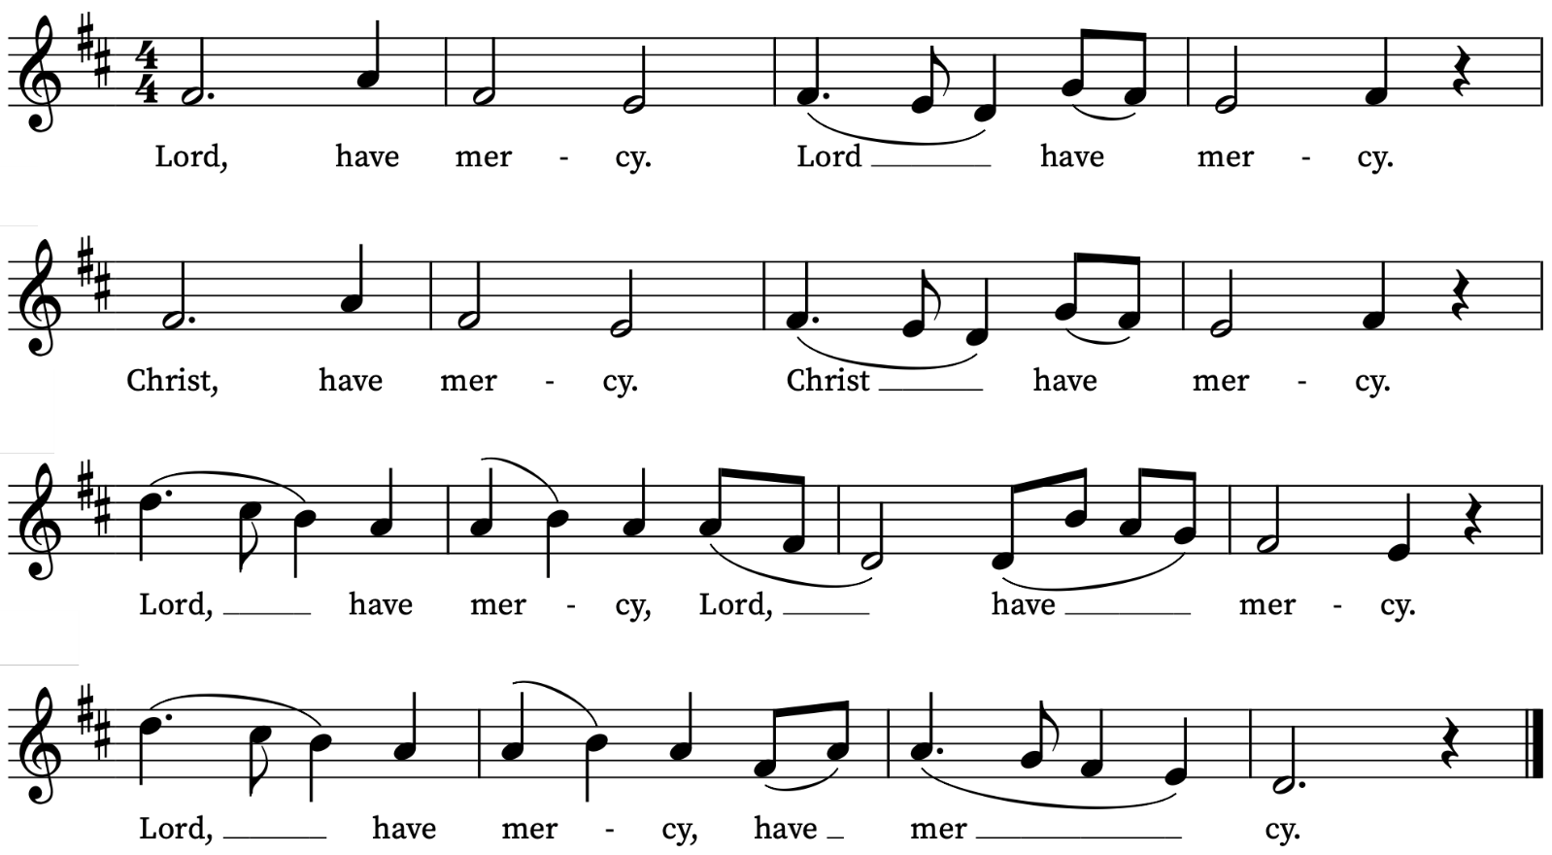

First Reading
Genesis 1:1 – 2:3
A reading from the book of Genesis
In the beginning when God created the heavens and the earth, the earth was a formless void and darkness covered the face of the deep, while a wind from God swept over the face of the waters. Then God said, ‘Let there be light’; and there was light. And God saw that the light was good; and God separated the light from the darkness. God called the light Day, and the darkness he called Night. And there was evening and there was morning, the first day.
And God said, ‘Let there be a dome in the midst of the waters, and let it separate the waters from the waters.’ So God made the dome and separated the waters that were under the dome from the waters that were above the dome. And it was so. God called the dome Sky. And there was evening and there was morning, the second day.
And God said, ‘Let the waters under the sky be gathered together into one place, and let the dry land appear.’ And it was so. God called the dry land Earth, and the waters that were gathered together he called Seas. And God saw that it was good. Then God said, ‘Let the earth put forth vegetation: plants yielding seed, and fruit trees of every kind on earth that bear fruit with the seed in it.’ And it was so. The earth brought forth vegetation: plants yielding seed of every kind, and trees of every kind bearing fruit with the seed in it. And God saw that it was good. And there was evening and there was morning, the third day.
And God said, ‘Let there be lights in the dome of the sky to separate the day from the night; and let them be for signs and for seasons and for days and years, and let them be lights in the dome of the sky to give light upon the earth.’ And it was so. God made the two great lights—the greater light to rule the day and the lesser light to rule the night—and the stars. God set them in the dome of the sky to give light upon the earth, to rule over the day and over the night, and to separate the light from the darkness. And God saw that it was good. And there was evening and there was morning, the fourth day.
And God said, ‘Let the waters bring forth swarms of living creatures, and let birds fly above the earth across the dome of the sky.’ So God created the great sea monsters and every living creature that moves, of every kind, with which the waters swarm, and every winged bird of every kind. And God saw that it was good. God blessed them, saying, ‘Be fruitful and multiply and fill the waters in the seas, and let birds multiply on the earth.’ And there was evening and there was morning, the fifth day.
And God said, ‘Let the earth bring forth living creatures of every kind: cattle and creeping things and wild animals of the earth of every kind.’ And it was so. God made the wild animals of the earth of every kind, and the cattle of every kind, and everything that creeps upon the ground of every kind. And God saw that it was good.
Then God said, ‘Let us make humankind in our image, according to our likeness; and let them have dominion over the fish of the sea, and over the birds of the air, and over the cattle, and over all the wild animals of the earth, and over every creeping thing that creeps upon the earth.’
So God created humankind in his image,
in the image of God he created them;
male and female he created them.
God blessed them, and God said to them, ‘Be fruitful and multiply, and fill the earth and subdue it; and have dominion over the fish of the sea and over the birds of the air and over every living thing that moves upon the earth.’ God said, ‘See, I have given you every plant yielding seed that is upon the face of all the earth, and every tree with seed in its fruit; you shall have them for food. And to every beast of the earth, and to every bird of the air, and to everything that creeps on the earth, everything that has the breath of life, I have given every green plant for food.’ And it was so. God saw everything that he had made, and indeed, it was very good. And there was evening and there was morning, the sixth day.
Thus the heavens and the earth were finished, and all their multitude. And on the seventh day God finished the work that he had done, and he rested on the seventh day from all the work that he had done. So God blessed the seventh day and hallowed it, because on it God rested from all the work that he had done in creation.
This is the Word of the Lord
Thanks be to God
Psalm 136: 1-9
Confitemini
O give thanks unto the Lord, for he is gracious : and his mercy endureth for ever.
2 O give thanks unto the God of all gods : for his mercy endureth for ever.
3 O thank the Lord of all lords : for his mercy endureth for ever.
4 Who only doeth great wonders : for his mercy endureth for ever.
5 Who by his excellent wisdom made the heavens : for his mercy endureth for ever.
6 Who laid out the earth above the waters : for his mercy endureth for ever.
7 Who hath made great lights : for his mercy endureth for ever;
8 The sun to rule the day : for his mercy endureth for ever;
9 The moon and the stars to govern the night : for his mercy endureth for ever.

Second Reading
Romans 8: 18-25
A reading from Paul’s Letter to the Romans
I consider that the sufferings of this present time are not worth comparing with the glory about to be revealed to us. For the creation waits with eager longing for the revealing of the children of God; for the creation was subjected to futility, not of its own will but by the will of the one who subjected it, in hope that the creation itself will be set free from its bondage to decay and will obtain the freedom of the glory of the children of God. We know that the whole creation has been groaning in labour pains until now; and not only the creation, but we ourselves, who have the first fruits of the Spirit, groan inwardly while we wait for adoption, the redemption of our bodies. For in hope we were saved. Now hope that is seen is not hope. For who hopes for what is seen? But if we hope for what we do not see, we wait for it with patience.
This is the Word of the Lord
Thanks be to God

Gradual Hymn
In heavenly love abiding,
no change my heart shall fear;
and safe is such confiding,
for nothing changes here.
The storm may roar without me,
my heart may low be laid;
but God is round about me,
and can I be dismayed?
Wherever he may guide me,
no want shall turn me back;
my Shepherd is beside me,
and nothing can I lack.
His wisdom ever waketh,
his sight is never dim,
he knows the way he taketh,
and I will walk with him.
Green pastures are before me,
which yet I have not seen;
bright skies will soon be o'er me,
where darkest clouds have been.
My hope I cannot measure,
my path to life is free;
my Saviour has my treasure,
and he will walk with me.
Words: Anna Laetitia Waring (1820-1910) based on Psalm 23
Melody: David Jenkins (1848-1915)

Gospel Reading
Matthew 6: 25-34
Hear the Gospel of our Lord Jesus Christ according to Matthew
Glory be to thee, O Lord
‘Therefore I tell you, do not worry about your life, what you will eat or what you will drink, or about your body, what you will wear. Is not life more than food, and the body more than clothing? Look at the birds of the air; they neither sow nor reap nor gather into barns, and yet your heavenly Father feeds them. Are you not of more value than they? And can any of you by worrying add a single hour to your span of life? And why do you worry about clothing? Consider the lilies of the field, how they grow; they neither toil nor spin, yet I tell you, even Solomon in all his glory was not clothed like one of these. But if God so clothes the grass of the field, which is alive today and tomorrow is thrown into the oven, will he not much more clothe you—you of little faith? Therefore do not worry, saying, “What will we eat?” or “What will we drink?” or “What will we wear?” For it is the Gentiles who strive for all these things; and indeed your heavenly Father knows that you need all these things. But strive first for the kingdom of God and his righteousness, and all these things will be given to you as well.
‘So do not worry about tomorrow, for tomorrow will bring worries of its own. Today’s trouble is enough for today.
This is the Gospel of the Lord
Praise be to thee, O Christ

Today’s Music
Mass setting
(Gloria, Sanctus/Benedictus and Agnus Dei)
Communion Service in C minor – Charles Wood
Anthem
Awake the harp from The Creation – FJ Haydn
Awake the harp, the lyre awake,
And let your joyful song resound,
Rejoice in the Lord, the mighty God:
For He both the heavens and the earth
Hath cloth'd in stately dress.
Communion
Agnus Dei from Communion Service in C minor – Charles Wood
Tantum ergo – Maurice Duruflé
Tantum ergo Sacramentum Veneremur cernui:
Et antiquum Documentum Novo cedat ritui:
Praestet fides supplementum Sensuum defectui.
Genitori, Genitoque laus et jubilatio, salus, honor, virtus quoque
sit et benedictio: procedenti ab utroque compar sit laudatio. Amen.
Down in adoration falling, Lo! the sacred Host we hail,
Lo! o'er ancient forms departing Newer rites of grace prevail;
Faith for all defects supplying, Where the feeble senses fail.
To the everlasting Father, And the Son Who reigns on high
With the Holy Ghost proceeding Forth from Each eternally,
Be salvation, honour, blessing, Might and endless majesty. Amen.
Organ Postlude
Carillon – Herbert Brewer
Prayers for the week
We ask God’s blessing on Antonia Thwaites and Lars Fischer and on Valerie Johnson and Edward Voegli who are getting married in church this week.
We pray for those in need: Anthony, Fran Barlow, Ian Clark, Helen Delap, Dan Delap, Delroy Donegal, Andrew Fraser, Nick Hervey, Susan and Anthony Holland, Carole Hubble, Nancy John, Lena Kimming, Lylian Meira, Nancy Mence, Nimal Menon, Vernon Mustoe, Nicola Orme, Tony Othen, Vinubhai Patel, Jessica Springbett, Jean Smith, Tina Stanley, Jessica Tipton, Sabrina Unold, George Voelker, Pauline Youll, and Joshua Zitha.
We remember those who have died recently, including David Donaghy, Christopher Follett, Hessie Hervey, Aminta Prowse and Richard Pulkowski. We remember those who have died in Iran in recent weeks, praying by name for: Kiarash, Mohammad, Soroush, Sina, Alireza, Hossein, Davoud, Akbar, Many, and Mosin. We ask God’s blessing and comfort on all mourning the loss of loved ones.
We will be starting afresh with the list of names of those who are ill or in need from Sunday 15 February. If you would like to retain (or add) names of loved ones on the list please email David McEvoy dmcevoy@btinternet.com by Wednesday 11 February.
Supporting St Alfege Church
Please do make a gift to support the life and ministry of St Alfege Church – during the collection in the service or by using a card reader at the North and West Doors. Please complete a Gift Aid envelope (if you are eligible) whether you donate by cash or card. You can also use this QR code to donate. | 

2026 LENT COURSE

This year’s Lent Course will follow a programme designed by Embrace the Middle East entitled Gracious Dialogue: A Guide to Listening and Speaking Well about Israel and Palestine. The purpose of the course is to help church groups engage in respectful, informed conversations about the complexities of the Israel-Palestine conflict. The course provides theological perspectives, historical context, and guidance on encouraging empathy and understanding across differing viewpoints.

Participants are invited to purchase the course booklet from their group leader at the price of £7. Everyone is asked to commit to the same group throughout the course if possible.

8.00pm Tuesdays (starting 24 February): online, led by Moira Searle and others. To join and get Zoom links, email Richard Mash at rsmash03@gmail.com.

7.00pm Wednesdays (starting 25 February): at the Vicarage, 33 Park Vista, led by the Revd Simon Winn and others. To join, email St Alfege church office: office@st-alfege.org.uk.

10.00am Thursdays (starting 26 February): in the Parish Small Hall at St Alfege Church, led by the Revd Robert Tobin and others. To join, email chaplain@ornc.org.

Services this Week
Sunday 8 February Second Sunday before Lent
8.00am Holy Communion (Said) (Book of Common Prayer)
10.00am Sung Eucharist and Children’s Church
Monday 9 February
8.30am Morning Prayer
11.00am Wedding Antonia Thwaites and Lars Fisher
Tuesday 10 February
8.30am Morning Prayer
Wednesday 11 February
8.30am Morning Prayer
Thursday 12 February
8.30am Morning Prayer
11.00am Wedding Valerie Johnson and Edward Voegli
Sunday 15 February Sunday before Lent
8.00am Holy Communion (Said) (Book of Common Prayer)
10.00am Sung Eucharist and Children’s Church
Walk-in Wednesdays
Every Wednesday 10am-12noon in the small hall
Contact us
Vicar: Revd Simon Winn
Curate: Revd Dr Tati Gutteridge (on maternity leave)
Church Office: 020 8853 0687
Email: office@st-alfege.org.uk Website: www.st-alfege.org.uk
Safeguarding Team
Karen Hansen Lead Safeguarding Officer 07866 932 894
Carole Moses Safeguarding Officer 07889 396 671
Irene Bishop Safeguarding Officer 020 8698 2658
safeguarding@st-alfege.org.uk

