

Sung Eucharist
Conversion of Paul
Sunday 25 January 2026
Welcome to our services of Holy Communion today. Revd Simon Winn, Vicar, is presiding and preaching at 8am and 10am. We sing together the Kyrie from Schubert’s German Mass (on page 2 of this sheet).
Readings
Acts 9: 1-22
Psalm 67
Galatians 1: 11-16a
Matthew 19: 27-30
Hymns
199 Immortal, invisible, God only wise
118 Firmly I believe and truly
431 We have a gospel to proclaim
Lord, you give the great commission (Hyfrydol) (on page x of this sheet)
Collect
Almighty God, who caused the light of the gospel to shine throughout the world through the preaching of your servant Saint Paul: grant that we who celebrate his wonderful conversion may follow him in bearing witness to your truth;
through Jesus Christ your Son our Lord, who is alive and reigns with you, in the unity of the Holy Spirit, one God, now and for ever. Amen
Prayer after Communion
Almighty God, who on the day of Pentecost sent your Holy Spirit to the apostles with the wind from heaven and in tongues of flame, filling them with joy and boldness to preach the gospel: by the power of the same Spirit strengthen us to witness to your truth and to draw everyone to the fire of your love; through Jesus Christ our Lord. Amen
Kyrie
We sing the Kyrie from Schubert’s German Mass
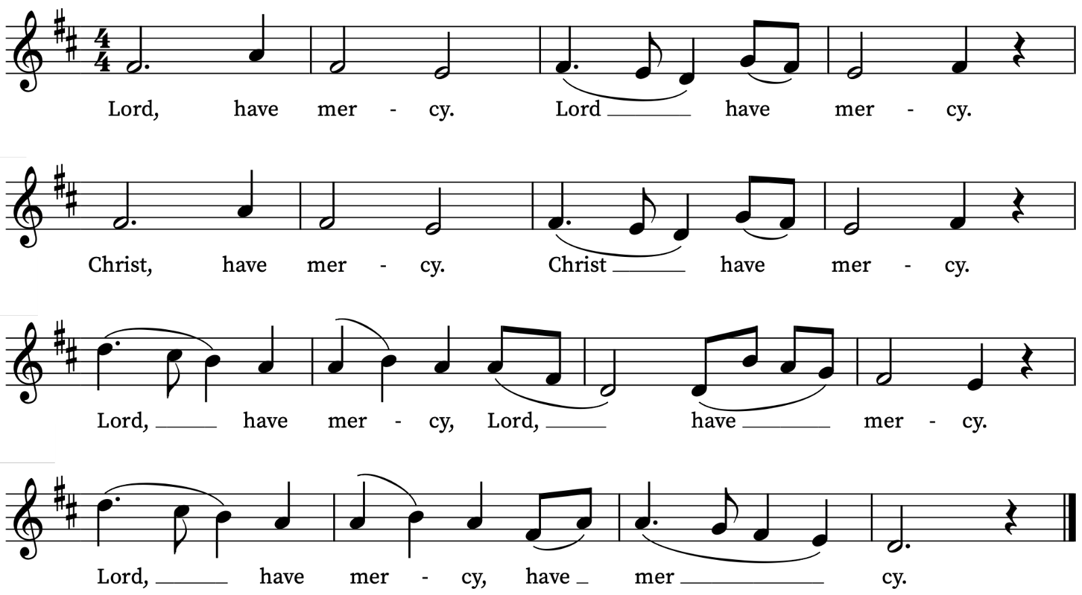
First Reading
Acts 9: 1-22
A reading from the Acts of the Apostles
Meanwhile Saul, still breathing threats and murder against the disciples of the Lord, went to the high priest and asked him for letters to the synagogues at Damascus, so that if he found any who belonged to the Way, men or women, he might bring them bound to Jerusalem. Now as he was going along and approaching Damascus, suddenly a light from heaven flashed around him. He fell to the ground and heard a voice saying to him, ‘Saul, Saul, why do you persecute me?’ He asked, ‘Who are you, Lord?’ The reply came, ‘I am Jesus, whom you are persecuting. But get up and enter the city, and you will be told what you are to do.’ The men who were travelling with him stood speechless because they heard the voice but saw no one. Saul got up from the ground, and though his eyes were open, he could see nothing; so they led him by the hand and brought him into Damascus. For three days he was without sight, and neither ate nor drank.
Now there was a disciple in Damascus named Ananias. The Lord said to him in a vision, ‘Ananias.’ He answered, ‘Here I am, Lord.’ The Lord said to him, ‘Get up and go to the street called Straight, and at the house of Judas look for a man of Tarsus named Saul. At this moment he is praying, and he has seen in a vision a man named Ananias come in and lay his hands on him so that he might regain his sight.’ But Ananias answered, ‘Lord, I have heard from many about this man, how much evil he has done to your saints in Jerusalem; and here he has authority from the chief priests to bind all who invoke your name.’ But the Lord said to him, ‘Go, for he is an instrument whom I have chosen to bring my name before Gentiles and kings and before the people of Israel; I myself will show him how much he must suffer for the sake of my name.’ So Ananias went and entered the house. He laid his hands on Saul and said, ‘Brother Saul, the Lord Jesus, who appeared to you on your way here, has sent me so that you may regain your sight and be filled with the Holy Spirit.’ And immediately something like scales fell from his eyes, and his sight was restored. Then he got up and was baptized, and after taking some food, he regained his strength.
For several days he was with the disciples in Damascus, and immediately he began to proclaim Jesus in the synagogues, saying, ‘He is the Son of God.’ All who heard him were amazed and said, ‘Is not this the man who made havoc in Jerusalem among those who invoked this name? And has he not come here for the purpose of bringing them bound before the chief priests?’ Saul became increasingly more powerful and confounded the Jews who lived in Damascus by proving that Jesus was the Messiah.
This is the Word of the Lord
Thanks be to God

Psalm 67
Deus misereatur
God be merciful unto us, and bless us : and shew us the light of his countenance, and be merciful unto us:
2 That thy way may be known upon earth : thy saving health among all nations.
3 Let the people praise thee, O God : yea, let all the people praise thee.
4 O let the nations rejoice and be glad : for thou shalt judge the folk righteously, and govern the nations upon earth.
5 Let the people praise thee, O God : let all the people praise thee.
6 Then shall the earth bring forth her increase : and God, even our own God, shall give us his blessing.
7 God shall bless us : and all the ends of the world shall fear him.
Second Reading
Galatians 1: 11-16a
A reading from Paul’s Letter to the Galatians
For I want you to know, brothers and sisters, that the gospel that was proclaimed by me is not of human origin; for I did not receive it from a human source, nor was I taught it, but I received it through a revelation of Jesus Christ.
You have heard, no doubt, of my earlier life in Judaism. I was violently persecuting the church of God and was trying to destroy it. I advanced in Judaism beyond many among my people of the same age, for I was far more zealous for the traditions of my ancestors. But when God, who had set me apart before I was born and called me through his grace, was pleased to reveal his Son to me, so that I might proclaim him among the Gentiles.
This is the Word of the Lord
Thanks be to God
Gospel Reading
Matthew 19: 27-30
Alleluia, alleluia.
Christ was revealed in the flesh, proclaimed among the nations
And believed in throughout the world.
Alleluia
Hear the Gospel of our Lord Jesus Christ according to Matthew
Glory be to thee, O Lord
Then Peter said in reply, ‘Look, we have left everything and followed you. What then will we have?’ Jesus said to them, ‘Truly I tell you, at the renewal of all things, when the Son of Man is seated on the throne of his glory, you who have followed me will also sit on twelve thrones, judging the twelve tribes of Israel. And everyone who has left houses or brothers or sisters or father or mother or children or fields, for my name’s sake, will receive a hundredfold, and will inherit eternal life. But many who are first will be last, and the last will be first.
This is the Gospel of the Lord
Praise be to thee, O Christ
Today’s Music
Mass setting
Missa Brevis in D KV.194 – W.A. Mozart
Anthem
Beati quorum via – C.V. Stanford
Beati quorum via integra est: qui ambulant in lege Domini.
Happy are those whose way is blameless, who walk in the law of the Lord.
Psalm 119 v1
Communion
Agnus Dei from Missa Brevis in D KV.194 – W.A. Mozart
Ave verum corpus – Edward Elgar
Ave verum corpus, natum de Maria Virgine:
vere passum, immolatum in cruce pro homine:
cuius latus perforatum, unda fluxit et sanguine:
esto nobis praegustatum in mortis examine.
O Jesu dulcis, o Jesu pie, o Jesu Fili Mariae, miserere mei. Amen.
Hail, real body, born of the Virgin Mary,
who truly suffered, sacrificed on the cross for mankind,
whose pierced side flowed with water and blood;
be unto us the foretaste in the trial of death.
O gentle, O holy one! O Jesu, Son of Mary. Amen
Organ Postlude
Prelude on Hyrfydol – Ralph Vaughan Williams
Final Hymn
Lord, you give the great commission:
“Heal the sick and preach the word.”
Lest the Church neglect its mission,
and the gospel go unheard,
help us witness to your purpose
with renewed integrity:
Refrain:
With the Spirit’s gifts empow’r us
for the work of ministry.
Lord, you call us to your service:
“In my name, baptize and teach.”
That the world may trust your promise,
life abundant meant for each,
give us all new fervour, draw us
closer in community: Refrain
Lord, you make the common holy:
“This my body, this my blood.”
Let us all, for earth’s true glory,
daily lift life heavenward,
asking that the world around us
share your children’s liberty: Refrain
Lord, you show us love’s true measure:
“Father, what they do, forgive.”
Yet we hoard as private treasure
all that you so freely give.
May your care and mercy lead us
to a just society: Refrain
Lord, you bless with words assuring:
“I am with you to the end.”
Faith and hope and love restoring,
may we serve as you intend
and, amid the cares that claim us,
hold in mind eternity: Refrain
Words: Jeffrey Rowthorn. Tune: Hyfrydol.
Prayers for the week
We pray for those in need: Anthony, Fran Barlow, Ian Clark, Helen Delap, Dan Delap, Delroy Donegal, Andrew Fraser, Hessie Hervey, Nick Hervey, Carole Hubble, Nancy John, Lena Kimming, Lylian Meira, Nancy Mence, Nimal Menon, Nicola Orme, Tony Othen, Vinubhai Patel, Jessica Springbett, Jean Smith, Tina Stanley, Jessica Tipton, Sabrina Unold, George Voelker, Pauline Youll, and Joshua Zitha.
We remember those who have died recently, including Kiarash, Mohammad, Soroush, Sina, Alireza, Hossein, Davoud, Akbar, Gordon Anderson, David Donaghy, Christopher Follett, Aminta Prowse and David Weaver. We also remember Alan Munden on his year’s mind. We ask God’s blessing and comfort on all mourning the loss of loved ones.
We will be starting afresh with the list of names of those who are ill or in need from Sunday 15 February. If you would like to retain (or add) names of loved ones on the list please email David McEvoy dmcevoy@btinternet.com by Wednesday 11 February.
Supporting St Alfege Church
Please do make a gift to support the life and ministry of St Alfege Church – during the collection in the service or by using a card reader at the North and West Doors. Please complete a Gift Aid envelope (if you are eligible) whether you donate by cash or card. You can also use this QR code to donate. | 
Services this Week
Sunday 25 January Conversion of Paul
8.00am Holy Communion (Said) (Book of Common Prayer)
10.00am Sung Eucharist and Children’s Church
4.00pm Choral Evensong (please note new time)
Monday 26 January
8.30am Morning Prayer
Tuesday 27 January Holocaust Memorial Day
8.30am Morning Prayer
Wednesday 28 January
8.30am Morning Prayer
Thursday 29 January
8.30am Morning Prayer
Sunday 1 February Candlemas
8.00am Holy Communion (Said) (Book of Common Prayer)
10.00am All Age Eucharist with baptisms
5.30pm Abide, a reflective service with music from the Taizé tradition
Walk-in Wednesdays
Every Wednesday 10am-12noon in the small hall
Contact us
Vicar: Revd Simon Winn
Curate: Revd Dr Tati Gutteridge (on maternity leave)
Church Office: 020 8853 0687
Email: office@st-alfege.org.uk Website: www.st-alfege.org.uk
Safeguarding Team
safeguarding@st-alfege.org.uk

