

Parish Eucharist
First Sunday of Christmas
28 December 2025
Welcome to our services of Holy Communion today. Revd Simon Winn, Vicar, is presiding and preaching at 8am and presiding at 10am. Peter Kinnison, Reader, is preaching at 10am. The choir and Children’s Church take a break this week. We sing together the Kyrie, Gloria, Sanctus and Agnus Dei from Schubert’s German Mass (on pages 6 to 10 of this sheet).
Readings
Isaiah 63: 7-9
Psalm 148 (said)
Hebrews 2: 10-18
Matthew 2: 13-23
Hymns
39 Angels from the realms of glory (omit v4)
In the night, the sound of crying (Tune: Sussex)
(on page 4 of this sheet)
42 In the bleak midwinter
35 Hark the herald angels sing
Collect
Almighty God, who wonderfully created us in your own image
and yet more wonderfully restored us through your Son Jesus Christ: grant that, as he came to share in our humanity, so we may share the life of his divinity; who is alive and reigns with you, in the unity of the Holy Spirit, one God, now and for ever.
Amen
Prayer after Communion
Heavenly Father, whose blessed Son shared at Nazareth the life of an earthly home: help your Church to live as one family,
united in love and obedience, and bring us all at last to our home in heaven; through Jesus Christ our Lord. Amen
Old Testament Reading
Isaiah 63: 7-9
A reading from the Prophet Isaiah
I will recount the gracious deeds of the Lord,
the praiseworthy acts of the Lord,
because of all that the Lord has done for us,
and the great favour to the house of Israel
that he has shown them according to his mercy,
according to the abundance of his steadfast love.
For he said, ‘Surely they are my people,
children who will not deal falsely’;
and he became their saviour
in all their distress.
It was no messenger or angel
but his presence that saved them;
in his love and in his pity he redeemed them;
he lifted them up and carried them all the days of old.
This is the Word of the Lord
Thanks be to God
Psalm 148
1 Alleluia.
Praise the Lord from the heavens; ♦
praise him in the heights.
2 Praise him, all you his angels; ♦
praise him, all his host.
3 Praise him, sun and moon; ♦
praise him, all you stars of light.
4 Praise him, heaven of heavens, ♦
and you waters above the heavens.
5 Let them praise the name of the Lord, ♦
for he commanded and they were created.
6 He made them fast for ever and ever; ♦
he gave them a law which shall not pass away.
7 Praise the Lord from the earth, ♦
you sea monsters and all deeps;
8 Fire and hail, snow and mist, ♦
tempestuous wind, fulfilling his word;
9 Mountains and all hills, ♦
fruit trees and all cedars;
10 Wild beasts and all cattle, ♦
creeping things and birds on the wing;
11 Kings of the earth and all peoples, ♦
princes and all rulers of the world;
12 Young men and women,
old and young together; ♦
let them praise the name of the Lord.
13 For his name only is exalted, ♦
his splendour above earth and heaven.
14 He has raised up the horn of his people
and praise for all his faithful servants, ♦
the children of Israel, a people who are near him. Alleluia.

New Testament Reading
Hebrews 2: 10-18
A reading from the Letter to the Hebrews
It was fitting that God, for whom and through whom all things exist, in bringing many children to glory, should make the pioneer of their salvation perfect through sufferings. For the one who sanctifies and those who are sanctified all have one Father. For this reason Jesus is not ashamed to call them brothers and sisters, saying,
‘I will proclaim your name to my brothers and sisters,
in the midst of the congregation I will praise you.’

And again,
‘I will put my trust in him.’
And again,
‘Here am I and the children whom God has given me.’
Since, therefore, the children share flesh and blood, he himself likewise shared the same things, so that through death he might destroy the one who has the power of death, that is, the devil, and free those who all their lives were held in slavery by the fear of death. For it is clear that he did not come to help angels, but the descendants of Abraham. Therefore he had to become like his brothers and sisters in every respect, so that he might be a merciful and faithful high priest in the service of God, to make a sacrifice of atonement for the sins of the people. Because he himself was tested by what he suffered, he is able to help those who are being tested.
This is the Word of the Lord
Thanks be to God
Hymn
In the night, the sound of crying
whimpers from a babe so small:
angels hail the new-born infant
in that dingy cattle-stall.
In the night, the sound of crying –
Mary journeys on with tears,
further from the home she treasures,
onward to uncertain years.
In the night, the sound of crying –
fury nothing can assuage!
Schemes of pointless, brutal murder
spring from Herod’s jealous rage.
In the night, the sound of crying –
agonies beyond belief!
Soldiers searching, children slaughtered –
parents overwhelmed with grief.
In the night, the sound of crying –
cries of faith, though hope looks vain;
cries of joy, for Christ has conquered,
and, with justice, comes to reign.

Words: Martin Leckebusch (born 1962) Tune: Sussex
Gospel Reading
Matthew 2: 13-23
Hear the Gospel of our Lord Jesus Christ according to Matthew
Glory be to thee, O Lord
Now after the Magi had left, an angel of the Lord appeared to Joseph in a dream and said, ‘Get up, take the child and his mother, and flee to Egypt, and remain there until I tell you; for Herod is about to search for the child, to destroy him.’ Then Joseph got up, took the child and his mother by night, and went to Egypt, and remained there until the death of Herod. This was to fulfil what had been spoken by the Lord through the prophet, ‘Out of Egypt I have called my son.’
When Herod saw that he had been tricked by the wise men, he was infuriated, and he sent and killed all the children in and around Bethlehem who were two years old or under, according to the time that he had learned from the wise men. Then was fulfilled what had been spoken through the prophet Jeremiah:
‘A voice was heard in Ramah,
wailing and loud lamentation,
Rachel weeping for her children;
she refused to be consoled, because they are no more.’
When Herod died, an angel of the Lord suddenly appeared in a dream to Joseph in Egypt and said, ‘Get up, take the child and his mother, and go to the land of Israel, for those who were seeking the child’s life are dead.’ Then Joseph got up, took the child and his mother, and went to the land of Israel. But when he heard that Archelaus was ruling over Judea in place of his father Herod, he was afraid to go there. And after being warned in a dream, he went away to the district of Galilee. There he made his home in a town called Nazareth, so that what had been spoken through the prophets might be fulfilled, ‘He will be called a Nazorean.’
This is the Gospel of the Lord
Praise be to thee, O Christ
Kyrie
We sing the Kyrie from Schubert’s German Mass
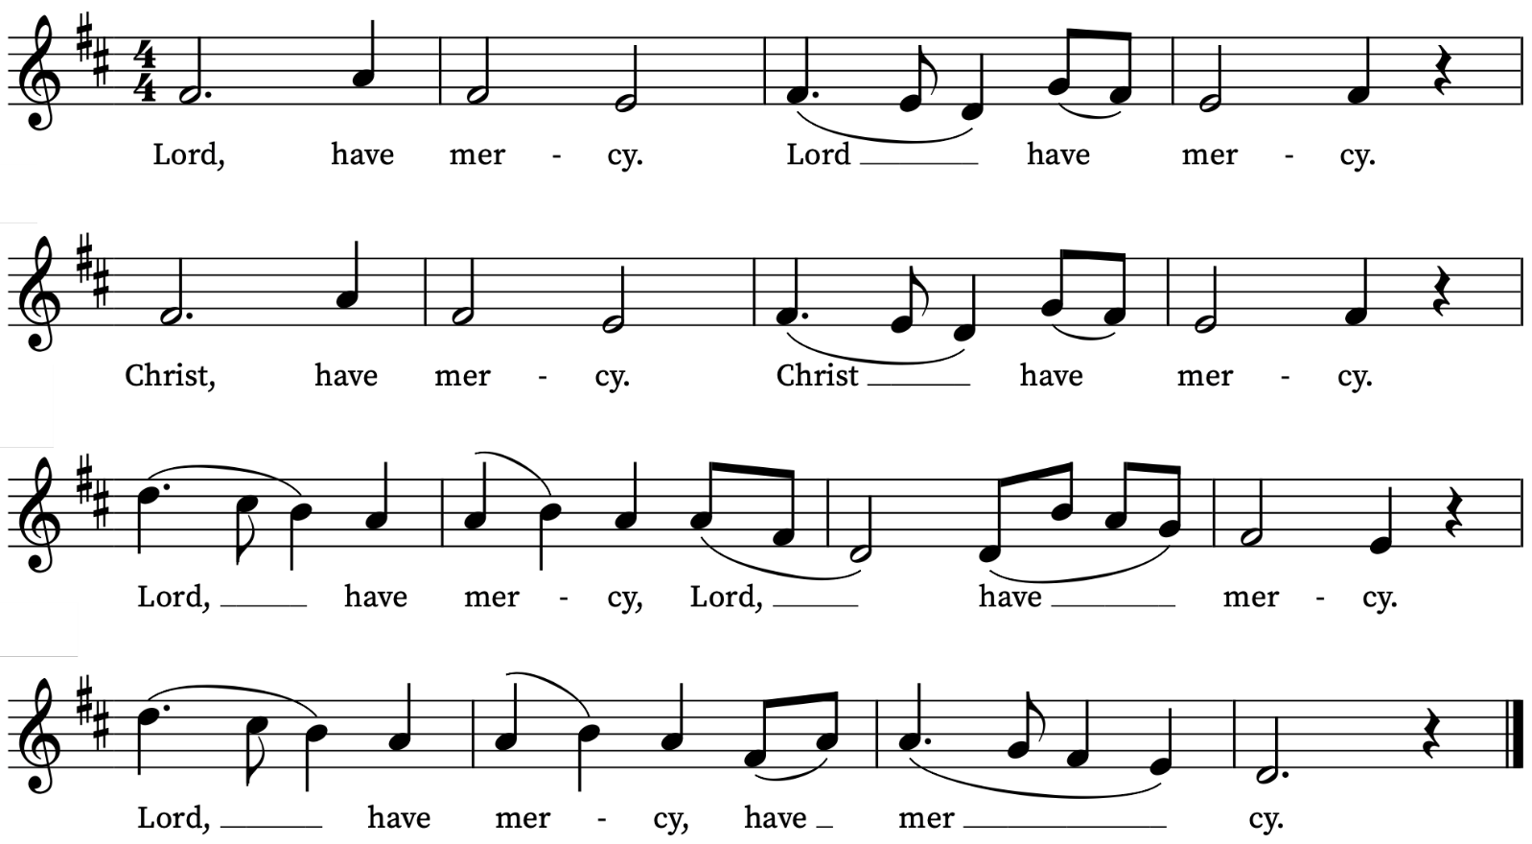

Gloria
We sing the Gloria from Schubert’s German Mass
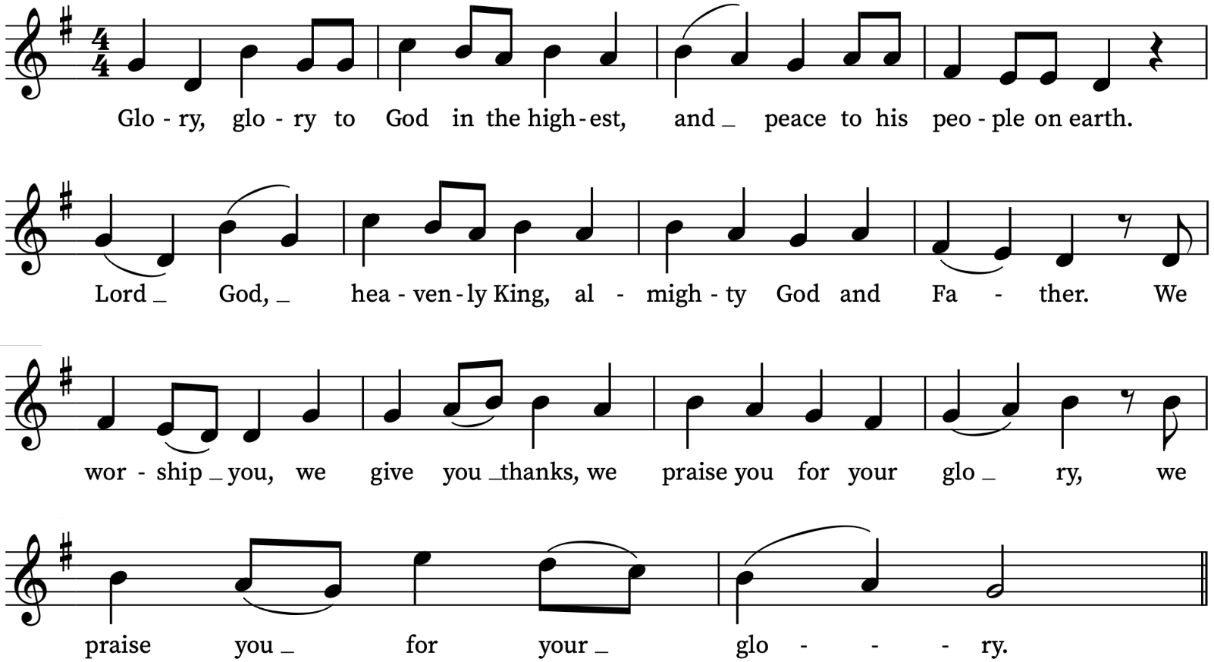
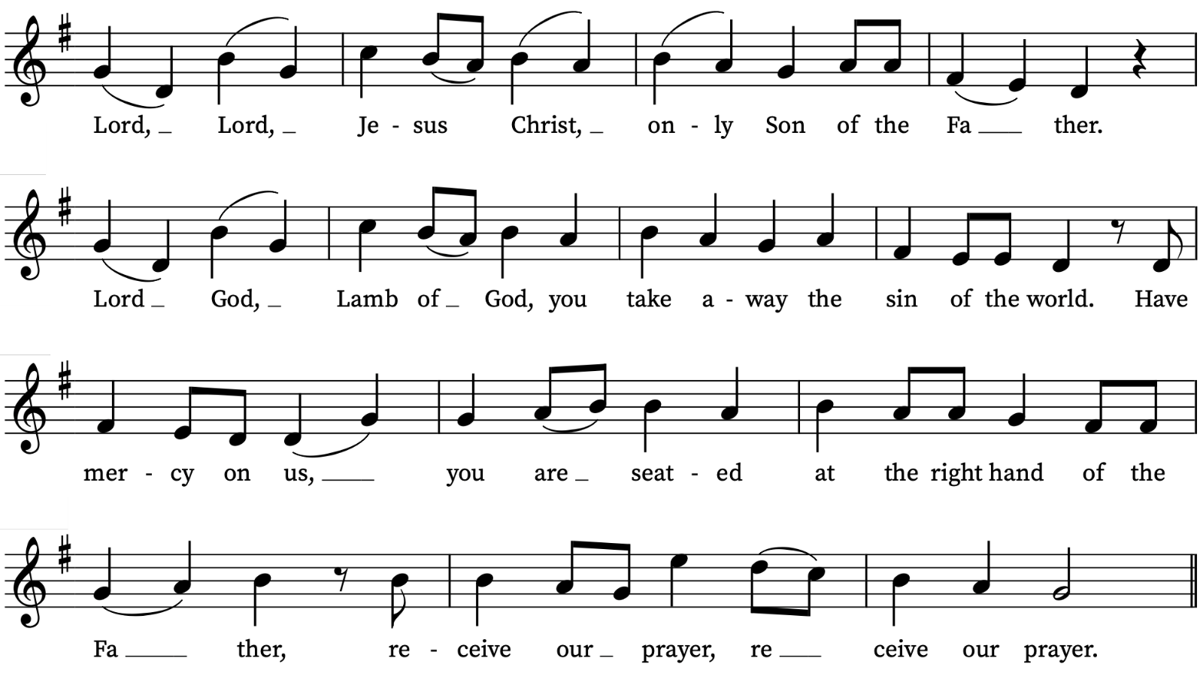

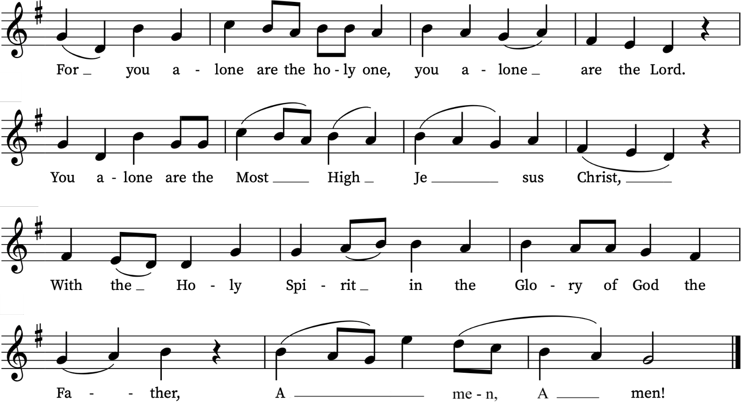

Sanctus/Benedictus
We sing the Sanctus/Benedictus from Schubert’s German Mass
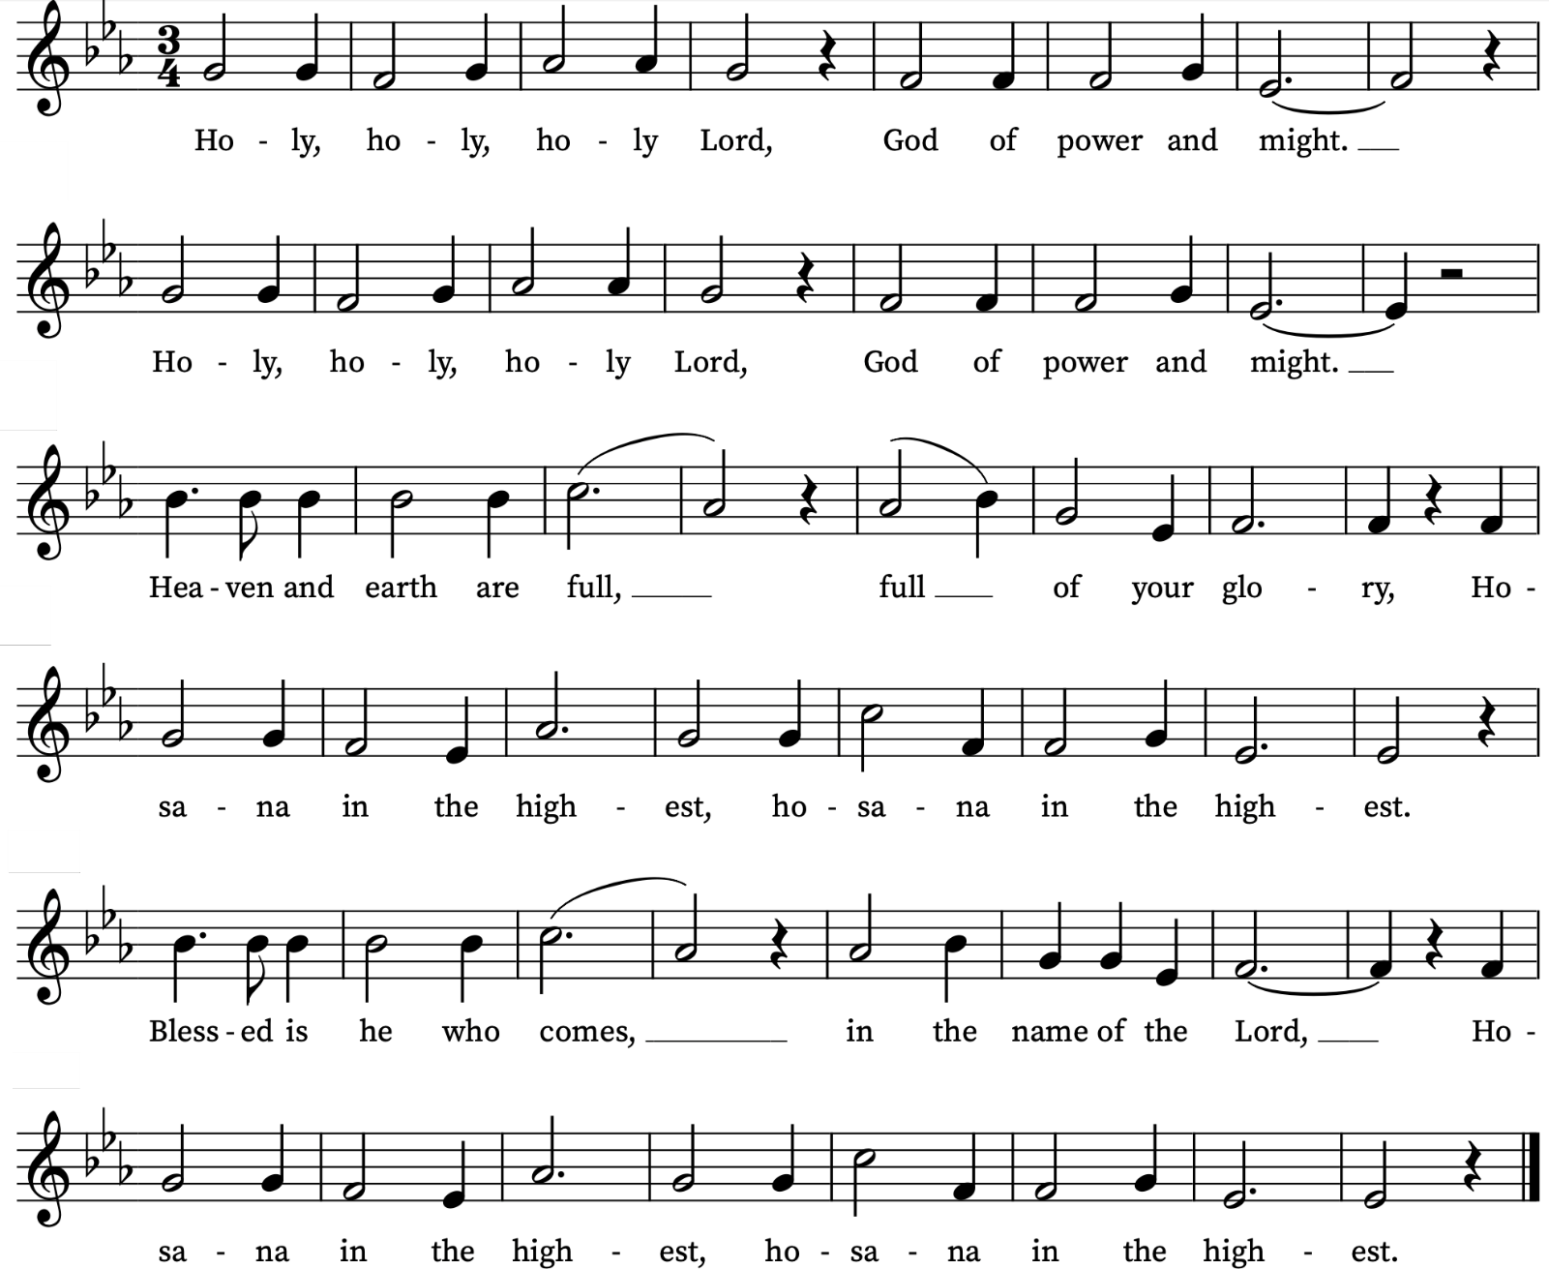
Agnus Dei
We sing the Agnus Dei from Schubert’s German Mass
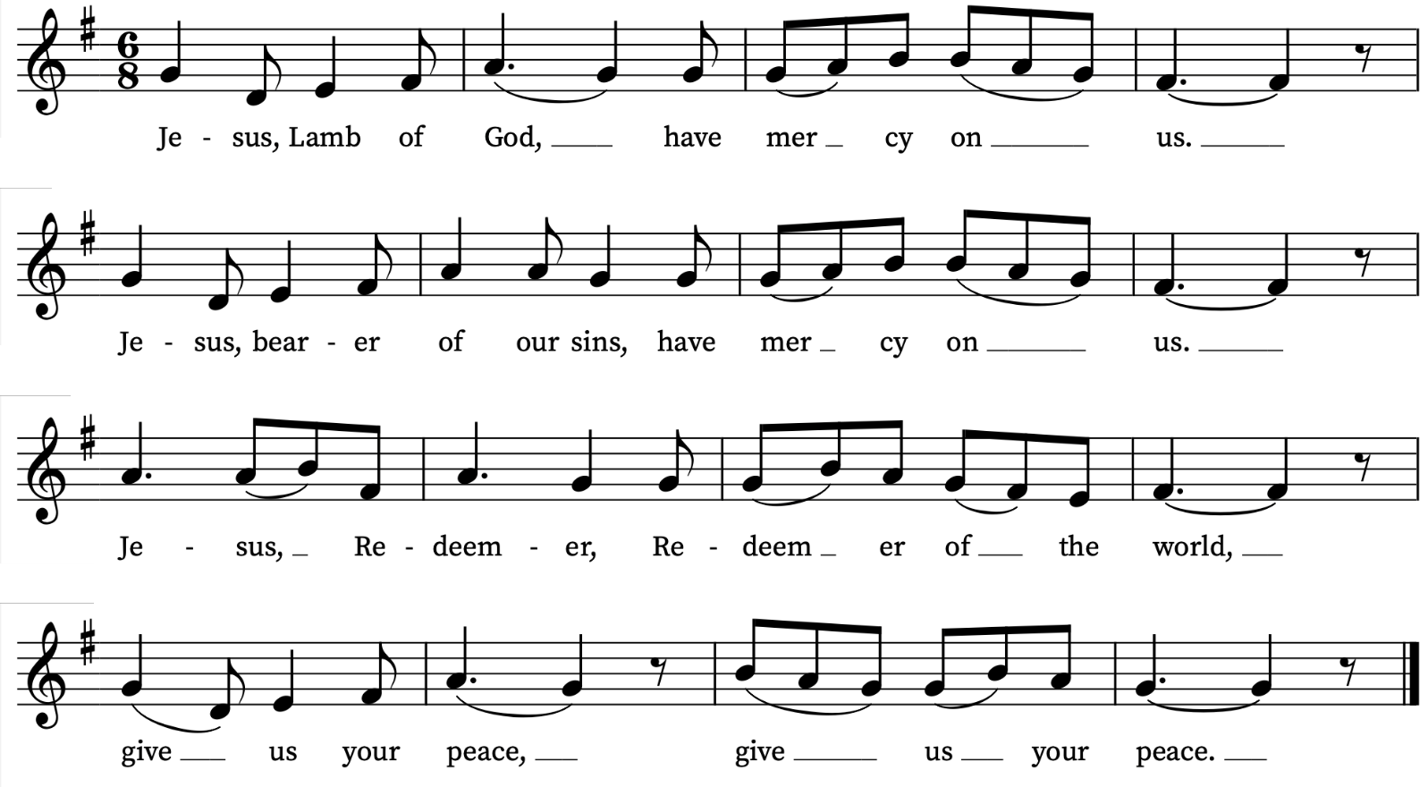

Prayers for the week
We pray for those in need: Aminta and Anthony, Fran Barlow, Ian Clark, Helen and Dan Delap, Delroy Donegal, Andrew Fraser, Jo Fortheringham, Hessie and Nick Hervey, Carole Hubble, Glynne and Nancy John, Lena Kimming, James Markham, Lylian Meira, Nancy Mence, Nimal Menon, Nicola Orme, Tony Othen, Vinubhai Patel, Eva Preisich, Jessica Springbett, Jean Smith, Tina Stanley, Jessica Tipton, Sabrina Unold, George Voelker, Drew Webster, Pauline Youll, and Joshua Zitha.
We remember those who have died recently, including Gordon Anderson, Ted Cantrell, Faith Clarke, Ken Eastwood, Margaret Foreman, Glynne John, Ian McWilliam, and David Weaver. We also remember Elisabeth and Frank Abrahams, Louisa Bond, Christabel Drakes, and I.P. Karyawasan on their year’s minds. We ask God’s blessing and comfort on all mourning the loss of loved ones.
To include names of loved ones on the prayer list, please contact David McEvoy dmcevoy@btinternet.com
Contact Us
Vicar: Revd Simon Winn
Curate: Revd Dr Tati Gutteridge (on maternity leave)
Church Office: 020 8853 0687
email: office@st-alfege.org.uk www.st-alfege.org.uk
Safeguarding Team
Karen Hansen Lead Safeguarding Officer 07866 932 894
Carole Moses Safeguarding Officer 07889 396 671
Irene Bishop Safeguarding Officer 020 8698 2658
safeguarding@st-alfege.org.uk

Services Christmas and New Year
Sunday 28 December First Sunday of Christmas
8.00am Holy Communion (Book of Common Prayer)
10.00am Parish Eucharist
There are no weekday services this week
Sunday 4 January 2026 Feast of Epiphany
8.00am Holy Communion (Said) (Book of Common Prayer)
10.00am Choral Eucharist and Children’s Church
5.30pm Abide, a contemplative service with music from Taizé
Regular weekday services resume with Morning Prayer at 8.30am on Monday 5 January

Supporting St Alfege Church
Please do make a gift to support the life and ministry of St Alfege Church – during the collection in the service or by using a card reader at the North and West Doors. Please complete a Gift Aid envelope (if you are eligible) whether you donate by cash or card. You can also use this QR code to donate. | 