

Sung Eucharist
Second Sunday of Advent
7 December 2025
Welcome to our services of Holy Communion today. Revd Dr Tati Gutteridge, Curate, is presiding and preaching at 8am and preaching at 10am. Revd Simon Winn, Vicar, is presiding at 10am. We all sing the Kyrie on page 2.
Readings
Isaiah 11: 1-10
Psalm 72: 1-7
Romans 15: 4-13
Matthew 3: 1-12
Hymns
24 Hark a thrilling voice is sounding
178 Thy kingdom come!
27 On Jordan’s Bank
142 Hail to the Lord’s anointed (omit verses 3 & 4)
Collect
O Lord, raise up, we pray, your power and come among us,
and with great might succour us; that whereas, through our sins and wickedness we are grievously hindered in running the race that is set before us, your bountiful grace and mercy may speedily help and deliver us; through Jesus Christ your Son our Lord, to whom with you and the Holy Spirit, be honour and glory, now and for ever. Amen
Prayer after Communion
Father in heaven, who sent your Son to redeem the world
and will send him again to be our judge: give us grace so to imitate him in the humility and purity of his first coming that, when he comes again, we may be ready to greet him with joyful love and firm faith; through Jesus Christ our Lord. Amen

This Week’s Advent Wreath Prayer
God our Father, you spoke to the prophets of old of a Saviour who would bring peace. You helped them to spread the joyful message of his coming kingdom. Help us, as we prepare to celebrate his birth, to share with those around us the good news of your power and love. We ask this through Jesus Christ, the light who is coming into the world. Amen.

Kyrie
Please join in singing the Kyrie from Schubert’s German Mass.
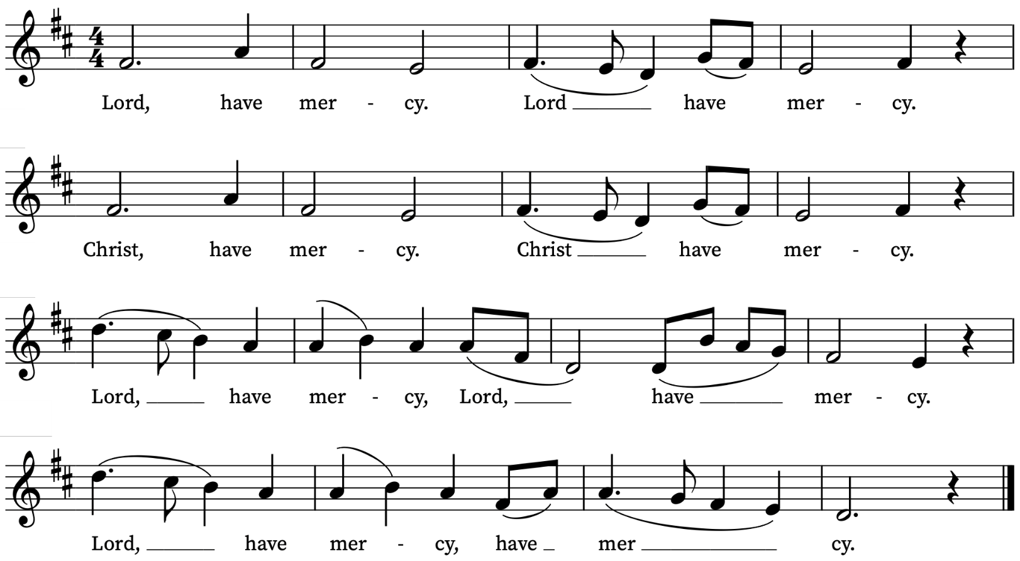

Old Testament Reading
Isaiah 11: 1-10
A reading from the Prophet Isaiah
A shoot shall come out from the stock of Jesse,
and a branch shall grow out of his roots.
The spirit of the Lord shall rest on him,
the spirit of wisdom and understanding,
the spirit of counsel and might,
the spirit of knowledge and the fear of the Lord.
His delight shall be in the fear of the Lord.
He shall not judge by what his eyes see,
or decide by what his ears hear;
but with righteousness he shall judge the poor,
and decide with equity for the meek of the earth;
he shall strike the earth with the rod of his mouth,
and with the breath of his lips he shall kill the wicked.
Righteousness shall be the belt around his waist,
and faithfulness the belt around his loins.
The wolf shall live with the lamb,
the leopard shall lie down with the kid,
the calf and the lion and the fatling together,
and a little child shall lead them.
The cow and the bear shall graze,
their young shall lie down together;
and the lion shall eat straw like the ox.
The nursing child shall play over the hole of the asp,
and the weaned child shall put its hand on the adder’s den.
They will not hurt or destroy
on all my holy mountain;
for the earth will be full of the knowledge of the Lord
as the waters cover the sea.
On that day the root of Jesse shall stand as a signal to the peoples; the nations shall inquire of him, and his dwelling shall be glorious.
This is the Word of the Lord
Thanks be to God

Psalm 72: 1-7
Deus, judicium
Give the King thy judgements, O God : and thy righteousness unto the King's son.
2 Then shall he judge thy people according unto right : and defend the poor.
3 The mountains also shall bring peace : and the little hills righteousness unto the people.
4 He shall keep the simple folk by their right : defend the children of the poor, and punish the wrong-doer.
5 They shall fear thee, as long as the sun and moon endureth : from one generation to another.
6 He shall come down like the rain into a fleece of wool : even as the drops that water the earth.
7 In his time shall the righteous flourish : yea, and abundance of peace, so long as the moon endureth.

New Testament Reading
Romans 15: 4-13
A reading from the Letter of Paul to the Romans
For whatever was written in former days was written for our instruction, so that by steadfastness and by the encouragement of the scriptures we might have hope. May the God of steadfastness and encouragement grant you to live in harmony with one another, in accordance with Christ Jesus, so that together you may with one voice glorify the God and Father of our Lord Jesus Christ.
Welcome one another, therefore, just as Christ has welcomed you, for the glory of God. For I tell you that Christ has become a servant of the circumcised on behalf of the truth of God in order that he might confirm the promises given to the patriarchs, and in order that the Gentiles might glorify God for his mercy. As it is written,
‘Therefore I will confess you among the Gentiles,
and sing praises to your name’;
and again he says,
‘Rejoice, O Gentiles, with his people’;
and again,
‘Praise the Lord, all you Gentiles,
and let all the peoples praise him’;
and again Isaiah says,
‘The root of Jesse shall come,
the one who rises to rule the Gentiles;
in him the Gentiles shall hope.’
May the God of hope fill you with all joy and peace in believing, so that you may abound in hope by the power of the Holy Spirit.
This is the Word of the Lord
Thanks be to God
Gospel
Matthew 3: 1-12
Hear the Gospel of our Lord Jesus Christ according to Matthew
Glory be to thee, O Lord
In those days John the Baptist appeared in the wilderness of Judea, proclaiming, ‘Repent, for the kingdom of heaven has come near.’ This is the one of whom the prophet Isaiah spoke when he said,
‘The voice of one crying out in the wilderness:
“Prepare the way of the Lord,
make his paths straight.”’
Now John wore clothing of camel’s hair with a leather belt around his waist, and his food was locusts and wild honey. Then the people of Jerusalem and all Judea were going out to him, and all the region along the Jordan, and they were baptized by him in the river Jordan, confessing their sins.
But when he saw many Pharisees and Sadducees coming for baptism, he said to them, ‘You brood of vipers! Who warned you to flee from the wrath to come? Bear fruit worthy of repentance. Do not presume to say to yourselves, “We have Abraham as our ancestor”; for I tell you, God is able from these stones to raise up children to Abraham. Even now the axe is lying at the root of the trees; every tree therefore that does not bear good fruit is cut down and thrown into the fire.
‘I baptize you with water for repentance, but one who is more powerful than I is coming after me; I am not worthy to carry his sandals. He will baptize you with the Holy Spirit and fire. His winnowing-fork is in his hand, and he will clear his threshing-floor and will gather his wheat into the granary; but the chaff he will burn with unquenchable fire.’
This is the Gospel of the Lord
Praise be to thee, O Christ
Today’s Music
Mass setting
Kyrie, Gloria, Sanctus/Benedictus and Agnus Dei from Missa Tertia: Octavi Toni – Giovanni Croce
Anthem
Rorate coeli – G.P. da Palestrina
Rorate coeli desuper,
et nubes pluant justum:
aperiatur terra et germinet Salvatorem.
Ostende nobis, Domine, misericordiam tuam,
et salutare tuum da nobis:
veni Domine, et noli tardare.
Alleluia.
Drop down dew, ye heavens, from above
and let the clouds pour down righteousness:
let the earth open and bring forth the Saviour.
Show us thy mercy, O Lord,
and grant us thy salvation: (Psalm 85:8)
come, O Lord, and do not delay.
Alleluia.
Antiphon for the Fourth Sunday of Advent
Communion
Agnus Dei from Missa Tertia: Octavi Toni – Giovanni Croce
Organ Postlude
Es ist ein Ros entsprungen – Johannes Brahms
St Alfege Christmas Fair
Today Sunday 7 December from 1.00 - 4.30pm
Prayers for the week
We pray for those in need: Aminta and Anthony, Fran Barlow, Ian Clark, Helen and Dan Delap, Andrew Fraser, Jo Fortheringham, Hessie and Nick Hervey, Glynne and Nancy John, Lena Kimming, James Markham, Lylian Meira, Nimal Menon, Tony Othen, Vinubhai Patel, Eva Preisich, Jessica Springbett, Jean Smith, Tina Stanley, Jessica Tipton, Sabrina Unold, George Voelker, Drew Webster, Pauline Youll, and Joshua Zitha.
We remember those who have died recently, including Gordon Anderson, Dan Iorga, Catherine Varney and David Weaver. We also remember Angus Thomson and Winston Davies on their year’s minds. We ask God’s blessing and comfort on all mourning the loss of loved ones.
To include names of loved ones on the prayer list, please contact David McEvoy dmcevoy@btinternet.com
A prayer for the Holy Land
Gracious Father, whose blessed Son Jesus Christ came down from heaven to be the true bread which gives life to the world: In your mercy, provide for all those in Gaza and beyond who suffer from hunger and starvation, that they may be given both physical bread to nourish their bodies and heavenly bread to sustain their souls. By the power of your Spirit, bring a speedy end to this cruel war, the release of all captives, care for the sick and wounded, comfort for those who have lost loved-ones, and the opening of a pathway for a just and lasting peace here in the very homeland where your Son, our Lord Jesus Christ, ministered during his earthly life; who lives and reigns with you and the Holy Spirit, one God, now and forever. Amen.
The Most Reverend Dr Hosam E. Naoum, Anglican Archbishop in Jerusalem, August, 2025
Supporting St Alfege Church
Please do make a gift to support the life and ministry of St Alfege Church – during the collection in the service or by using a card reader at the North and West Doors. Please complete a Gift Aid envelope (if you are eligible) whether you donate by cash or card. You can also use this QR code to donate. | 

Advent & Christmas Services 2025
These special services for Advent and Christmas are in addition to our normal Sunday and weekday services
Saturday 13 December
4pm Children's Church | Christmas Window reveal with carols
Sunday 14 December Third Sunday of Advent
10am All Age Eucharist with Nativity Play
Parish Communion with Children’s Church Nativity Play
3pm Lugandan Christmas Service
Sunday 21 December Fourth Sunday of Advent
6.30pm Service of Nine Lessons and Carols
A candlelit service with readings, hymns and carols with St Alfege Church choir, directed by Joshua Ryan
Monday 22 December
6.30pm Blue Christmas service
A reflective service of Holy Communion close to the longest night, especially for those who find Christmas a difficult time.
Wednesday 24 December Christmas Eve
5.00pm Christingle and Crib Service
A short joyful candlelit service for all ages to begin Christmas.
11.00pm Midnight Mass
A choral celebration of Christmas with carols and candlelight
Thursday 25 December Christmas Day
11am Sung Eucharist
Holy Communion with carols for all ages on Christmas morning.
Sunday 28 December
8.00am Holy Communion (Said)(Book of Common Prayer)
10.00am Parish Eucharist (Sung)
Sunday 4 January 2026 Feast of Epiphany
8.00am Holy Communion (Said) (Book of Common Prayer) 10.00am Parish Eucharist (Sung)

Services this week
Today, Sunday 7 December Second Sunday of Advent
8.00am Holy Communion (Book of Common Prayer)
10.00am Sung Eucharist
No Abide today. Next service Sunday 4 January at 5.30pm
Monday 8 December
8.30am Morning Prayer
Tuesday 9 December
8.30am Morning Prayer
Wednesday 10 December
8.30am Morning Prayer
Thursday 11 December
8.00am Holy Communion
Sunday 14 December Third Sunday of Advent
8.00am Holy Communion (Book of Common Prayer)
10.00am Sung Eucharist
12.45 to 2.00pm (approx.) A cohort of the Pipes and Drums from General Gordon School will hold a short reflection in church (General Gordon was baptized here) followed by a performance outside the church.
Walk-In Wednesdays
Every Wednesday 10am-12noon in the Frank Smith Room in the hall.
Contact Us
Vicar: Revd Simon Winn
Curate: Revd Dr Tati Gutteridge
Church Office: 020 8853 0687
email: office@st-alfege.org.uk www.st-alfege.org.uk
Safeguarding Team
Karen Hansen Lead Safeguarding Officer 07866 932 894
Carole Moses Safeguarding Officer 07889 396 671
Irene Bishop Safeguarding Officer 020 8698 2658
safeguarding@st-alfege.org.uk

