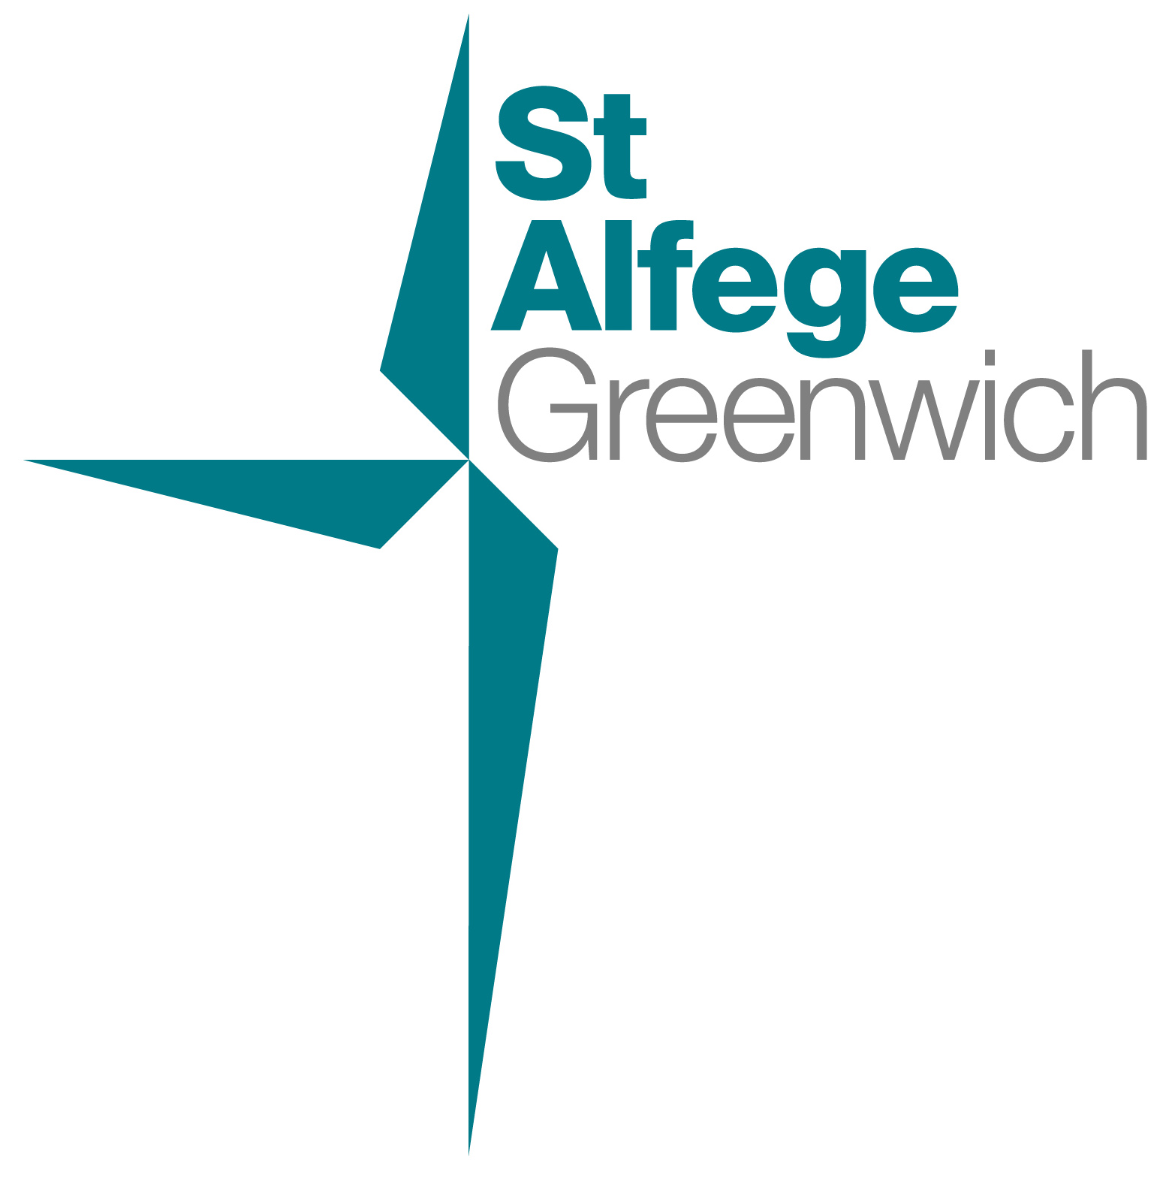

Advent & Christmas Services 2025
These special services for Advent and Christmas are in addition to our normal Sunday and weekday services
Sunday 30 November First Sunday of Advent
6.30pm Service of Music and Readings for Advent
A service of music and readings to begin the season, with St Alfege Church choir, directed by Joshua Ryan
Saturday 13 December
4pm Childrens Church | Christmas Window reveal with carols
Sunday 14 December Third Sunday of Advent
10am All Age Eucharist with Nativity Play
Parish Communion with Children’s Church Nativity Play
3pm Lugandan Christmas Service
Sunday 21 December Fourth Sunday of Advent
6.30pm Service of Nine Lessons and Carols
A candlelit service with readings, hymns and carols with St Alfege Church choir, directed by Joshua Ryan
Monday 22 December
6.30pm Blue Christmas service
A reflective service of Holy Communion close to the longest night, especially for those who find Christmas a difficult time.
Wednesday 24 December Christmas Eve
5.00pm Christingle and Crib Service
A short joyful candlelit service for all ages to begin Christmas.
11.00pm Midnight Mass
A choral celebration of Christmas with carols and candlelight
Thursday 25 December Christmas Day
11am Sung Eucharist
Holy Communion with carols for all ages on Christmas morning.
Sunday 28 December
8.00am Holy Communion (Said)(Book of Common Prayer)
10.00am Parish Eucharist (Sung)
Sunday 4 January 2026 Feast of Epiphany
8.00am Holy Communion (Said) (Book of Common Prayer)
10.00am Parish Eucharist (Sung)
Further details about services at St Alfege Church here:  St Alfege Church, Greenwich : Services  Further details about concerts and events here:  St Alfege Church, Greenwich : Concerts and recitals | 

